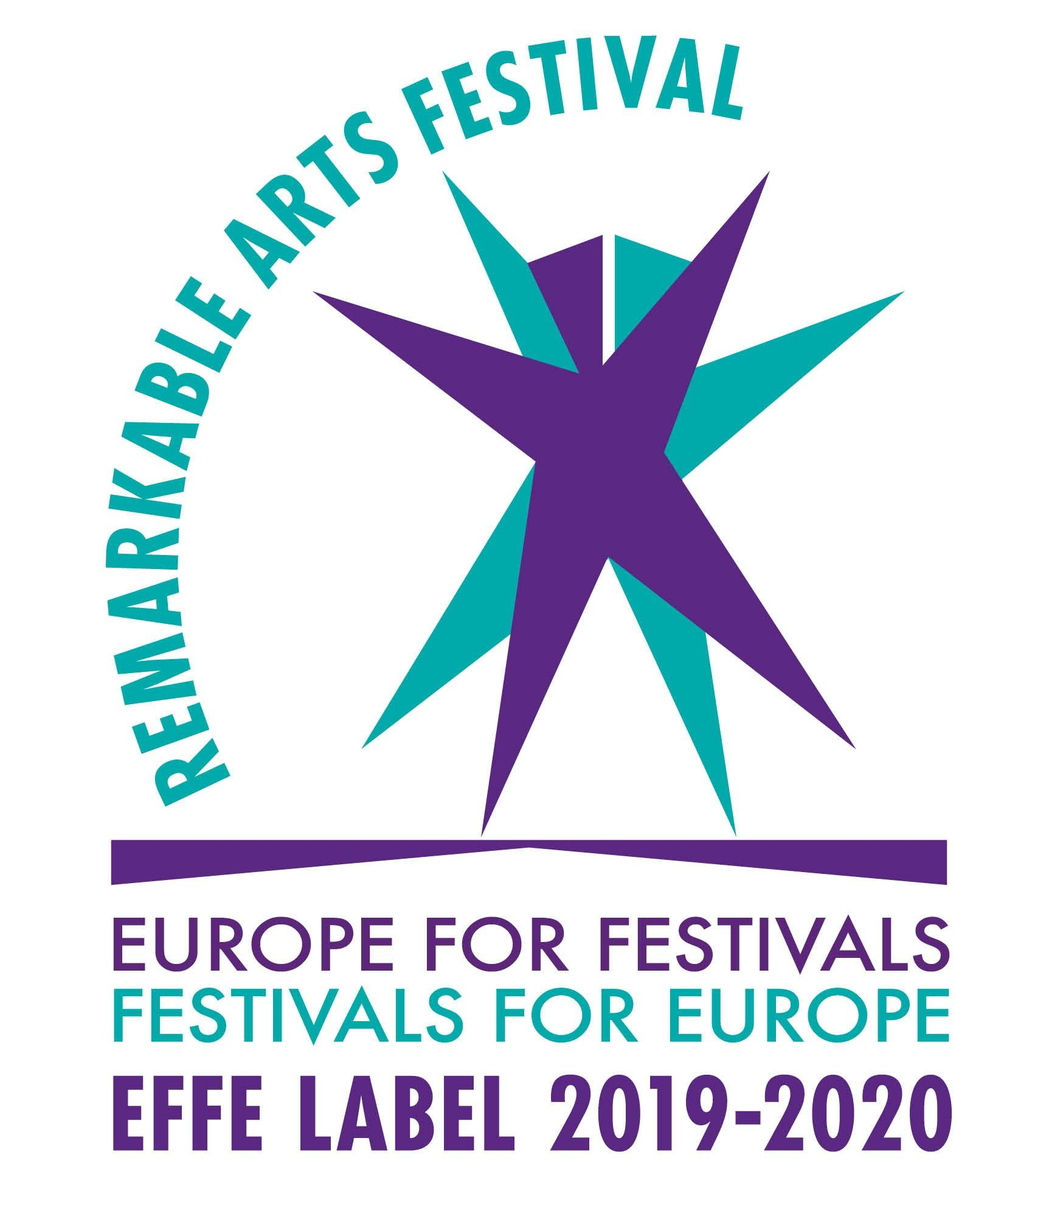
25th ATHENS INTERNATIONAL FILM FESTIVAL

18th - 29th September 2019
PRESS RELEASE
Announcing the titles of the films in the Greek Short Stories in Competition section
New Greek cinema through 47 short films!

The Athens International Film Festival has actively supported Greek cinema as a testament to its love for the sector.

For the best part of a decade, the Festival’s Greek Short Stories in Competition section has been carefully helping new Greek short films make their way to the big screen and find their audience. The love and trust exhibited by the Festival is reciprocated by Greek film creators as they continue to submit an increasing number of their films thus making the Festival a champion in showcasing the most creative works Greek film production has to offer.

Having presented more than 400 films since 2012 the lively and exciting Greek Short Stories in Competition section is an integral part of the 25th anniversary edition of the Athens International Film Festival.

This year’s submissions (311) have surpassed last year’s record number of submissions (244). This proves that Greek cinema is present and active and new Greek creators entrust the Festival and its audience with the presentation of their work.
The selection process by the Festival’s programme selection team has been completed and 47 films have been chosen to compete for the awards of the 25th Athens International Film Festival.

The films which will be competing are (in alphabetical order):

A Jar of Nuts (Savvas Stavrou)
A Patch of Blue (Memi Koupa)
All the Fires the Fire (Efthimis Kosemund Sanidis)
Alpha Male (Christos Dimolikas)
Automatic (Emma Doxiadi)
Basil (Vangelis Serfas)
Cedar Wolf (Sofia Georgovassili)
Chekhov's Gun (Christos Argiros)
Chimera (Melpomeni)
Chopper (Giorgos Kapsanakis)
Cloud (Michael Demetrius)
Dog of Chamomile (Kostis Charamountanis)
Draw with Me (Constantine Venetopoulos)
Ellinikon (Konstantinos Prepis)
Flickering Souls Set Alight (Iakovos Panagopoulos)
Fugue (Laura Neri)
Gregale (Alexandros Kontos)
Heat Wave (Fokion Xenos)
Hyped (Alkis Papastathopoulos)
I am Mackenzie (Artemis Athanasiadou)
I Only See In me the Sea (Alexis Chatzigiannis, Yorgos Kyvernitis, Nefeli Oikonomou Pantzou, Maria Sidiropoulou)
Ifigeneia: No More Tears (George Georgakopoulos)
In the Room (Yeorgia M. Sotirchou)
Index (Nicolas Kolovos)
Ivan (Panagiotis Kountouras)
Jenny and John (Nikoleta Leousi)
Mila (Andreas Vakalios)
Off Guard (Daina Papadaki)
One (Stella Serefoglou)
Oxytocin (Konstantinos Kardakaris)
Postcards from the End of the World (Konstantinos Antonopoulos)
Rearrangement (Emilios Avraam)
Sable Noir (Thanasis Trouboukis)
Sad Girl Weekend (Dimitris Tsakaleas, Lida Vartzioti)
Seawolf (Chris Sitaridis)
Son (Kostas Tataroglou)
The Arm Wrestler (Georgios Gousis)
The Canaries (Yorgos Kyvernitis)
The Distance Between Us and the Sky (Vasilis Kekatos)
The Dude (Alexandros Kakaniaris)
The Mechanic (Dimitris Kotselis)
The Righteous (Christos Pitharas)
The Weight of the Sea (Kostis Alevizos)
Violent Equation (Antonis Doussias)
W (Stelios Koupetoris)
Wax and Feathers (Marios Lizides)
Yazidi (Hektor Sakaloglou)

THE JURY
The jury to decide on the winners and present the awards of the Greek Short Stories in Competition section of the 25th Athens International Film Festival will consist of:

Amanda Livanou (President), producer
Lina Nikolakopoulou, lyricist
Christos Voupouras, director
Marisha Triantafyllidou, actress
Dimitris Vrahnos, radio producer / radio program director at Melodia radio station

THE AWARDS
The final selection of the films which will comprise the Greek Short Stories in Competition section will be judged by the jury who will present the following awards:

- Best Film
- Runner-up Best Film
- Best Director
- Best Screenplay
- Best Performance by an Actor
- Best Performance by an Actress

The award for Best Film is accompanied by a € 2,000 cash prize, kindly sponsored by the Greek Film Center for the third year running.
The Runner-up Best Film is accompanied by a € 1,000 cash prize, kindly sponsored by the Greek Film Center which honours their intent to encourage the production of Greek films.

____________________________________
This year’s programme will be presented at the Festival’s Press Conference to be held on Wednesday 11th September 2019 in the function room of the Friends of Music Society of the Athens Concert Hall.
The celebratory 25th organisation of the Festival will take place from 18th to 29th of September 2019.
The Main Sponsor of the 25th Athens International Film Festival is COSMOTETV.
Additional information about events and screenings, as well as continuous updates on the activities and news of the 25th Athens International Film Festival can be found on the following websites:
www.cinemagazine.gr | www.aiff.gr

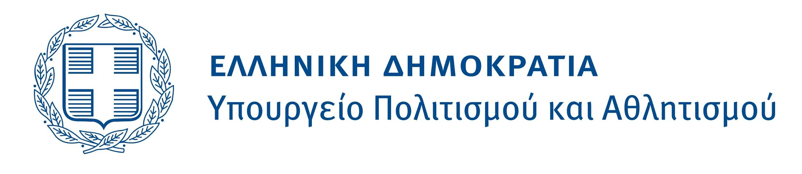
The 25th Athens International Film Festival is held under the auspices and with the financial support of the Ministry of Culture and Sports.

ORGANISED BY
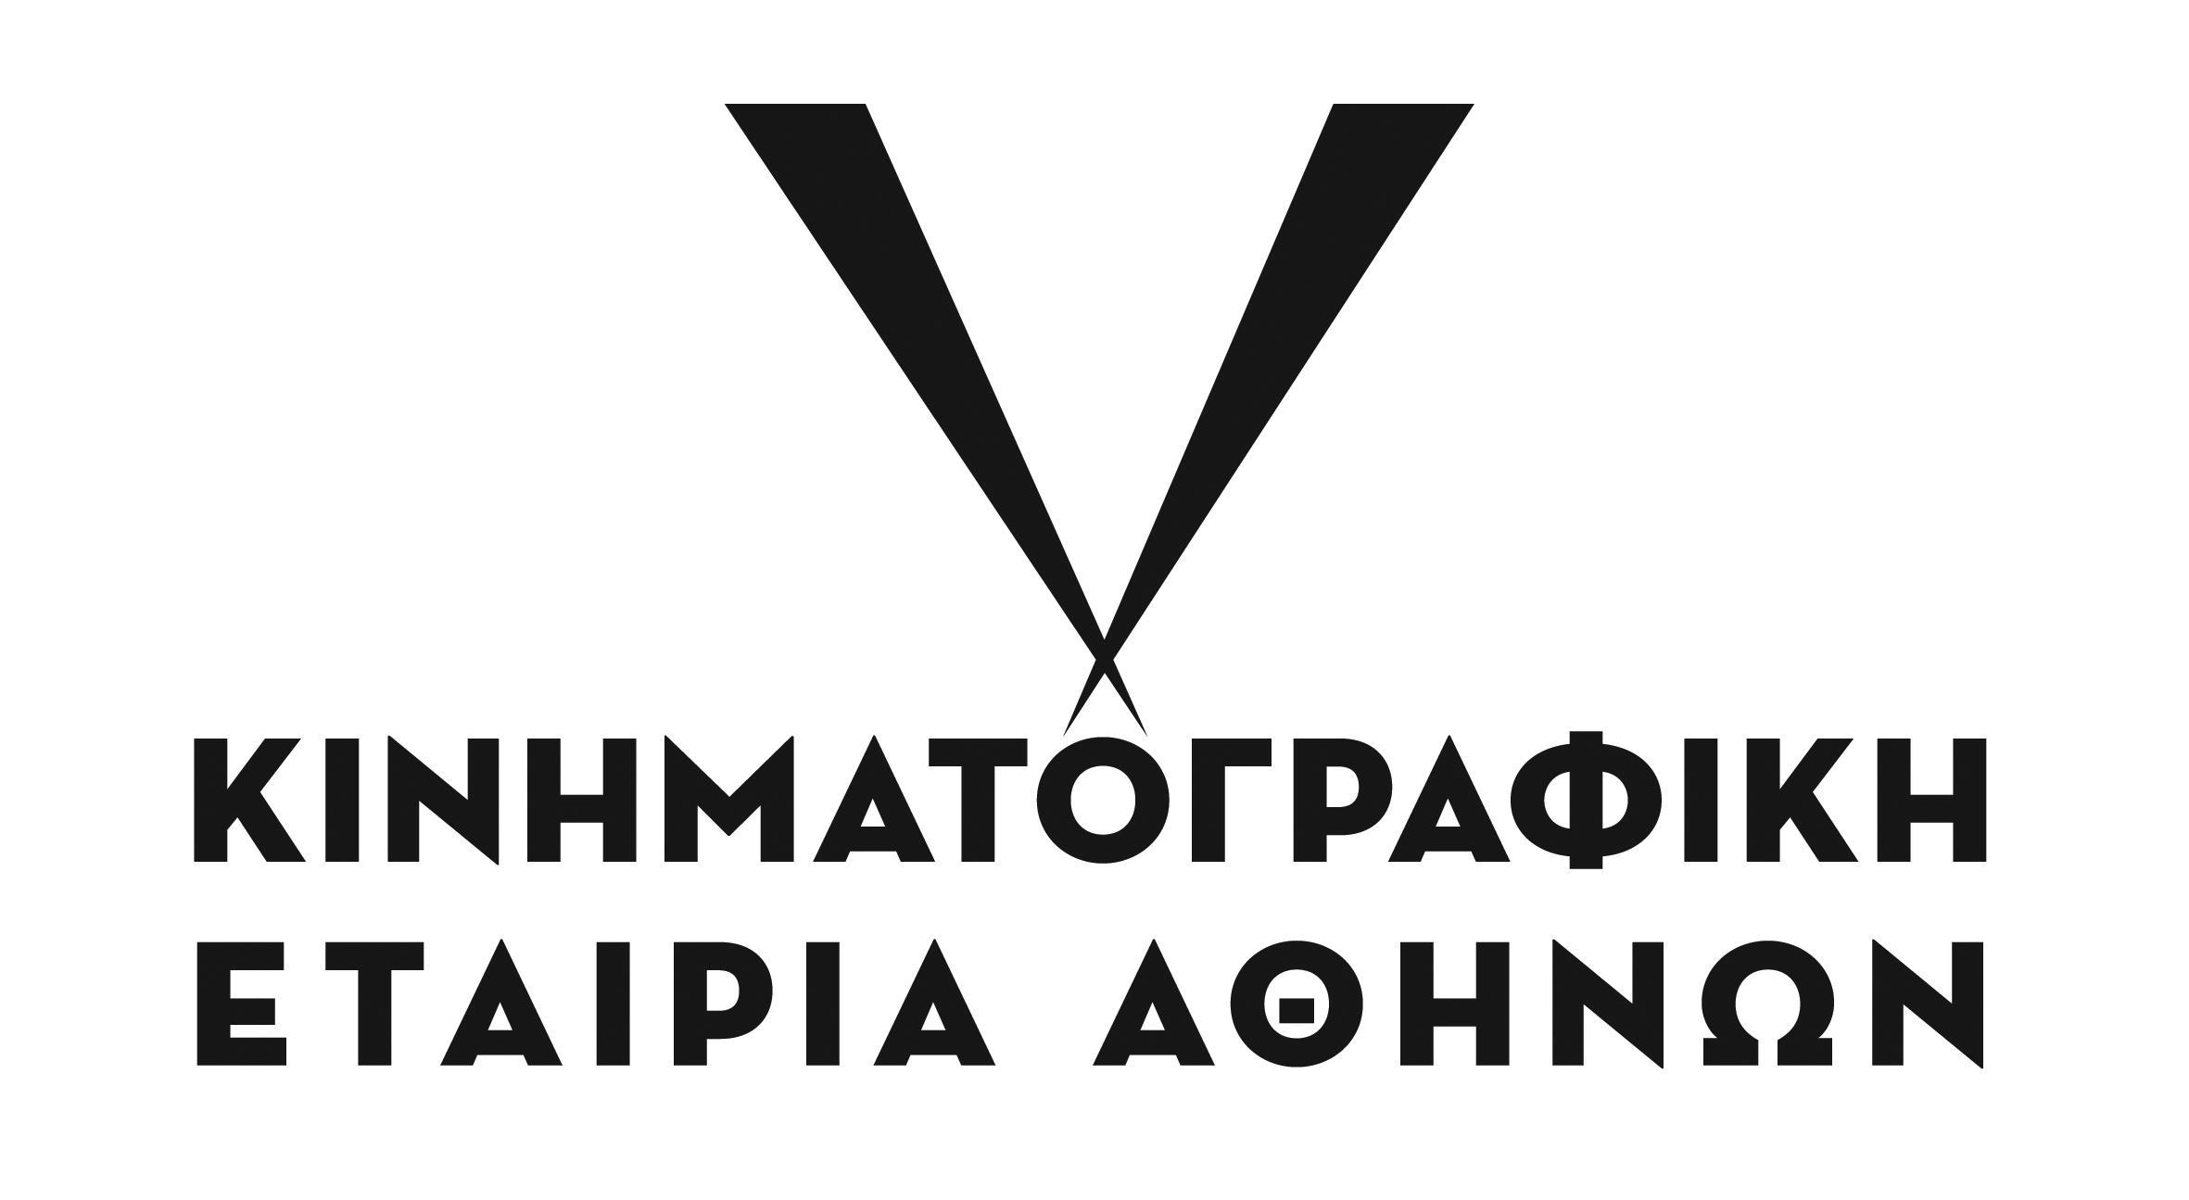
CO-ORGANISED BY
MAIN SPONSOR
EVENTS SUPPORTER
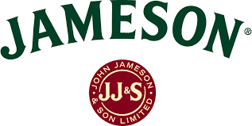
SPONSOR OF THE AUDIENCE AWARD
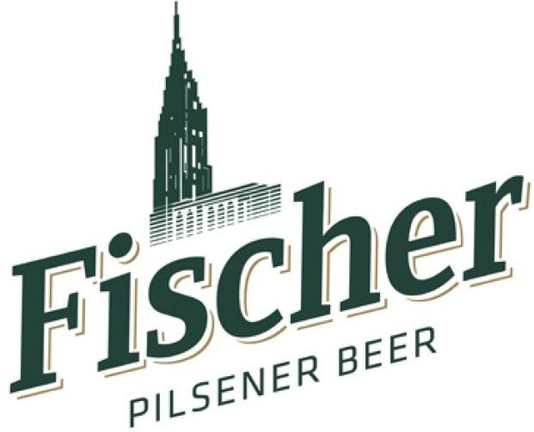
COMMUNICATION SPONSORS
