25th ATHENS INTERNATIONAL FILM FESTIVAL
18 - 29 September 2019
PRESS RELEASE
The closing film: Costa-Gavras’ “Adults in the Room” in attendance of the director
In its 25 successful years, the Athens International Film Festival has honoured without fail and has lovingly promoted Greek cinema and its great film directors.
This year’s anniversary edition of the Festival honours this long-standing tradition and we are especially happy to select the most anticipated Greek film of the year, “Adults in the Room” by the world renowned director Costa-Gavras as the closing film for the 25th Athens International Film Festival.
The film is based on the book of the same name by Yanis Varoufakis and tells the story of the challenging negotiations between Greece and the E.U. (Eurogroup) on how to manage the Greek national debt crisis at the start of 2015 and is characterised as “a modern-day ancient Greek tragedy”, where “behind closed doors a human tragedy unfolds”.
The world premiere of “Adults in the Room” will take place at the Venice Film Festival. Indeed, Costa-Gavras will be this year’s honoured person at the Venice Film Festival as he will be presented with the Jaeger-Le Coultre Glory to the Filmmaker 2019 award for his lifetime contribution to cinema.
“Adults in the Room” will make its nationwide Greek premiere on Saturday 28th September 2019 courtesy of Odeon, following the closing ceremony and presentation of awards of the 25th Athens International Film Festival. The director himself, Mr Costa-Gavras, will attend the premiere of the film along with key members of the cast and crew.
During his glorious career, the world renowned Greek director has directed more than 20 films and has won the Best Foreign Language Oscar Academy Award and the Best Film Editing Academy Award as well as the Cannes Jury Prize award in 1969 for the film “Z”, the Cannes Film Festival Palme d’Or award and the Best Screenplay Oscar in 1982 for “Missing” and the Berlin International Film Festival Golden Berlin Bear award in 1990 for “Music Box”.

The closing film:
“Adults in the Room”
Script - Director: Costa-Gavras
Starring: Christos Loulis, Alexandros Bourdoumis, Ulrich Tukur, Daan Schuurmans, Dimitris Tarloou, Christos Stergioglou, Cornelius Obonya, Francesco Acquaroli, Vincent Nemeth, Aurélien Recoing, Thanos Tokakis, Alexandros Logothetis, Themis Panou, Josiane Pinson, Geronge Lenz, Maria Protopappa.
Special participation: Valeria Golino, Georges Corraface.
Producers: Michèle Ray and Alexandre Gavras
Co-Producers: Brahim Chioua, Manos Krezias
Music Composer: Alexandre Desplat
Director of Photography: Yorgos Arvanitis (A.F.C- G.S.C)
Editor: Costa-Gavras and Lambis Haralampidis

The film will be released in Greek cinemas by Odeon on October 3.

Additional information regarding the highly anticipated nationwide Greek premiere will be announced soon.
____________________________________
This year’s programme will be presented at the Festival’s Press Conference to be held on Wednesday 11th September 2019 in the function room of the Friends of Music Society of the Athens Concert Hall.
The celebratory 25th organisation of the Festival will take place from 18th to 29th of September 2019.
The Main Sponsor of the 25th Athens International Film Festival is COSMOTETV.
Additional information about events and screenings, as well as continuous updates on the activities and news of the 25th Athens International Film Festival can be found on the following websites:
www.cinemagazine.gr | www.aiff.gr
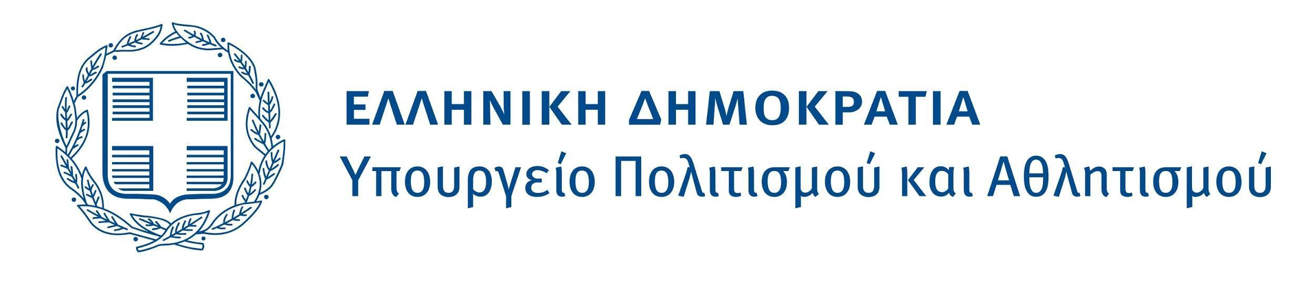
The 25th Athens International Film Festival is held under the auspices and with the financial support of the Ministry of Culture and Sports.

ORGANISED BY
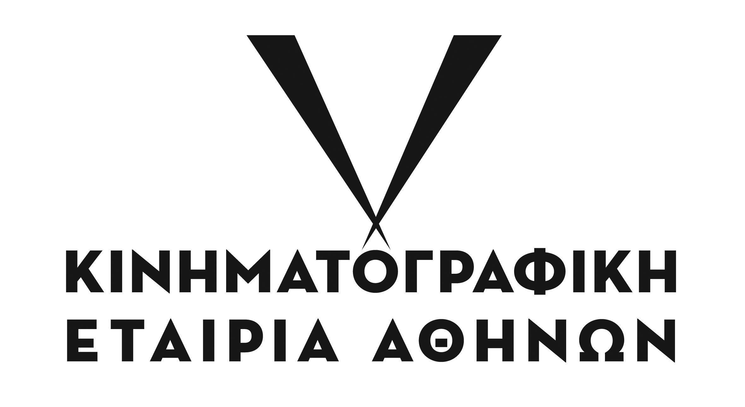
CO-ORGANISED BY
MAIN SPONSOR
EVENTS SUPPORTER
SPONSOR OF THE AUDIENCE AWARD
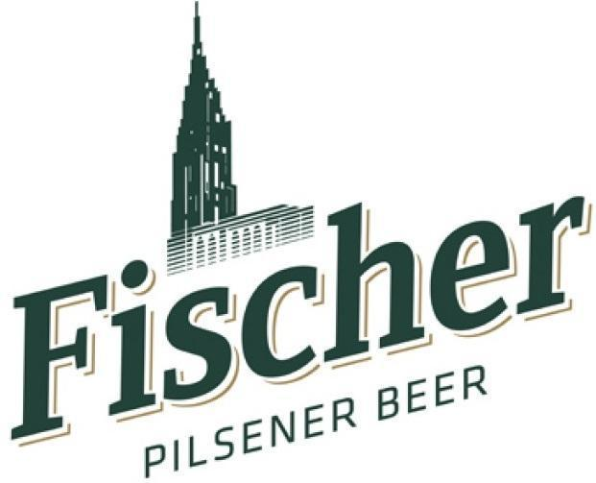
COMMUNICATION SPONSORS
