25th ATHENS INTERNATIONAL
FILM FESTIVAL |
September 18 - 29, 2019
PRESS RELEASE
TRIBUTE
Urban legends:
the sublime cinema of Edward Yang
‘Edward Yang was one of the leading Taiwanese filmmakers of the late 20th century. ‘That Day, On the Beach’ (1983), Yang’s miraculous debut feature film, was the way this pioneering director set the foundations for the cinematic New Wave of Taiwan and introduced the legendary cinematographer Christohper Doyle to the audience (and later on to Wong Kar-wai). In his much-praised ‘Taipei Story’ (1985) he offered the leading role to Hou Hsiao-hsien, one of the greatest creators of modern cinema, co-writing the script. With his epic ‘A Brighter Summer Day’ (1991), the undisputed masterpiece of his filmography, he gained international admiration and saw his film voted by 5000 top critics abroad as one of the 100 most important films ever made. With his polyphonic drama ‘Yi Yi’ (2000) he was won the Direction Award at Cannes and gained international acclaim. The film holds a place among the ten best films of the decade according to respectable media (New York Times, Village Voice, Sight and Sound) and extremely important theoreticians such as Susan Sontag.
Through his artistically exciting filmography of twenty years filled with gems, the Taiwanese director became the poet of elaborate narration, of the conflict between the old world with the new one and our effort to remain unfazed before the cataclysmic political and social changes that take place in our little worlds, our communities, our cities, our countries.
Edward Yang (1947-2007) left this world too young, at the age of 59 and the peak of an amazing career, which was bound to give even more masterpieces. His film legacy though places him deservedly, next to the greatest directors of modern Asian cinema, and it is this very legacy that is presented at the 25th AIFF’ special feature. It’s the first time that the Greek audience will have the chance to watch all Edward Yang’s films on the big screen digitally remastered. Mrs Kaili Peng, composer, collaborator and Yang’s life-partner will be our special guest.
The tribute’s films:
THAT DAY, ON THE BEACH | HAI TAN DE YI TIAN (1983)
TAIPEI STORY (1985) | QĪNGMÉIZHÚMĂ
THE TERRORIZERS | KONG BU FEN ZI (1986)
A BRIGHTER SUMMER DAY | GŬLĬNG JIĒ SH ÀONIÁN SH RÉN SH ÌJIÀN (1991)
A CONFUCIAN CONFUSION (1994) | DU LI SHI DAI
MAHJONG | MAJIANG (1996)
YI YI: A ONE AND A TWO... | YI YI: A ONE AND A TWO…(2000)

The tribute is supported by the Taipei representative office in Greece
Please find the TRIBUTE’s PHOTOS here
____________________________________
This year’s programme will be presented at the Festival’s Press Conference to be held on Wednesday 11th September 2019 in the function room of the Friends of Music Society of the Athens Concert Hall.
The celebratory 25th organisation of the Festival will take place from 18th to 29th of September 2019.
The Main Sponsor of the 25th Athens International Film Festival is COSMOTETV.
Additional information about events and screenings, as well as continuous updates on the activities and news of the 25th Athens International Film Festival can be found on the following websites:
www.cinemagazine.gr | www.aiff.gr
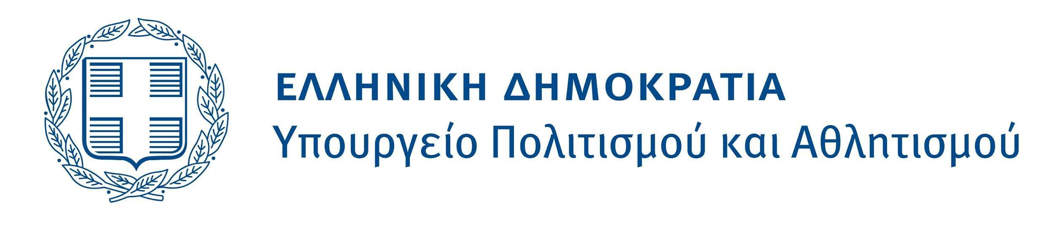
The 25th Athens International Film Festival is held under the auspices and with the financial support of the Ministry of Culture and Sports.

