27thATHENS INTERNATIONAL FILM FESTIVAL | 22nd September - 3rd October 2021
PRESS RELEASE
THE POSTER
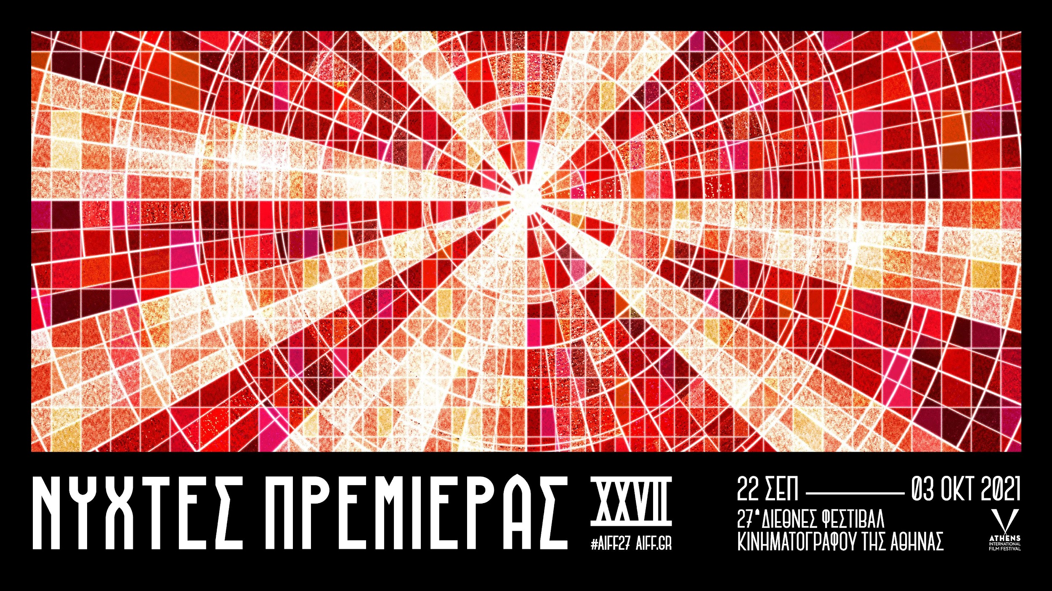

It is with great pleasure that we present the poster of the 27th Athens International Film Festival.
The concept behind this year’s design in the words of the designer himself, Vassilis Mexis: “How many times have we entered a cinema to deify a form of film or left the cinema following a screening with a feeling of redemption? The cinema might as well be considered an alternative place of worship. But in this place, light isn’t at odds with darkness but rather emerges from it and heralds the commencement of a magnificent ritual. For this reason, this year, an innumerable number of small glass images comprise the great luminous source of the cinematic Mystery which Godard defines as “truth 24 frames-per-second”, and so leaving bias aside, the 27th event of the Festival invites us to worship the 7th Art”.
Vassilis Mexis, a first class Honours graduate in Graphic Design, has been creating the posters for the Athens Open Air Film Festival and the Athens International Film Festival since 2016. Since 2013 he has also been working in the advertising sector as Art Director with a number of distinguished campaigns under his belt. He has also edited the covers of books and high-circulation magazines. His work has been showcased both in print and online media having received awards in national and international competitions.
The poster for the 27th event of the Festival was presented exclusively and as a surprise by the Artistic Director of the Festival, Mr Loukas Katsikas, on Thursday 29thJuly as part of yet another special event of the 11th Athens Open Air Festival. A special and touching event as after 31 years of “silence” a screening was hosted once more at one of the loveliest open air cinemas in town: “AB” in Ano Patisia which has re-opened thanks to the commendable efforts of and renovation by the Municipality of Athens.
With the initiative taken by the 11th Athens Open Air Film Festival, last night “AB” hosted its first cinematic screening, showing the classic and recipient of the Palme d’Or award “The Wages of Fear” directed by Henri-Georges Clouzot and in collaboration with the 5th Plein Air French Film Festival .
The impressively sized screen of this historic open air cinema in combination with the spectacular and commanding design of the poster won a warm applause from the large audience while Loukas Katsikas related this year’s Festival identity with the concept of cinema as a religious experience and a means of manifesting worship as he stated that “Our religion is film, directors are our saints, films our holy scriptures and cinemas our places of worship. With the poster of the 27th Athens International Film Festival we celebrate the temples of great cinematic Mysteries”.

A high resolution poster can be found (vertical and landscape files)
HERE.

Audience members were kept refreshed by film fans’ beer of choice, Fischer.

We would like to remind you that in light of the health pandemic faced in Greece and abroad and following the safe and successful running of last year’s hybrid event of the Festival our aim is to host the 27th Athens International Film Festival in both open-air and indoor cinemas always respectful of the rules and adhering to the specifications for running the event as defined by the competent bodies of State and with utmost regard for the safety of the public and our audience members.
For viewers (medically vulnerable, caretakers or other people who work in close proximity to medically vulnerable people, etc.) who would not otherwise be able to attend screenings, for the second year running the Athens International Film Festival will make a part of its programme available online via the purpose-built and popular digital platform online.aiff.gr through which a certain number of geo-blocked screenings have been secured, adhering to all safety standards and to a high level of digital interaction matching the standards successfully set by last year’s Festival event as well as other major international festivals.
In the event that the pandemic conditions render it necessary, the platform in question will also be able to facilitate the digital fulfillment of the Festival in its entirety while maintaining the inclusion of side events such as masterclasses, debates, the introduction of films by their directors, Q&A sessions as well as a wide-ranging interaction with the audience, adapted to the digital environment.

The 27th Athens International Film Festival will take place between 22nd September and the 3rd October 2021.
For updates and more information tune into the sites of aiff.gr and cinemagazine.gr and the relevant social media pages: Facebook AIFF, Instagram, Twitter.
The 27th Athens International Film Festival is affiliated with the PEP Attiki 2014 – 2020 and is co-funded by the European Regional Development Fund.

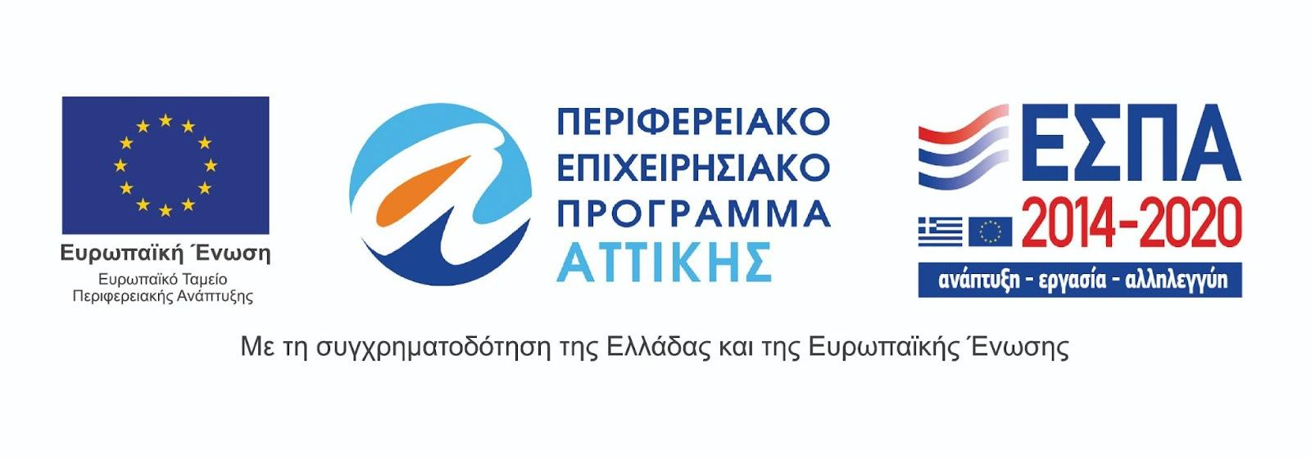
The 27th Athens International Film Festival takes place under the auspices of and with the financial support of the Ministry of Culture and Sports.
