28th ATHENS INTERNATIONAL FILM FESTIVAL | September 28 - October 9 2022
PRESS CONFERENCE INVITATION
Wednesday, September 21 | Astor Cinema | 19.00
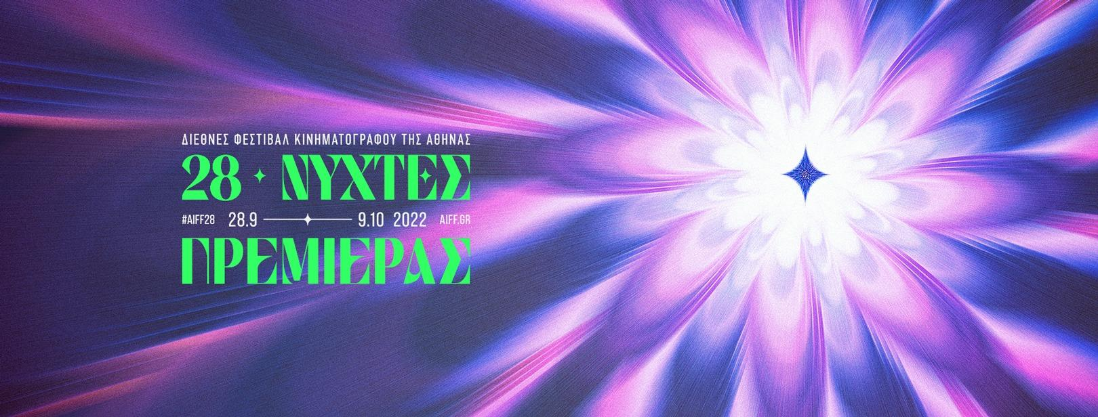

The Athens International Film Festival invites you to the Press Conference of the 28th edition, which will take place
on Wednesday 21 September 2022, at 19.00,
at the ASTOR Cinema (28 Stadiou Street, entrance from Stoa Korai).
During the Press Conference,
the Artistic Director of the Athens International Film Festival, Loukas Katsikas,
will announce the full programme of this year's event.
In the presence of directors, cast and crew and members of the journalistic community.
JAMESON will welcome you with cinephile cocktails.
#aiff28
The Athens International Film Festival, after the completely safe and successful hybrid staging of its two previous editions, will host its 28th edition exclusively in our favourite 12-month cinema theaters, always respecting the regulations and standards of the event, as defined by the competent bodies of the State.
#aiff28
The 28th Athens International Film Festival will take place from September 28 to October 9, 2022.

For constant updates and more information about the Athens International Film Festival Premiere Nights, please stay tuned to the sites of aiff.gr and cinemagazine.gr and our social media pages:: Facebook AIFF, AIFF Instagram, Cinemagazine Instagram, Twitter.

The 28th Athens International Film Festival is part of the Attica Regional Development Programme 2014-2020 and is co-funded by the European Regional Development Fund.

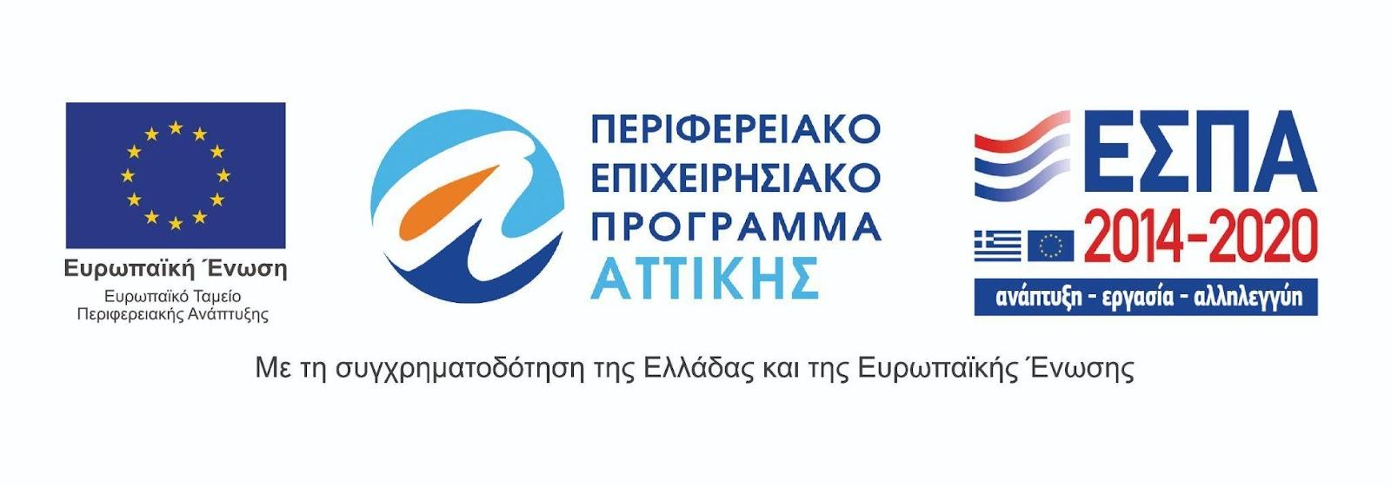
The 28th Athens International Film Festival is held under the auspices of the Ministry of Culture and Sports.
