28ΤΗ ATHENS INTERNATIONAL FILM FESTIVAL | September 28 - October 9 2022

PARALLEL EVENTS

«ENNIO FORMES» :
An exhibition dedicated to the great Italian Composer
Thursday 22.09 - Sunday 9.10
Opening Times: Tuesday - Friday (11.00 - 19.00), Saturday & Sunday (11.00 - 15.00). Monday Closed
Olympia Municipal Music Theatre ‘Maria Callas’ | Akadimias 59
Free Entrance
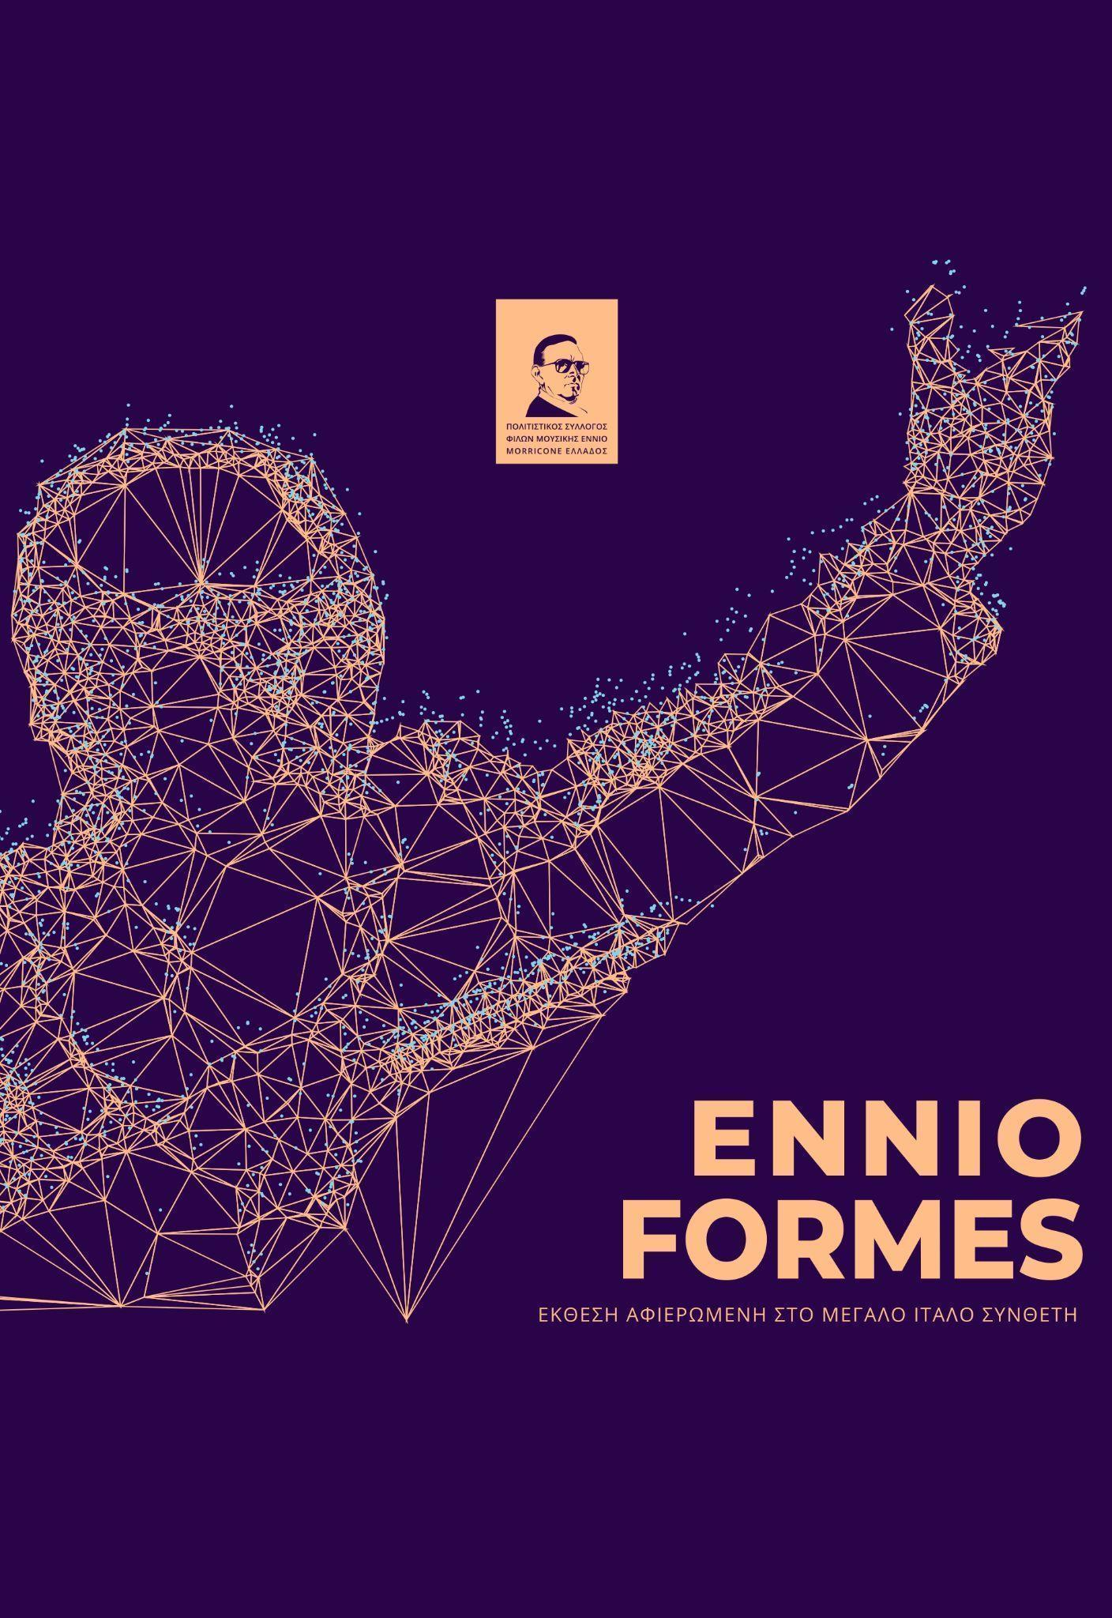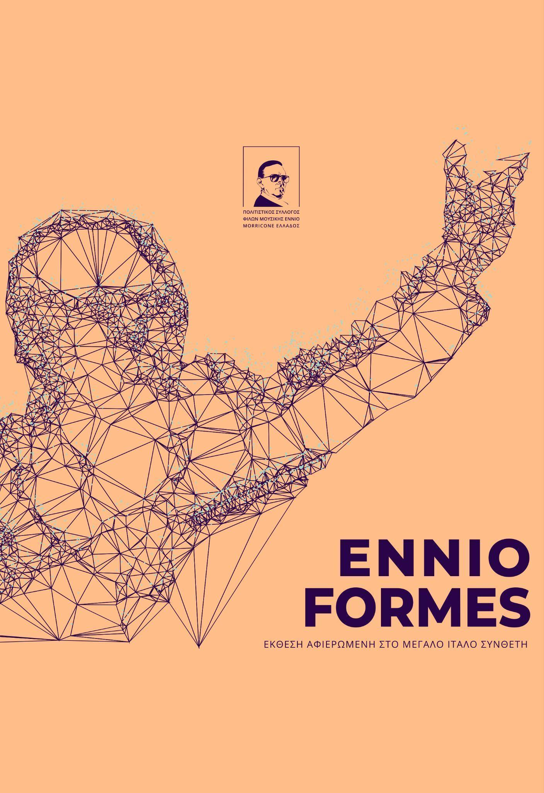
13 visual artists, graphic designers, street and tattoo artists created and present for the first time in Athens their work, in a group exhibition inspired by the great Italian composer. The initiative belongs to the Greek cultural association friends of Ennio Morricone’s music and refers to the presentation of visual work and image, inspired by the composer and his work.
The exhibition aims to bring together and in contact with a greater audience the artists who were inspired by the dynamics of Morricone’s music. His music is a way of thinking, an attitude, a philosophy, visualized in this exhibition through various creative techniques and visual writings. Every piece is inspired by his steps over the course of time. The participating visual artists were invited to depict Morricone not just as a representation or with references to his works, but to trace the notion, the impression and the feeling associated with the great composer.

The names of the artists are: G.Antonopoulos, Ast.Dimitriou, G.Dimitriou, D.Dimopoulos, D.Kalogirou, Ast.Laskaris, C.Laskaris, S.Bakalis, P.Dolas, G.Petrou, C.Samaras, E.Sarli, Z.Seitani, Al.Mantzari, P. Tsioutras, PUPPET.

Co-organized with the Greek cultural association friends of Ennio Morricone’s music , the Embassy of Italy, the Italian Institute of Culture and in collaboration with Culture, Sports & Youth Organisation of the City of Athens and Olympia Municipal Music Theatre ‘Maria Callas’
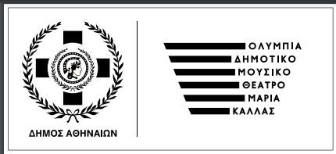

Book presentation ‘Ennio Morricone -In search of that sound – my music my life’, by Alessandro De Rosa, Translation: Anna Nousi, Metronomos
FRIDAY 30.09 | 12.00 |
Teaching Hall of the Music Library (Friends of Music Society, the Athens Concert Hall). (Vasilissis Sofias 85
Free Entrance
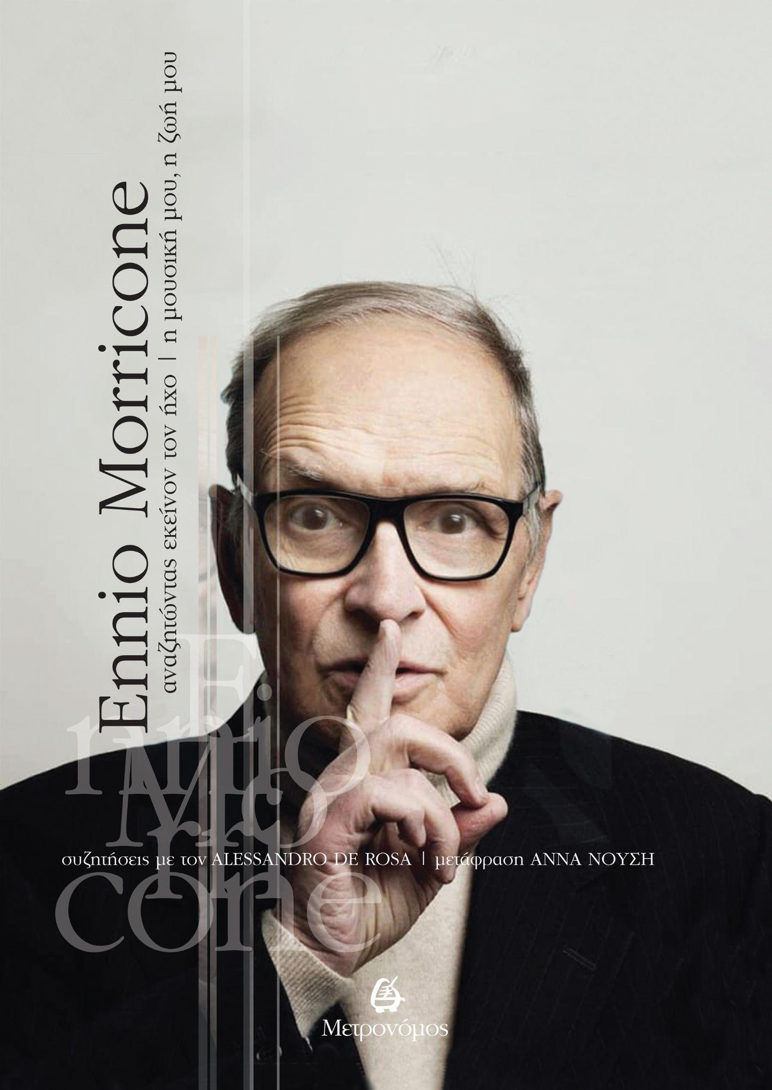
Alessandro de Rosa reads between the lines of the pentagram offering a valuable, authentic and detailed portrait, completing with words the iconic, clear sheet music of Morricone’s career.
On Friday 30th September, the Italian author and the translator of the book, Anna Nousi, will present the Greek edition by Metronomos Publishing, at the Athens Concert Hall Music Library. The special event will be honoured by the composer’s son, Marco Morricone and the documentary ‘Ennio’ producer, Gianni Russo. The discussion will be coordinated by Eleni Mitsiakis, Musicologist, Producer Coordinator of the Friends of Music Association and member of the International Federation of Film Music Critics (IFMCA). Cassandra Foundoulaki on the piano will accompany the event.

In collaboration with the Greek cultural association friends of Ennio Morricone’s music, the Embassy of Italy, the Italian Institute of Culture, the Friends of Music Society and Metronomos Publishing.
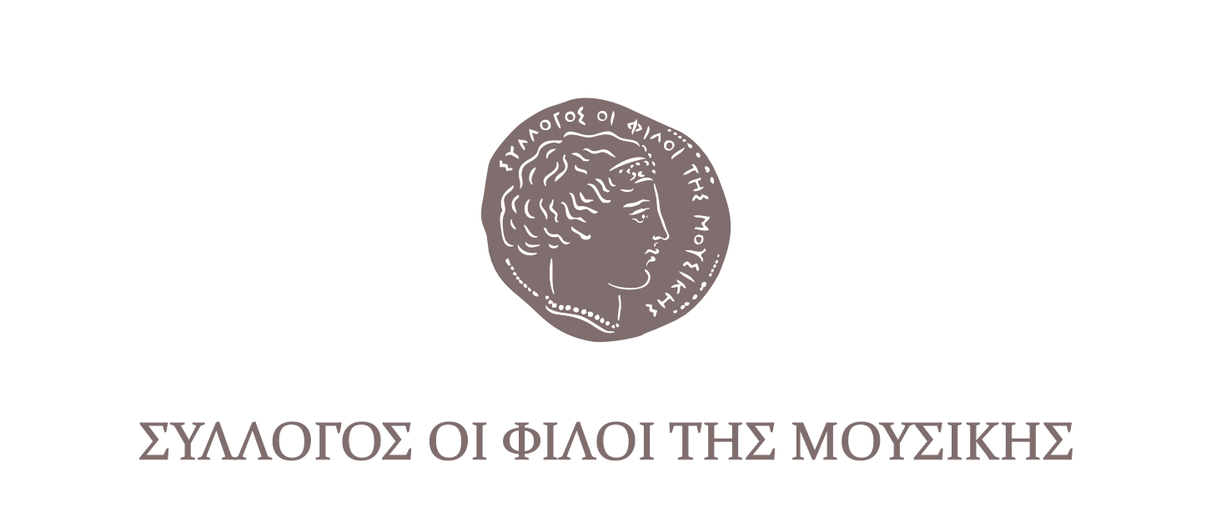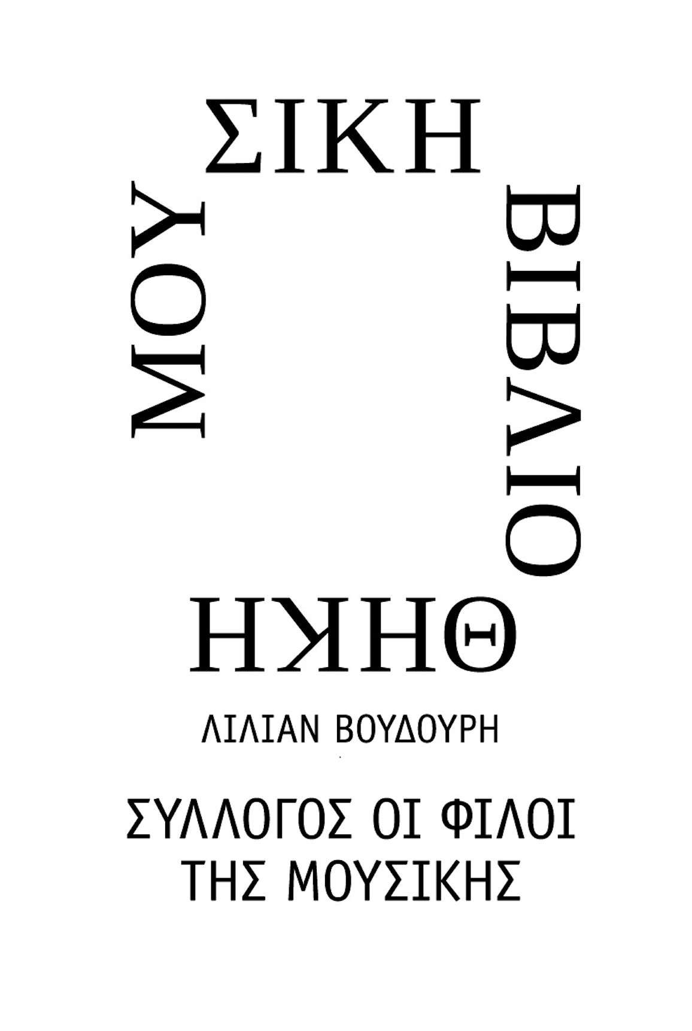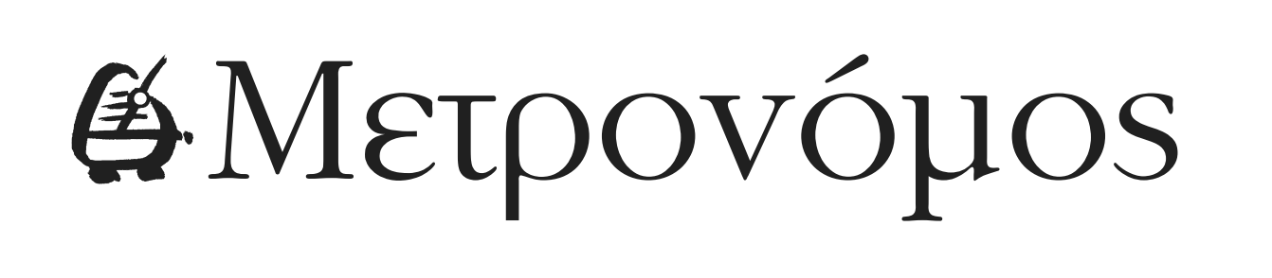
Follow the link for PHOTOGRAPHS of the tribute
MASTERCLASS «Festivals. What’s next? »
The path of Greek short films following the end of the Festivals.
MONDAY, 3 OCTOBER | 12:00
Exile Room | 12, Athinas Str, Monastiraki, Athens (Monastiraki Metro Station)
Free Entrance

Where do the short films go after the Festivals? What is their trajectory after the completion of the Festivals and their international or national premiere?
Is there space available or is space being created?
To these, among other questions, we will try to find answers, while suggesting ways of continuing the cinematic journey through compatible or alternative methods of distribution and promotional activities. Distinguished figures of the field will share their knowledge and experience on the longevity, promotion and cinematic, online or television presence of Greek short films.

In the consulting workshop, professionals of the field share their experience:
• Anna Kasimati (Media Hellas Office, Greek Film Centre)
• Ilias Dimitriou, Director (Microfilm Programme Coordinator, ERT).
•Kostis Kalapothakis, Screening Programme Training Manager (Piraeus Bank Group Cultural Foundation)
-•Babis Kontarakis, Venue Manager-Director (Astor, Andorra / Weird Wave)
•Tasos Melemenidis, CINOBO Program Manager
•Thelia Petraki, Director ("Helga is in Lund", "Bella")

Coordination: Panos Gkenas, Head Programmer of the Athens International Film Festival "Greek Short Stories" Competition Section.

In collaboration with Creative Europe Media / GFC

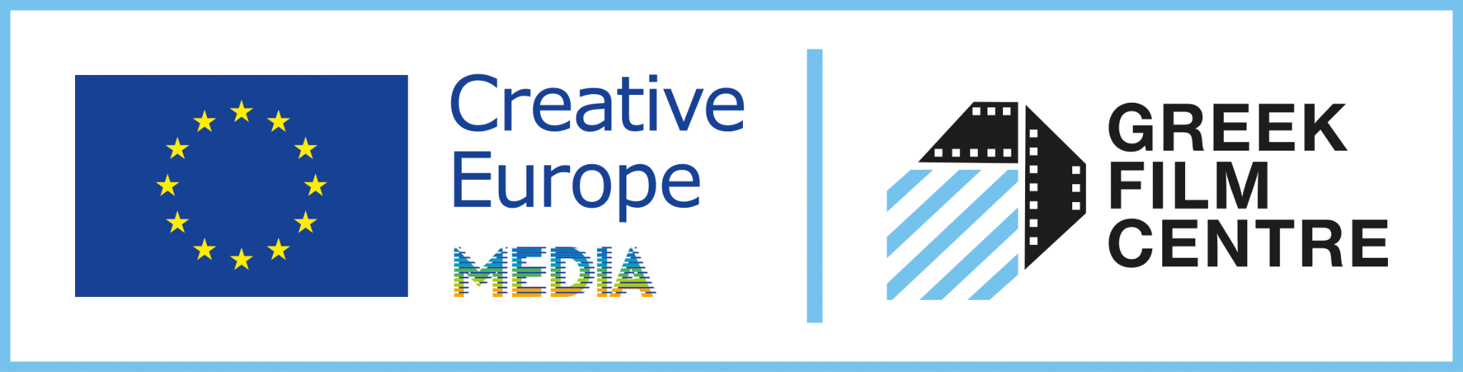

For constant updates and more information about the Athens International Film Festival stay tuned to aiff.gr and cinemagazine.gr and our social media pages:: Facebook AIFF, AIFF Instagram, Cinemagazine Instagram, Twitter.

The 28th Athens International Film Festival is part of the Attica Regional Development Programme 2014-2020 and is co-funded by the European Regional Development Fund.

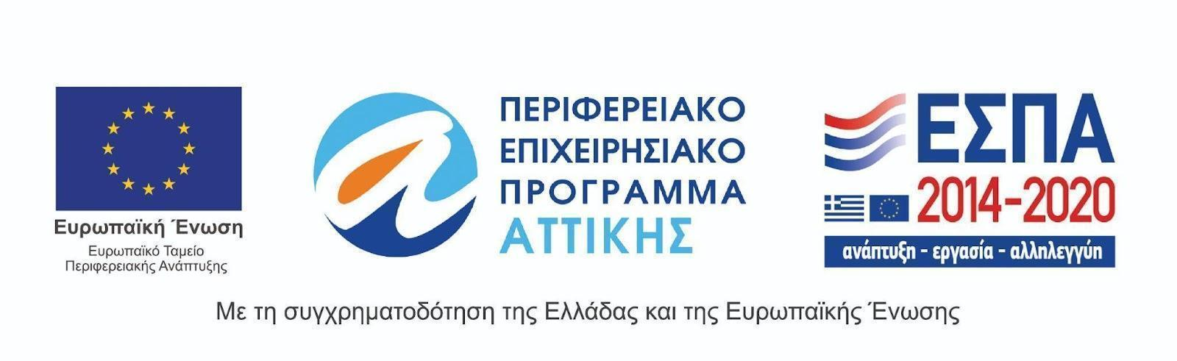
The 28th Athens International Film Festival is held under the auspices of the Ministry of Culture and Sports.
