PRESS RELEASE
«Next Stop: Cinema»
The Athens International Film Festival in Piraeus

17th-18th & 26th September

The 27th Athens International Film Festival docks and celebrates its collaboration with the Municipal Theatre Of Piraeus through three impressive screenings, two (double) by the port’s piers and one in the heart of the city, the emblematic theatre.

The Athens International Film Festival, true to the tradition it started with the Athens Open Air Film Festival wishing to expand their events beyond the tight confines of the city centre and to offer high quality screenings to all citizens and visitors of the city, has joined forces with the Municipal Theatre Of Piraeus to
celebrate the 27th organisation of the Athens International Film Festival with a series of screenings in impressive historical places of Piraeus!
The past meets the present with two pre-festival double, open air screenings, by the port, of four of the greatest and most popular opening films in the history of the Festival and a special premiere from this year’s programme of the 27th event of the Festival at the gem of a building that is the Municipal Theatre Of Piraeus.

Pre-Festival Event •
Fri 17th & Sat 18th September | Petrini Apothiki , Gate 2 Piraeus Port Authority
FREE ADMISSION (with reservation*)

Two double, open-air film screenings outside the stone warehouse of Gate 2 of the Piraeus Port Authority

Friday 17th September
1st Screening | 20:00
THE BRIDGES OF MADISON COUNTY by Clint Eastwood (1995, 135’)
Opening Film of the 1st Athens International Film Festival

A deeply human romantic film, “The Bridges of Madison County” confirmed Clint Eastwood’s status as one of the top directors of contemporary American cinema and earned Meryl Streep one of the most beautiful roles and one of the most worthy Oscar nominations of her career.

Starring: Clint Eastwood, Meryl Streep, Annie Corley, Victor Slezak

Friday 17th September
2nd Screening | 22:30
VOLVER by Pedro Almodóvar (2006, 121’)
Opening Film of the 11th Athens International Film Festival

Harbouring a well-kept secret, a mother returns from the afterlife to tie up loose ends with her daughters. A film that acts as the definition of the brilliance of simplicity with which Almodóvar leads his heroines to a new, universal and utterly touching revaluation of the “idea” of motherhood. In this “comic drama”, as he himself characterises his film, the famous Spanish director elicited amazing performances which resulted in the film winning the Best Actress Award for the female ensemble cast and the Best Screenplay Award at the Cannes Film Festival.

Starring: Penélope Cruz, Carmen Maura, Lola Dueñas, Blanca Portillo

Saturday 18th September
1st Screening | 20:00

WILD TALES (Relatos Salvajes) by Damián Szifron (2014, 122’)
Opening Film of the 20th Athens International Film Festival

A revelation of a film, made up of short stories, which met with unexpected artistic recognition and commercial success internationally, “Wild Tales” is a film which captivates the audience with its sardonic mood and irreverent humour, reminiscent of Pedro Almodóvar, who proudly produced the film. Full of original plot ideas, the Best Foreign Language Oscar-nominated “Wild Tales” is an entertaining reminder that society today requires us to use our savage instincts to make our way in the world.

Starring:
Ricardo Darín, Oscar Martínez, Darío Grandinetti, Rita Cortese

Saturday 18th September
2nd Screening | 22:30

PARASITE by Bong Joon Ho (2019, 132’)
Opening Film of the 25th Athens International Film Festival

A diabolical mix of dark comedy, social allegory and craftsmanship, which was legitimately honoured with the Cannes Film Festival Palme d’Or and 4 Oscars, making history as the first international film to ever win the statue for Best Motion Picture in the long history of the Academy Awards, telling the story of two four-member families, one poor and the other nouveau riche, “co-existing” in the latter’s luxurious house in an unexpected manner

Starring: Kang-ho Song, Sun-kyun Lee

*IMPORTANT INSTRUCTIONS for attending the open-air screenings by the port*
In order to protect public health and ensure that members of the audience attend screenings in an orderly manner, we would like to inform you that:
• Entry into the screening venue will only be possible with tickets bearing the ticket holder’s name. Audience members will be able to acquire these tickets FREE OF CHARGE through online reservation, which will commence on Monday, 13th September at midday on aiff.gr.
• Each audience member will be entitled to ONLY ONE ticket, so please make sure you arrive on time along with your companion in the event that you wish to be seated near each other.
• Social distancing will be strictly observed.

Festival Screening •
Sunday 26th September | Municipal Theatre Of Piraeus

The first Sunday of the Festival for the first time, the Municipal Theatre Of Piraeus will be among the venues used by the Festival as it will host the Greek premiere of a very special film from this year’s festival programme!

The film title will be announced on Wednesday 15th September during the Press Conference of the 27th AIFF and ticket presales will commence on Thursday 16th September, through Viva.gr
Ticket Price: 6 Euros.
* About the HEALTH PROTOCOLS in force for attending the screening at the MUNICIPAL THEATRE OF PIRAEUS *

• Admission will be allowed to:
- Those vaccinated or
- Those who have recovered (the diagnosis must have been made in the last 6 months) or
- Those who are unvaccinated and have received a negative rapid antigen test result in the last 48 hours.

• To be admitted, aside from the ticket, the following will be requested:
- a vaccination / recovery certificate or
- The negative rapid antigen test result (from the last 48 hours)
- proof of identity via ID card, passport or driving license.

• The use of a mask is mandatory in all rows and throughout the duration of the screening.

• Certain seats in the venue will be blocked out, indicated so with special signs by the Festival.

ALL SCREENING LOCATIONS ARE ACCESSIBLE FOR THE DISABLED

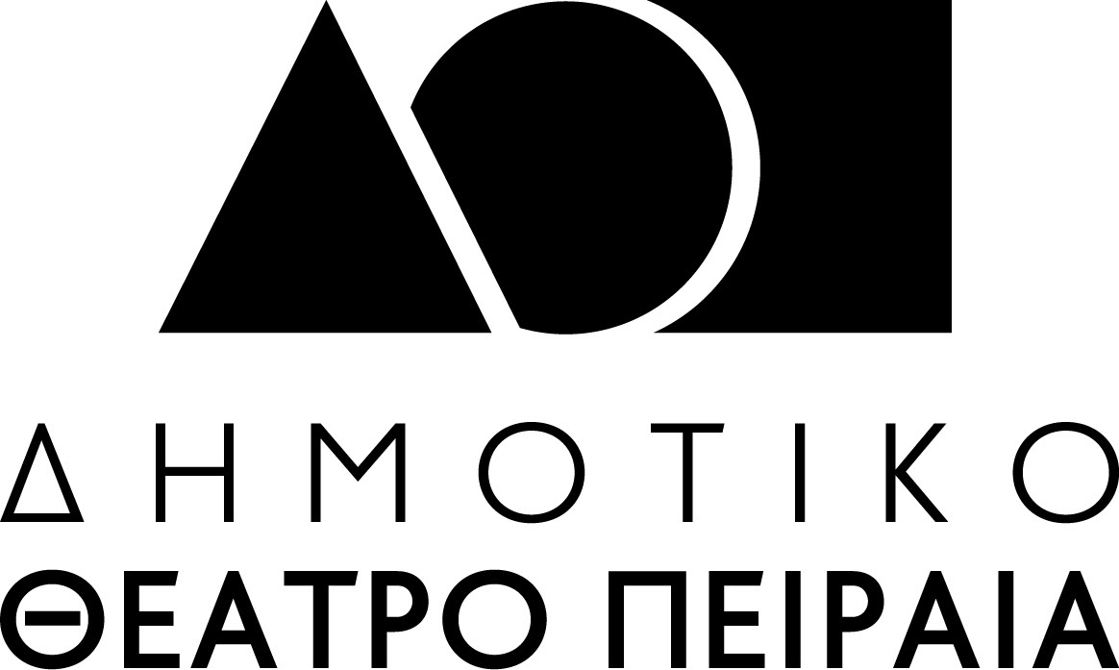

The 27th Athens International Film Festival will take place between 22nd September and the 3rd October 2021.
For updates and more information tune into the sites of aiff.gr and cinemagazine.gr and the relevant social media pages: Facebook AIFF, Instagram, Twitter.

We would like to remind you that in light of the health pandemic faced in Greece and abroad and following the safe and successful running of last year’s hybrid event of the Festival our aim is to host the 27th Athens International Film Festival in both open-air and indoor cinemas always respectful of the rules and adhering to the specifications for running the event as defined by the competent bodies of State and with utmost regard for the safety of the public and our audience members.
For viewers (medically vulnerable, caretakers or other people who work in close proximity to medically vulnerable people, etc.) who would not otherwise be able to attend screenings, for the second year running the Athens International Film Festival will make a part of its programme available online via the purpose-built and popular digital platform online.aiff.gr through which a certain number of geo-blocked screenings have been secured, adhering to all safety standards and to a high level of digital interaction matching the standards successfully set by last year’s Festival event as well as other major international festivals.
In the event that the pandemic conditions render it necessary, the platform in question will also be able to facilitate the digital fulfillment of the Festival in its entirety while maintaining the inclusion of side events such as masterclasses, debates, the introduction of films by their directors, Q&A sessions as well as a wide-ranging interaction with the audience, adapted to the digital environment.

The 27th Athens International Film Festival is affiliated with the PEP Attiki 2014 – 2020 and is co-funded by the European Regional Development Fund.

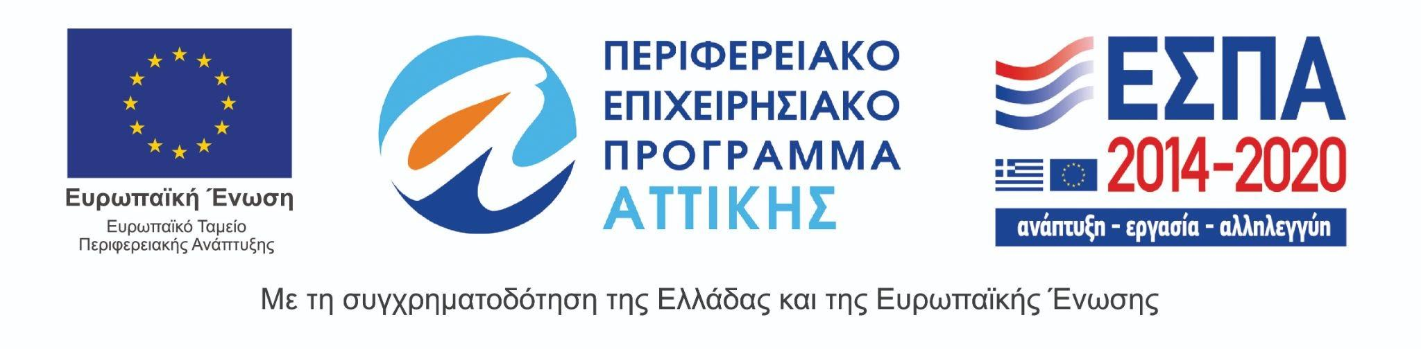

The 27th Athens International Film Festival takes place under the auspices of and with the financial support of the Ministry of Culture and Sports.
