27TH ATHENS INTERNATIONAL FILM FESTIVAL | 22nd September - 3rd October 2021

PRESS RELEASE
Αnnouncing the Titles and Jury Members of the Greek Short Stories - In Competition section
New Greek Cinema celebrates 10 years and is presented through 40 Greek Short Stories!

Since its inception, the Athens International Film Festival has actively supported Greek cinema. Highly-anticipated premieres of Greek films which are embraced by local audiences and travel throughout Greece and abroad, workshops for the development and production of films, honoured guests of the domestic film industry, awarding and promoting established or upcoming Greek directors are just some of the ingredients which build on keeping this loving and supporting relationship alive.
A special and strong bond between the Athens International Film Festival and Greek cinema is the Greek Short Stories - In Competition section, which this year celebrates 10 years of screenings of new Greek short films, a decade of ongoing and diligent support with the aim of helping fresh new Greek films make their way to the big screen and to their audience.
A love and trust that is reciprocated by Greek directors as is evident by the ever-increasing rate of films submitted to the Festival, which come to vigorously represent the most creative part of Greek film production .
Having presented a total of more than 510 films in the previous nine years, this year the lively and exciting Greek Short Stories - In Competition section celebrates 10 years of great short films which have told contemporary, funny, scary, poetic, romantic, metaphysical, dark and light stories in a special, imaginative and exciting way. 10 years of Greek Short Stories, which started in Athens and travelled to Europe and the rest of the world competing for awards and aiming to resonate globally, showcasing Greek film as an emerging narrative and relevant force.
This year’s 27th event has 273 participations which indicates that Greek film is present and active but also that new Greek directors trust the presentation of their work to the Festival and its audience.
The Festival’s film curation team has completed the film selection process. 40 films have been selected to compete for the awards of the 27th event.

The films of the Competition section
The films which will be competing (in alphabetical order based on their title) are:

"A La Carte": Taxiarxis Deligiannis, Vasilis Tsiouvaras
"A Summer Place": Alexandra Matheou
"After Noon": Alexis Koukias-Pantelis
"Alaska": Michalis Giagkounidis
"Amygdala": Maria Hatzakou
"Apallou": Niko Avgoustidis
"At The Airport": Michalis Mathioudakis
"Beauty": Thanos Liberopoulos
"Bluebird": Stergios Dinopoulos
"Brutalia, Days of Labour": Manolis Mavris
"Cortázar": Argyris Germanidis, Katerina Strauch
"Creatures of the Night": Memi Koupa
"Every Sunday": Keti Papadema
"Experience of Goodness": Eleni Alexandrakis
"Exploitation": Marina Symeou
"First Swim": Alexandros Kostopoulos
"Friends & Benefits": Maria Katsikadakou
"From the Balcony": Aris Kaplanidis
"Girlhood": Vania Turner, Maria Sidiropoulou
"Horsepower": Spyros Skandalos
"I, the house": Eleni Vergeti
"If you Were a Movie, you'd be a Short Film": Georgia Marangouli
"In Beauty it is Unfinished": Greko Sklavounos
"Lost & Found": Vivian Papageorgiou
"Luxenia": Dimitra Kondylatou
"Motorway 65": Evi Kalogiropoulou
"Reflections": Fotis Skourletis
"Sacralisons": Olia Verriopoulou
"Soul Food": Nikos Tseberopoulos
"The Beauty of Stigma": Helias Doulis
"The Giraffe": Connie Zikou
"The Night I Left America": Laki Karavias
"The Silver Mask": Thanos Topouzis
"The Student": Vasileios Kalamakis
"To Vancouver": Artemis Anastasiadou
"Umbilical": Elpida Stathatou
"Vathikofto": Ioanna Kryona
"Vidisova": George Panagopoulos
"Water on Mars": Nicos Panayotopoulos
"Zabeta": Elissavet Sfyri, Sofia Sfyri

The Jury
The Jury for the Greek Short Stories - In Competition section of the 27th Athens International Film Festival consists of the President, Sofia Exarchou, screenwriter and director as well as the following members: Neritan Zinxhiria, director, Spyros Kribalis, screenwriter, script editor and creative producer, Penelope Tsilika, actor, and Iosifina Grivea, entertainment editor, film critic and podcast host.

AWARDS | with the kind support of the Greek Film Centre

The selected films will be screened during the Festival and the Jury will present the following awards:
Golden Athena for Best Film which is accompanied by a € 2,000 cash prize, sponsored by the Greek Film Center, Silver Athena Special Jury Prize, Award for Best Director, and Award for Best Screenplay, each of which is accompanied by a € 1,000 cash prize, sponsored by the Greek Film Center, and awards for Best Performance by a Male Actor​ and Best Performance by a Female Actor

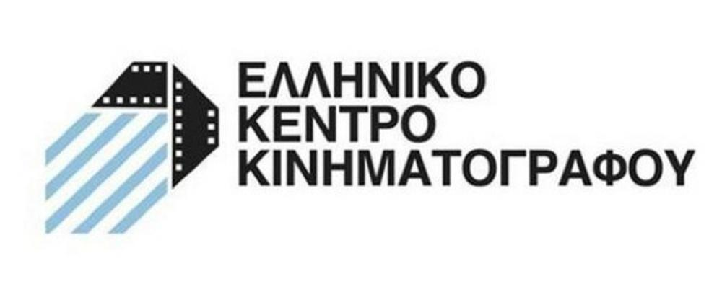
We would like to remind you that in light of the health pandemic faced in Greece and abroad and following the safe and successful running of last year’s hybrid event of the Festival our aim is to host the 27th Athens International Film Festival in both open-air and indoor cinemas always respectful of the rules and adhering to the specifications for running the event as defined by the competent bodies of State and with utmost regard for the safety of the public and our audience members.
For viewers (medically vulnerable, caretakers or other people who work in close proximity to medically vulnerable people, etc.) who would not otherwise be able to attend screenings, for the second year running the Athens International Film Festival will make a part of its programme available online via the purpose-built and popular digital platform online.aiff.gr through which a certain number of geo-blocked screenings have been secured, adhering to all safety standards and to a high level of digital interaction matching the standards successfully set by last year’s Festival event as well as other major international festivals.
In the event that the pandemic conditions render it necessary, the platform in question will also be able to facilitate the digital fulfillment of the Festival in its entirety while maintaining the inclusion of side events such as masterclasses, debates, the introduction of films by their directors, Q&A sessions as well as a wide-ranging interaction with the audience, adapted to the digital environment.

The 27th Athens International Film Festival will take place between 22nd September and the 3rd October 2021.
For updates and more information tune into the sites of aiff.gr and cinemagazine.gr and the relevant social media pages: Facebook AIFF, Instagram, Twitter.
The 27th Athens International Film Festival takes place under the auspices of and with the financial support of the Ministry of Culture and Sports.

The 27th Athens International Film Festival is affiliated with the PEP Attiki 2014 – 2020 and is co-funded by the European Regional Development Fund.

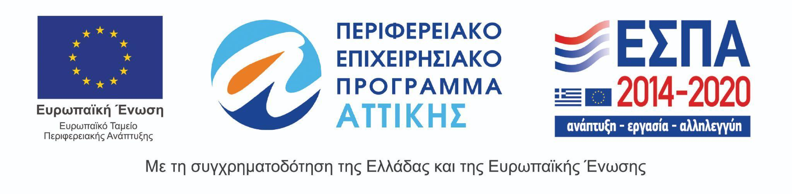
The 27th Athens International Film Festival takes place under the auspices of the Ministry of Culture and Sports.

