27th ATHENS INTERNATIONAL FILM FESTIVAL

PRESS RELEASE
TRIBUTE
THIS IS ORSON WELLES:
RECONSTRUCTING A GENIUS
“The truth about any man can only be calculated by the sum of everything that has been said about him.” Orson Welles
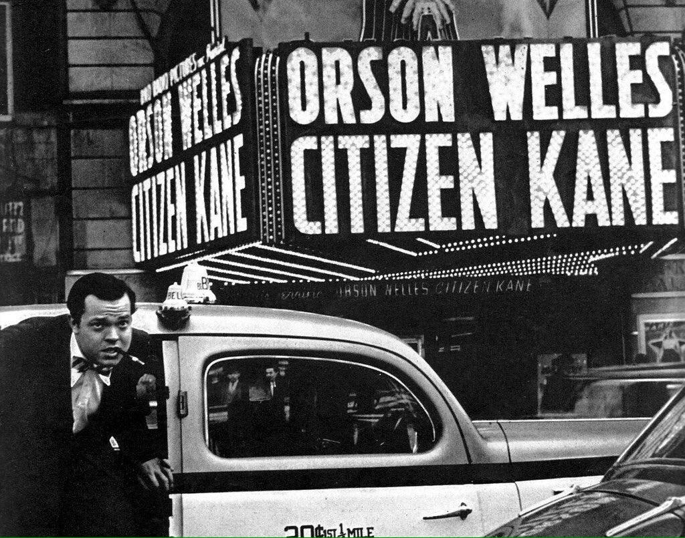
Never in the history of film has a director been the object of such idolisation and analysis as Orson Welles. Like an ongoing chapter, infinitely enhanced, our interest in Welles is renewed almost on an annual basis as he continues to inspire countless documentaries and fiction films, while to this day no director has been the source of such extensive bibliography nor such a newsworthy figure.
Posthumous fascination for his life’s work (completed and unfinished) has been impressively renewed and continues to be fuelled incessantly, as if it were the ultimate magic trick from beyond the grave by this sardonic wizard of cinema. The most recent example of this is the excitement caused by the news of an admirable undertaking this year in the hope of finding in Brazil the last remaining copy of the original uncut version of “The Magnificent Ambersons”.
It is of vital importance to remind and - mostly - to introduce new generations to his significant life’s work. And to do this properly, as the director himself would have wanted: in a dark cinema, with his glorious imagery being screened on the biggest possible screens.
Once more, kneeling before the magnificence of the “cathedral of directors” , from whence this year’s visual identity was inspired and on the occasion of “Citizen Kane’s” 80th anniversary, the 27th Athens International Film Festival, as is its duty, will present a respectful tribute to Welles and hopes to re-introduce his films by screening not only the most recent restorations but also the most complete versions of the films.
And so we will have the opportunity to watch “Touch of Evil” as its director had conceived it, owing to the fervent attempts of historians and film technicians to “restructure” the film according to the director’s original notes. Similarly, a version of “Mr Arkadin” will be screened closely resembling the director’s original cut, more so than any other version available in recent years. We will also enjoy a cinematic premiere of “Too Much Johnson”, Welles' first film made three years prior to “Citizen Kane”, which all thought lost in a 1970 fire before discovering a forgotten copy in an Italian warehouse, 70 years after it had been filmed. Every other film will be screened with the highest possible audiovisual quality.
Hence, for the duration of the 27th event of the Festival, the commanding voice will sound again in all of the city’s cinema venues and the larger than life visions of a man to whom, those of us who love film owe a lot, will live again.
Because size matters in cinema.

THE FILMS OF THE TRIBUTE:
TOO MUCH JOHNSON (1938)
CITIZEN KANE (1941)
THE MAGNIFICENT AMBERSONS (1942)
THE STRANGER (1946)
THE LADY FROM SHANGHAI (1947)
MACBETH (1948)
OTHELLO (1951)
MR. ARKADIN (1955)
TOUCH OF EVIL (1958)
THE TRIAL (1962)
CHIMES AT MIDNIGHT (1965)
THE IMMORTAL STORY (1968)
F FOR FAKE (1973)

The films of the tribute will be introduced by: the General Artistic Director of “Elevsis 2023 - European Capital of Culture”, Michael Marmarinos, the actor and director Dimitris Karatzas, the film critic Thodoris Koutsogiannopoulos, the journalist and translator Tina Mandilara and the Head of Curation at CINOBO, Tasos Melemenidis.

NB: The retrospective does not contain the (legitimately) disputed completion of 1992’s “Don Quixote “ by Jesús Franco, “Journey Into Fear” for which the directorial credit was never officially attributed to Welles and “The Other Side of the Wind” as the SVOD platform that owns the rights would not permit a festival screening of the film.

FIND PHOTOS OF THE FILMS HERE

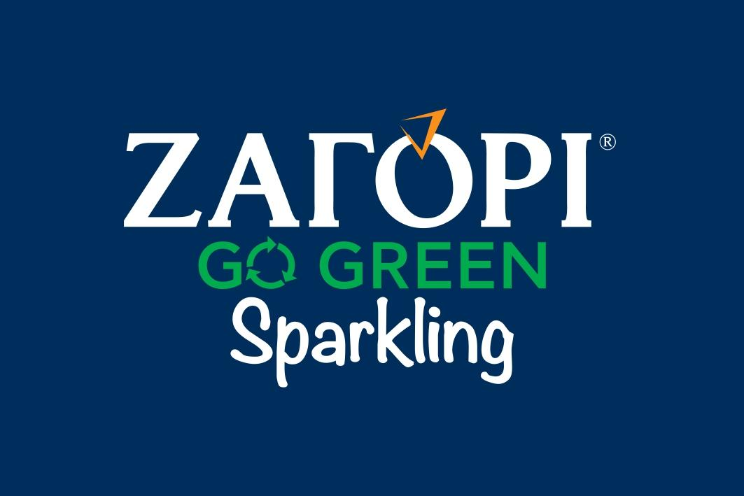
ZAGORI Go Green Sparkling is the sponsor of the Great Tribute “THIS IS ORSON WELLES: RECONSTRUCTING A GENIUS” at the 27th Athens International Film Festival.
The detailed programme of the 27th Athens International Film Festival will be presented at the PRESS CONFERENCE which will take place on Wednesday 15th September 2021, at the open air cinema AEGLI ZAPPION at 20:30 and will be streamed live through the Festival’s social media pages.

HYBRID VERSION OF THE 27TH ATHENS INTERNATIONAL FILM FESTIVAL
The city’s most important celebration, the Athens International Film Festival returns for the 27th year, optimistic and fully adapted to the new conditions, repeating the successful hybrid version of last year’s event, making itself accessible to as many viewers as possible.
The 27th AIFF will take place in the following indoor venues: ATHENS CONCERT HALL, IDEAL, DANAOS and TRIANON and for the first time at the MUNICIPAL THEATRE OF PIRAEUS as well as at the open air cinemas LAIS - The Greek Film Archive Foundation, RIVIERA, FLERY CINEMA and STELLA.
At the indoor venues (Athens Concert Hall, Danaos, Ideal, Trianon, Municipal Theatre of Athens) in accordance with the current health protocols, admission will be allowed to those who:
- are vaccinated
- were diagnosed with Covid-19 (the diagnosis must have been made in the last 6 months)
- who have received a negative rapid antigen test in the last 48 hours, in the event that they have not been vaccinated.

Viewers will be admitted with the following:

- a valid ticket
- a vaccination / recovery certificate or the negative rapid antigen test result
- proof of identity via ID card, passport or driving license.

Furthermore, for the added safety of our viewers, in collaboration with Festival Scope and Shift 72, the 27th Athens International Film Festival supplements its programme with a series of special screenings via a purpose-built digital platform (online.aiff.gr) where viewers will be able to enjoy films from the comfort of their homes, throughout Greece.

More specifically, the digital platform is included in this year’s event for viewers (medically vulnerable, caretakers or other people who work in close proximity to medically vulnerable people, etc.) who would not otherwise be able to attend screenings, by securing a certain number of geo-blocked screenings, adhering to all safety standards and to a high level of digital interaction matching the standards successfully set by major international festivals.
In the event that the pandemic conditions render it necessary, the platform in question will also be able to facilitate the digital fulfillment of part of the 27th ATHENS INTERNATIONAL FILM FESTIVAL while maintaining the inclusion of side events such as masterclasses, debates, the introduction of films by their directors, Q&A sessions as well as a wide-ranging interaction with the audience, adapted to the digital environment.

The 27th Athens International Film Festival will take place between 22nd September and the 3rd October 2021.
For updates and more information tune into the sites of aiff.gr and cinemagazine.gr and the relevant social media pages: Facebook AIFF, Instagram, Twitter.
The 27th Athens International Film Festival is affiliated with the PEP Attiki 2014 – 2020 and is co-funded by the European Regional Development Fund.
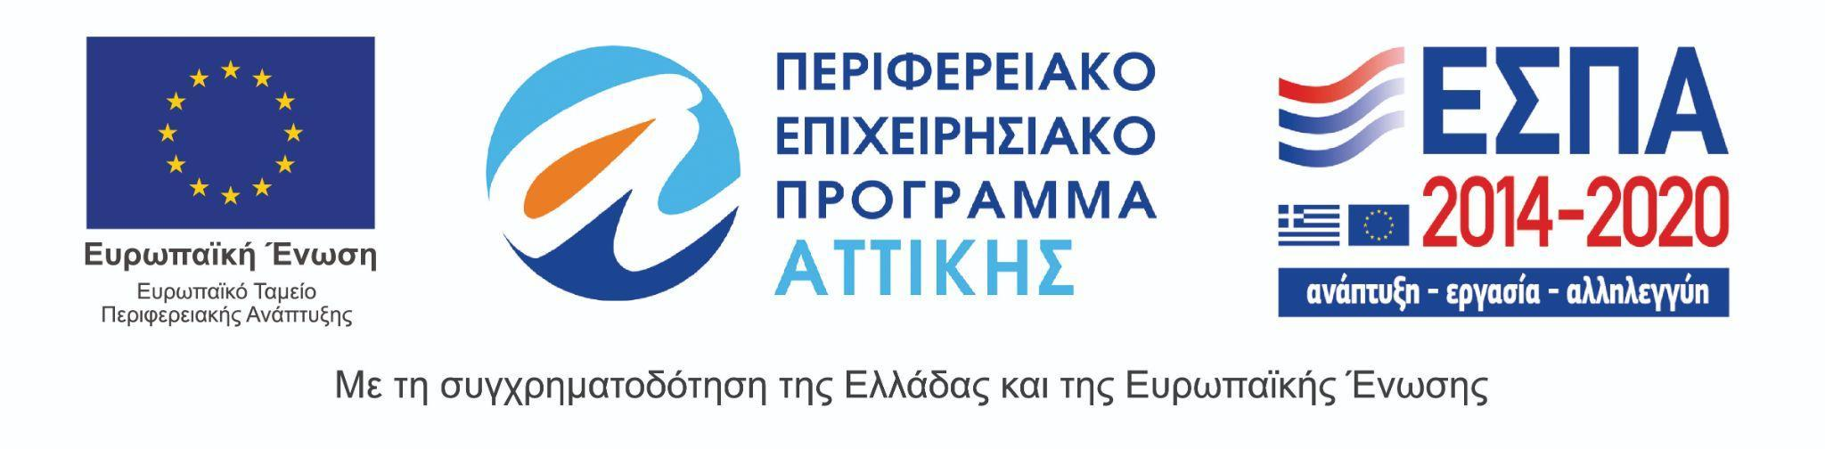
The 27th Athens International Film Festival takes place under the auspices of and with the financial support of the Ministry of Culture and Sports.

