27th ATHENS INTERNATIONAL FILM FESTIVAL

PRESS RELEASE
PRESS CONFERENCE
of the 27th ATHENS INTERNATIONAL FILM FESTIVAL
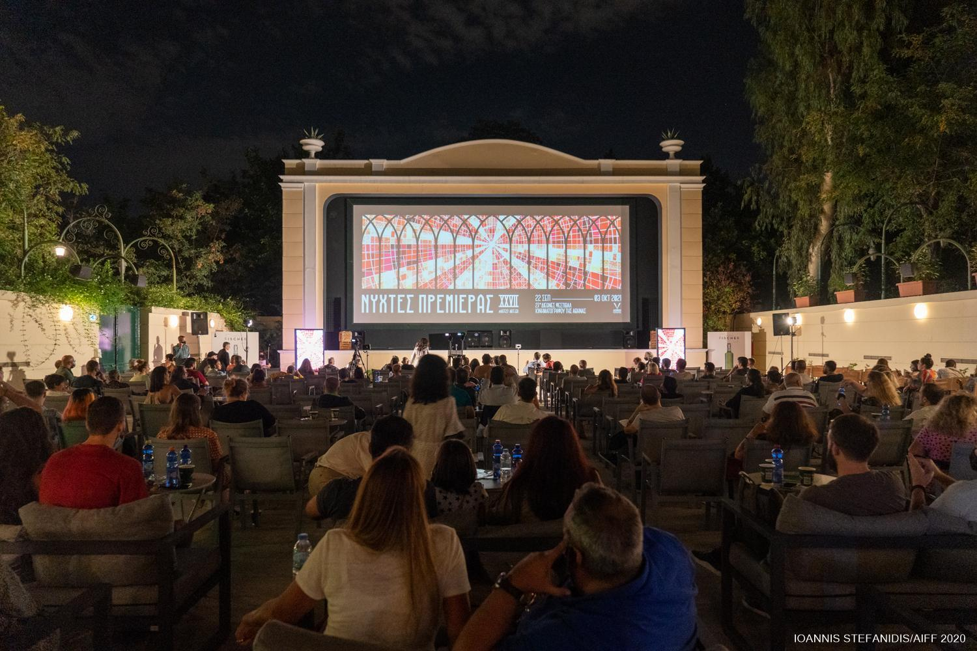
On Wednesday 15th September 2021 the Press Conference of the 27th Athens International Film Festival took place in the open-air cinema Aegli Zappeion, led by the Festival’s Artistic Director, Loukas Katsikas, in the presence of the Chair of the Athens Film Society, Ms Maria Bobola. The Secretary General of Public Investment and ESIF, Mr Dimitris Skalkos, the Deputy Regional Minister of Culture, Ms Mary Vidali, the Artistic Director of the Municipal Theatre of Piraeus, Mr Lefteris Giovanidis, and the Founding Director of the Athens Biennale, Poka- Yio, all honoured the event with their presence.

The Managing Director of the Athens International Film Festival, Ms Tatiana Pappa and the Festival’s Artistic Director, Mr Loukas Katsikas, welcomed those attending the Press Conference along with audience members watching the live broadcast of the event through the Festival’s social media pages.
Ms Tatiana Pappa welcomed the audience and began the event by expressing “our great joy for the successful and safe organisation of this year's summer festival. The Athens Open Air Film Festival filled our summer nights with quality cinema and faithful to its vision of introducing special cultural destinations to the residents and visitors of the city, the festival travelled to historic Eleusina and organized a series of wonderful activities in collaboration with ELEVSIS 2023 - EUROPEAN CAPITAL OF CULTURE”. Ms Pappa went on to thank the General Artistic Director of ELEVSIS 2023, Mr Michail Marmarinos, the Chair of the Board of Directors, Ms Despoina Geroulanou, Ms Panayides and the entire team for their collaboration.
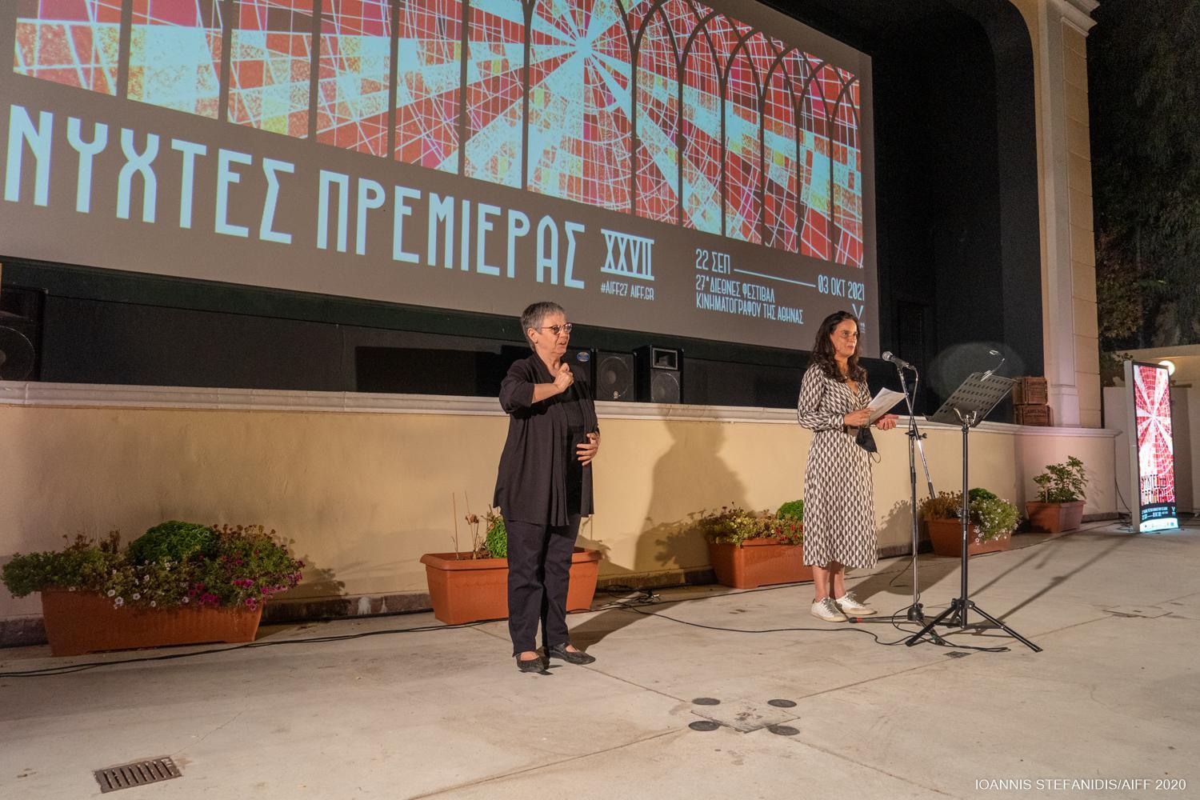
Ms Tatiana Pappa

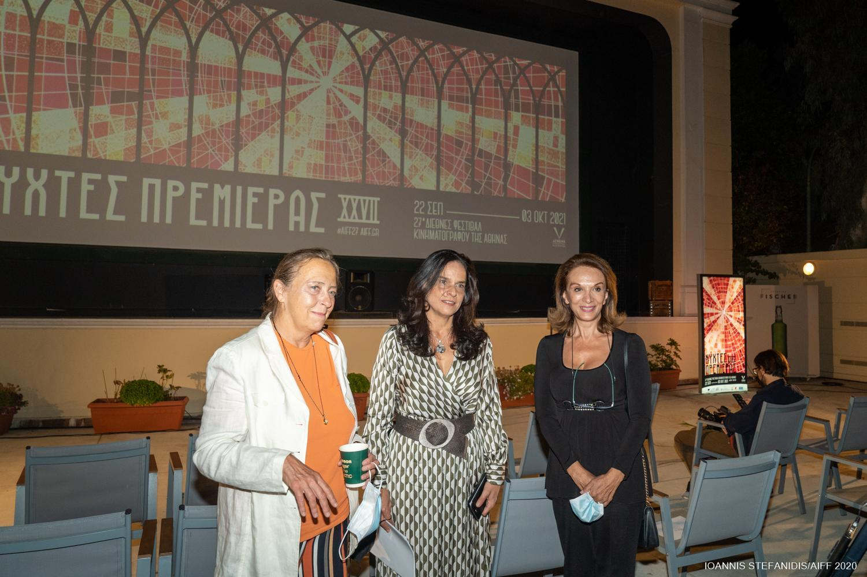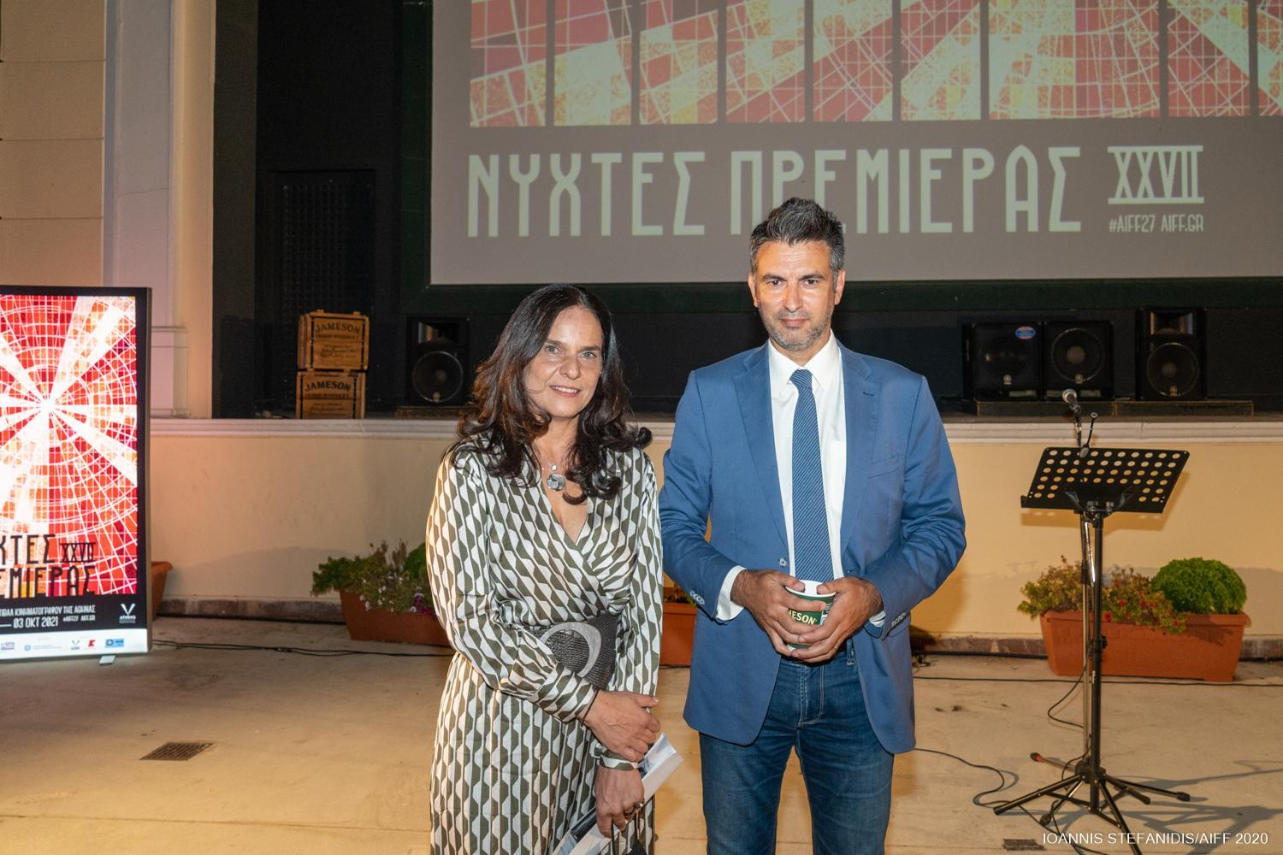
Ms Maria Bobola, Ms Tatiana Pappa, Ms Mary Vidali Ms Tatiana Pappa with Mr Dimitris Skalkos
Ms Pappa went on to give her “heartfelt” thanks to the Ministry of Development, the Minister Mr Adonis Georgiadis and especially the Secretary General of Public Investment and ESIF, Mr Dimitris Skalkos. She also thanked the Regional Authority of Attica, Mr Giorgos Patoulis and his associates in the Regional Council, Ms Mary Vidali, the Deputy Regional Minister of Culture, Mr Haris Romas, the Executive Regional Councillor responsible for theatrical and musical events, as well as the Head and all the Directors of the Managing Authority making the point that “thanks, mostly, to their generous support, it is possible to hold the Athens International Film Festival for a 27th year. We would also like to thank for the auspices and financial support, the Minister of Culture and Sports, Ms Lina Mendoni, the General Secretary of Contemporary Culture of the Ministry of Culture and Sports, Mr Nicholas Yatromanolakis, the General Directorate of Contemporary Culture, the General Secretary of Contemporary Culture, the Directorate of Performing Arts and Cinema as well as the City of Athens Cultural, Sport and Youth Organisation and its Chair, Ms Anna Rokofyllou, as thanks to all these institutions we are able to realise the 27th Athens International Film Festival: 14 days of screenings, 140 films, tens of thousands of spectators, more than 100 collaborators and suppliers, volunteers, a whole world that lives for the great celebration of cinema in Athens, and a world that lives off of this celebration. A celebration that gives the city the extroverted character it deserves as well as the glow it so desperately needs, especially these days. Under the current conditions it is impossible to support the institution of the Festival on private initiative alone, and so the Regional Authority of Attica and its Operational Program are at the same time the hope, the guarantor and the bridge for the future of this important institution, and offer us the certainty that in In the future, all the resources they will provide for the Festival will not only be obtained in time, but will also be utilized effectively by offering culture, entertainment and work!”.
Next, Ms Pappa invited the Secretary General of Public Investment and ESIF, Mr Dimitris Skalkos, and the Deputy Regional Minister of Culture, Ms Mary Vidali, to give a brief address. Mr Skalkos noted that he hopes “the difficult days which so devastated culture due to the pandemic are now behind us” and made a commitment that “the Ministry and the Regional Authority will always be allies and supporters of the Athens International Film Festival”.
He went on to refer to cinema stating that “Pedro Almodóvar once said that ‘cinema can fill in the empty spaces of your life and your loneliness’, but I prefer Martin Scorsese’s philosophy of ‘now more than ever we need to talk to each other, to listen to each other and understand how we see the world, and cinema is the best medium for doing this’ “ and went on to say that “cinema is a collective experience”. He closed his speech with the hope that everyone “gets to experience the 27th Athens International Film Festival together!”.
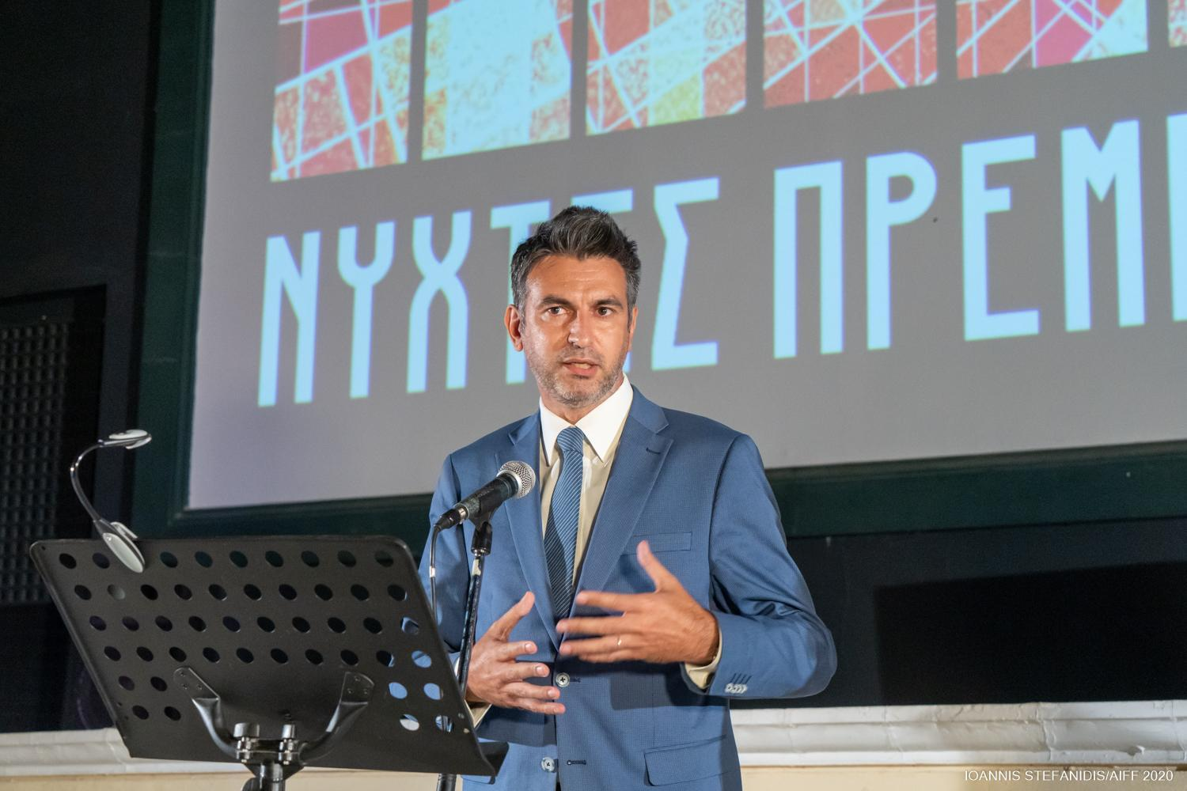
Mr Dimitris Skalkos
Ms Vidali extended the Regional Governor of Attica, Mr Patouli’s wishes and congratulations for the organisation of the event and she noted how important it is that the Regional Authority, in spite of the difficult circumstances, continues to support artists. She went on to say that “ it’s our duty to support the AIFF, not only for film lovers but also because it attracts youth to cinemas and helps them understand the value of quality film”.
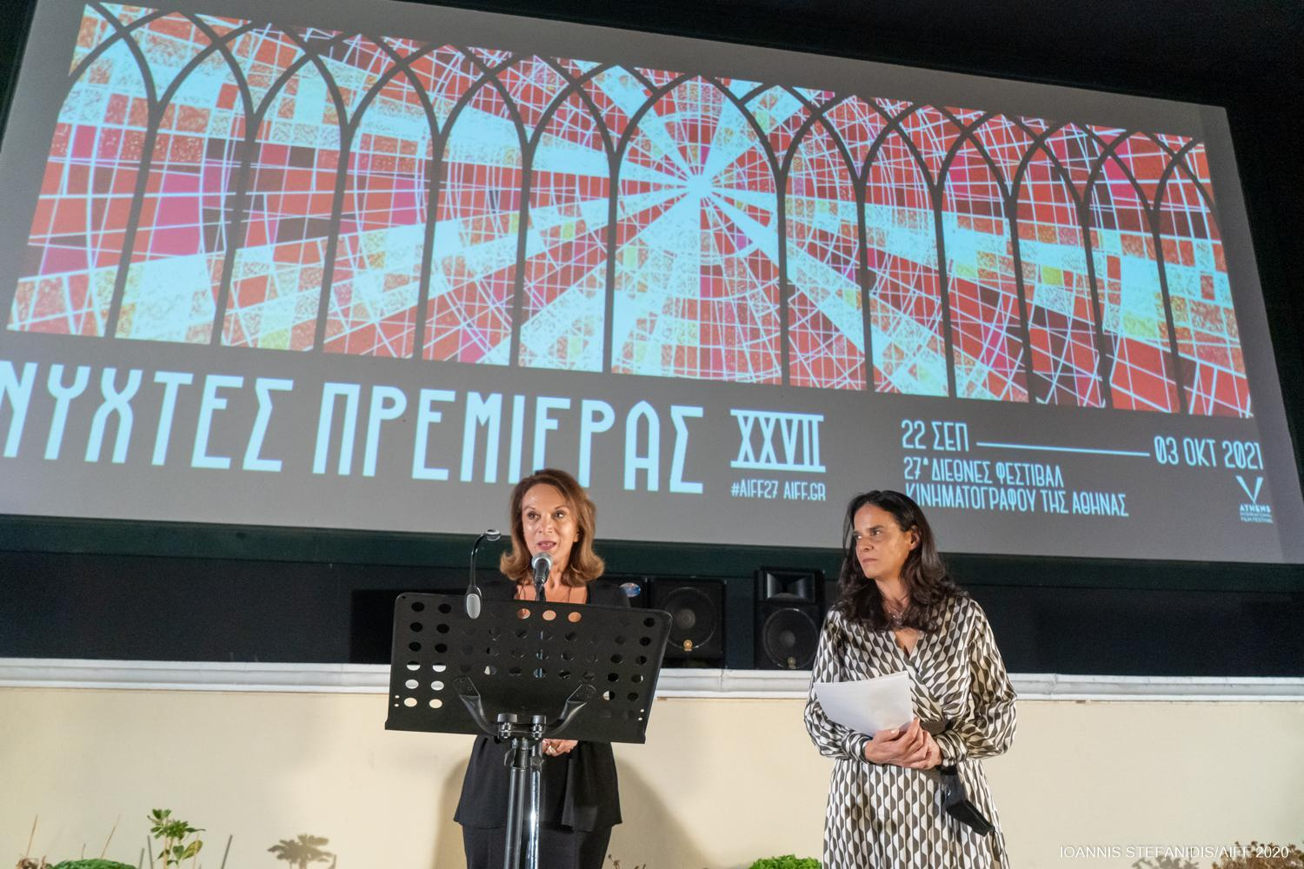
Ms Mary Vidali
Moving on, Ms Pappa thanked the sponsors of the event for their precious support (Fischer Audience Award, the events supporter Jameson, the sponsor of the Main Tribute ZAGORI Go Green Sparkling, the Air Travel Sponsor Aegean Airlines, the Transportation Sponsor SFAKIANAKIS, Zolotas Jewelry, the Athens Concert Hall, the Metropolitan College, Urban Rail Transport S.A.). She then invited the artistic director of the Athens International Film Festival, Mr Loukas Katsikas, to the podium to proceed with the presentation of the Festival programme.

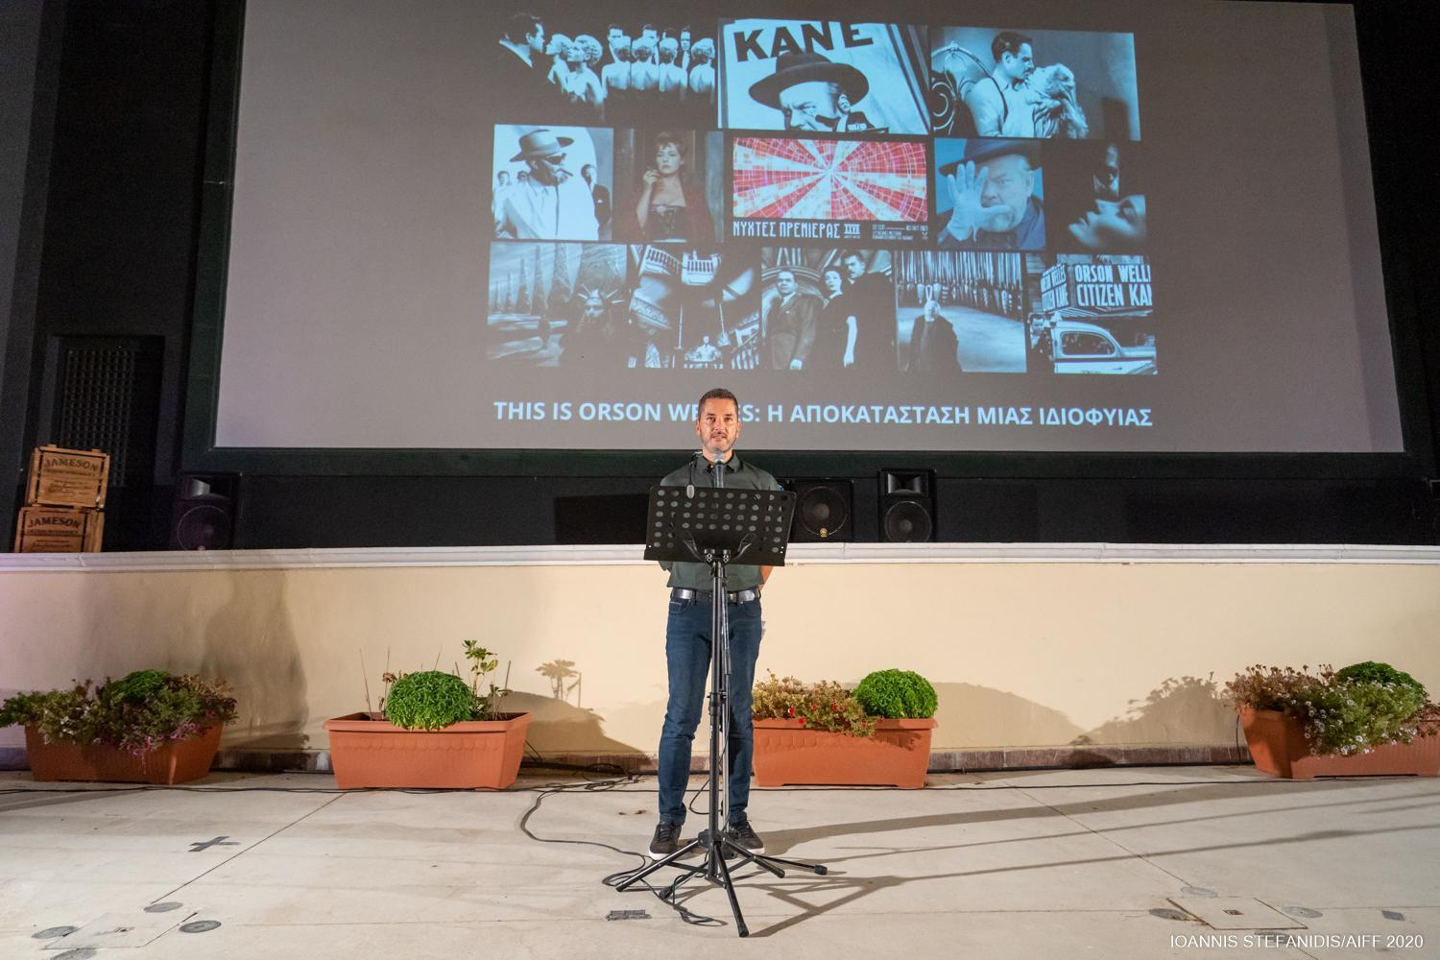Mr Loukas Katsikas
Loukas Katsikas welcomed the audience having first made reference to the totally safe and successful realisation of last year’s Festival event, in its hybrid format, and noted that the 27th event will be held in open air and indoor venues thus ensuring equal access for residents and visitors to the city.
He began his speech with a reference to this year’s Festival poster design with the idea behind it being that cinema is a religious experience and a form of worship, saying specifically that “our religion is film, directors are our saints, films our holy scriptures and cinemas our places of worship. With the poster of the 27th Athens International Film Festival we celebrate the temples of great cinematic Mysteries”.
He went on to announce with great pleasure two new collaborations they were proud to inaugurate between the 27th AIFF and two significant cultural institutions. The first collaboration is with the Municipal Theatre of Piraeus and includes a series of screenings at impressive and historical places of Piraeus so that the Athens International Film Festival may be celebrated there too. The past meets the present with two pre-festival double, open air & free admission screenings of four of the greatest and most popular opening films in the history of the Festival. The screenings will take place on Friday 17th and Saturday 18th September in the area outside the stone warehouse of Gate 2 of the Piraeus Port Authority. On Friday THE ARTIST by Michel Hazanavicius and VOLVER by Pedro Almodóvar will be screened and on Saturday WILD TALES by Damián Szifron and PARASITE by Bong Joon Ho. On Sunday 26th September, the jewel of a building that is the Municipal Theatre of Piraeus will be added to the list of Festival venues and will host two special Greek premieres from this year’s programme: the touching, suitable for all and heavily applauded at Cannes WHERE IS ANNA FRANK, which is the latest masterpiece by the award-winning Ari Folman (“Waltz with Bashir”), who will also attend the screening and LEAVE NO TRACES which was recently in competition, vying for the Golden Lion of the Venice International Film Festival.
At this point he invited to the stand, the Artistic Director of the Municipal Theatre of Piraeus, Mr Lefteris Giovanidis, who said “It was on a night in 1995 when I watched a film named “Kids” at the AIFF. It has been many years since and both the Festival and I have grown and matured. Piraeus has a special relationship with film and culture and so film activities need to return to the area. We start this with a festival, a great celebration, which we are hosting this September known as Art Port and which we have the pleasure to have participate in the Athens International Film Festival”.

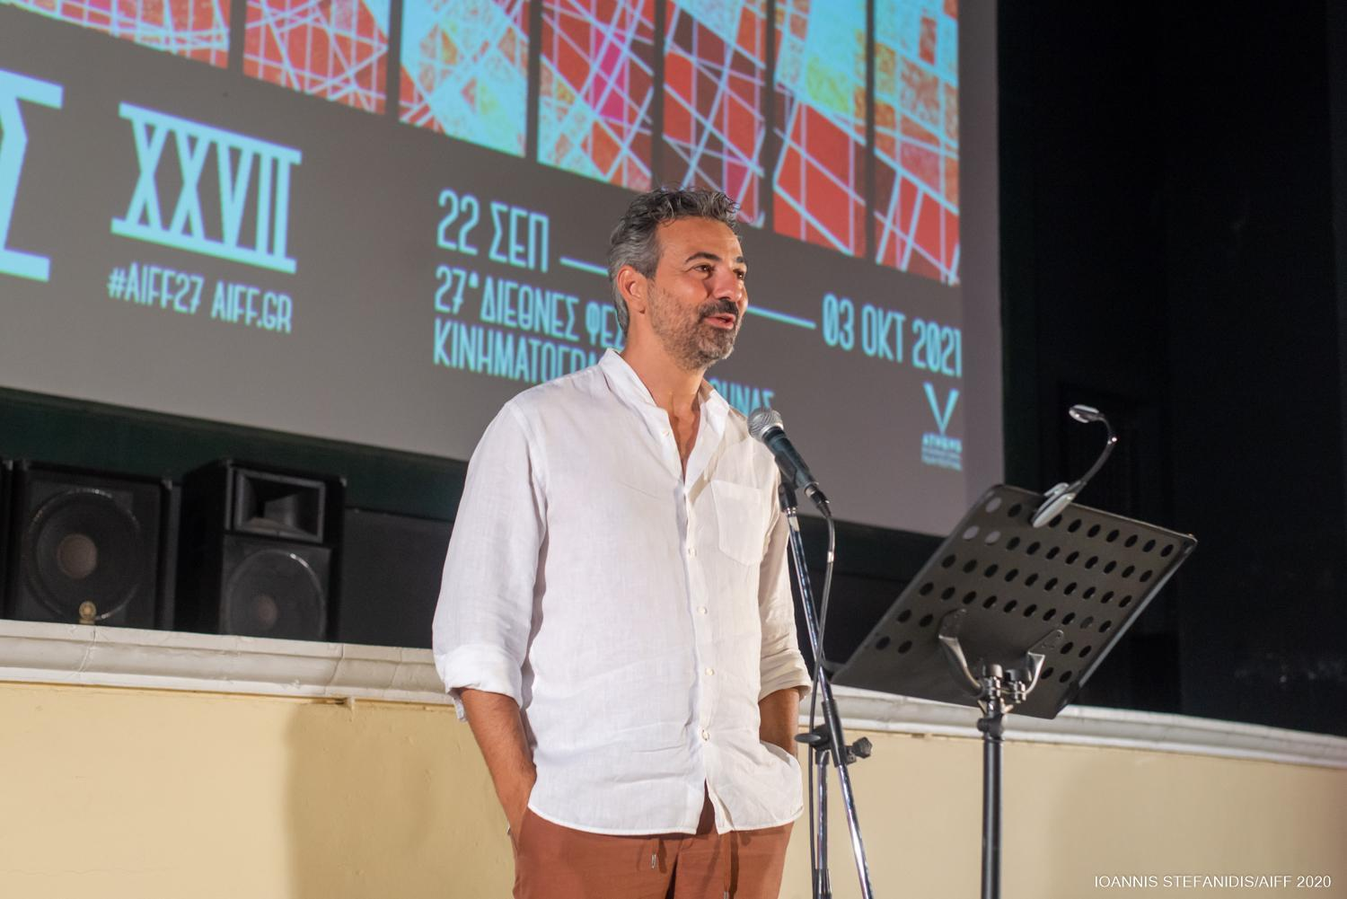M Mr Lefteris Giovanidis
The second collaboration presented by Loukas Katsikas and which commences this year is that between the AIFF and the Athens Biennale. As Mr Katsikas said “Two major cultural institutions join forces , as we hold the events in parallel and create an international cultural celebration for the residents and visitors of the city. Cinema constantly converses with and borrows from the performing and visual arts. That is why this year a series of films from the programme of the 27th Athens International Film Festival, become part of the 7th Athens BIENNALE entitled "ECLIPSE" as they tell stories about social, political and spiritual changes taking place globally and in Athens itself, touching on issues of identity, history and cultural complexity. Moreover, we take advantage of the happenstance of our events running in parallel by “sharing” international and prominent guests who will help frame our screenings and events”.
He went on to invite to the stage, the Founding Director of the Athens Biennale, Poka - Yio, who welcomed this collaboration warmly saying: “From my position as head of visual culture at the Onassis Foundation, I try, and it is the first thing I said, that the two art forms should come closer together, at least as close as they are to people’s hearts and what I say to my students at the School of Fine Arts, is ‘learn to tell stories’. The event is what promotes the work of creators to the outside world, many contemporary artists are currently taking their first steps towards making feature films and I think in the coming years culture and the art of storytelling will flourish. This way the work of these two institutions will be more connected".
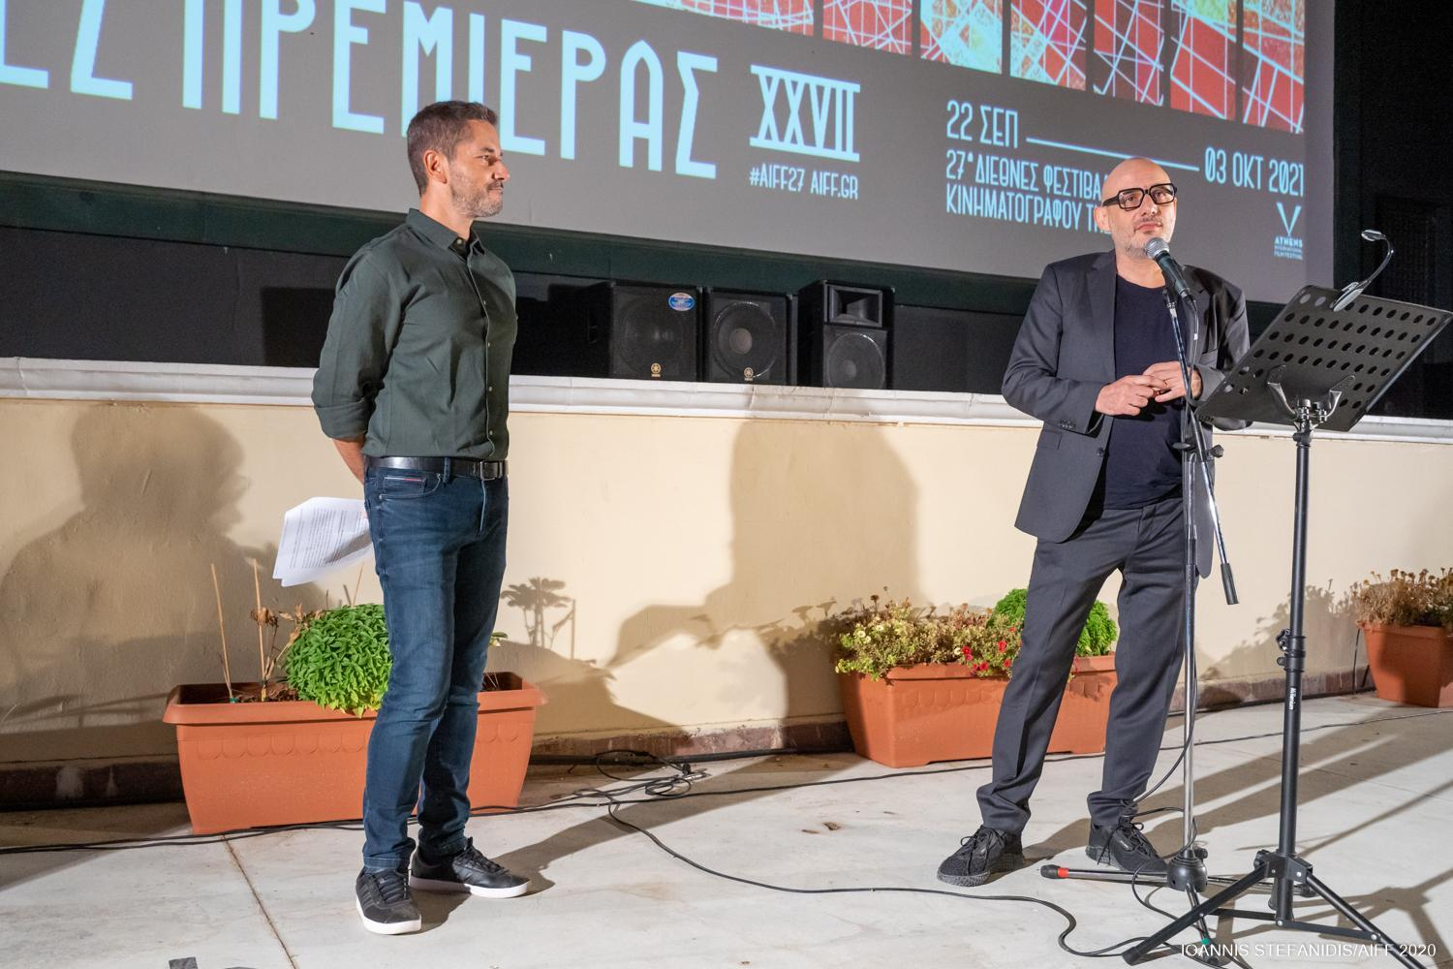Poka - Yio
The Festival’s artistic director took to the stage again to briefly present this year’s programme which will host 140 films, 3 Competition Sections, 2 Tributes, highly-anticipated premieres, side events and special screenings:
Having made mention of the opening and closing films of the 27th AIFF, Loukas Katsikas introduced the members of the International Committees and the awards which they will present and invited the Festival Programme Co-ordinator, Mr Nektarios Sakkas, to present the films of the International Competition Section (fiction) and the International Documentary Competition Section.
The jury that will award the prizes for our INTERNATIONAL COMPETITION Section consists of President, Babis Makridis, director and screenwriter and the following members: Dina Iordanova, film historian, Titus Kreyenberg, executive producer, Maria Nafpliotou, actress and Vangelis Raptopoulos, author.
The jury of the INTERNATIONAL DOCUMENTARY COMPETITION consists of President Markos Gastin, documentarian and producer and the following members: Thanasis Kampagiannis, lawyer, Katrine Kiilgaard, Director of Education at CPH:DOX , Noé Mendelle, director and producer and Aris Chatzistefanou, journalist and director.
The international awards GOLDEN ATHENA for BEST FILM and GOLDEN ATHENA for BEST DOCUMENTARY FILM are accompanied by a cash prize of 2,000 Euros and the award statuettes are kindly sponsored by ZOLOTAS jewellery stores. Our juries also present the CITY OF ATHENS BEST DIRECTOR AWARD and BEST SCREENPLAY AWARD, while the FISCHER AUDIENCE AWARD is also presented as part of the International Competition Section.
See in detail the films of the International Competition Section HERE and HERE.
Afterwards, the Head of the Greek Short Stories in Competition Section and Editor-in-Chief of cinemagazine.gr, Panos Gkenas, took to the podium to present one of the most loved, popular and dynamic sections of the Festival, the "Greek Short Stories", which this year celebrates 10 years. Mr Gkenas stated that “for a decade now the Festival’s ‘Greek Short Stories’ section has been diligent in its efforts to help new Greek films find their way to the big screen and to audiences. We owe a big thank you to the young Greek directors who have lovingly embraced this section and trusted it by submitting their films to the AIFF all these years at an ever-increasing rate."
He went on to announce the celebratory events of the 10-year anniversary: The Festival’s online platform (οnline.aiff.gr) will host all the short films which have won the Best Film award in recent years (“Chamomile” by Neritan Zinxhiria, “Red Hulk” by Asimina Proedrou, “II” by Efthimis Kosemund, “Simon Says” by Nikos Tseberopoulos, “Limbo” by Konstantina Kotzamani, “Copa-Loca” by Christos Massalas, “Hector Malot: The Last Day of the Year“ by Jacqueline Lentzou, “The Distance Between Us and the Sky “ by Vasilis Kekatos and “The End of Suffering (A Proposal)” by Jacqueline Lentzou), while from the 23rd September viewers will have the ability to watch, free of charge, a selection of some of the best Greek short films of recent years via the Festival’s platform at online.aiff.gr. We would like to thank the directors and their producers for allowing us to screen the films.
Furthermore, Panos Gkenos announced that on Monday 27th September an advisory workshop will take place in collaboration with Creative Europe MEDIA Desk and the Greek Film Centre on the subject of helping Greek short films become more visible and familiarising Greek directors with the various applications and the procedures that must be followed in order for their film to be selected to participate in an International Festival. In the workshop titled “Been there - Short that: Short Films - Long Journeys” the following will participate: Wouter Jansen, International distributor of short films, producer Fani Skartouli, director Konstantinos Antonopoulos and Anna Kasimati, Head of the Creative Europe MEDIA Desk Greece of the Greek Film Centre. Finally, he revealed that the AIFF will collaborate with the Piraeus Bank Group Cultural Foundation (PBGCF) with the aim of taking award-winning Greek films of this year's Festival event on a journey to museums of its network, thus giving the public outside of Athens the opportunity to experience Greek short films.

For this year's event, 40 Greek short stories, out of 273 entries, will compete for the awards, which this year are exclusively sponsored by the Greek Film Centre, a total amount of 5,000 Euros (2000 Euros for the GOLDEN ATHENA award and 1000 Euros each for the SILVER ATHENA, BEST DIRECTOR and BEST SCREENPLAY awards). Additionally, the Jury will traditionally present the BEST PERFORMANCE BY A FEMALE ACTOR and BEST PERFORMANCE BY A MALE ACTOR awards.

See in detail the jury and films of the Greek Short Stories in Competition Section HERE .

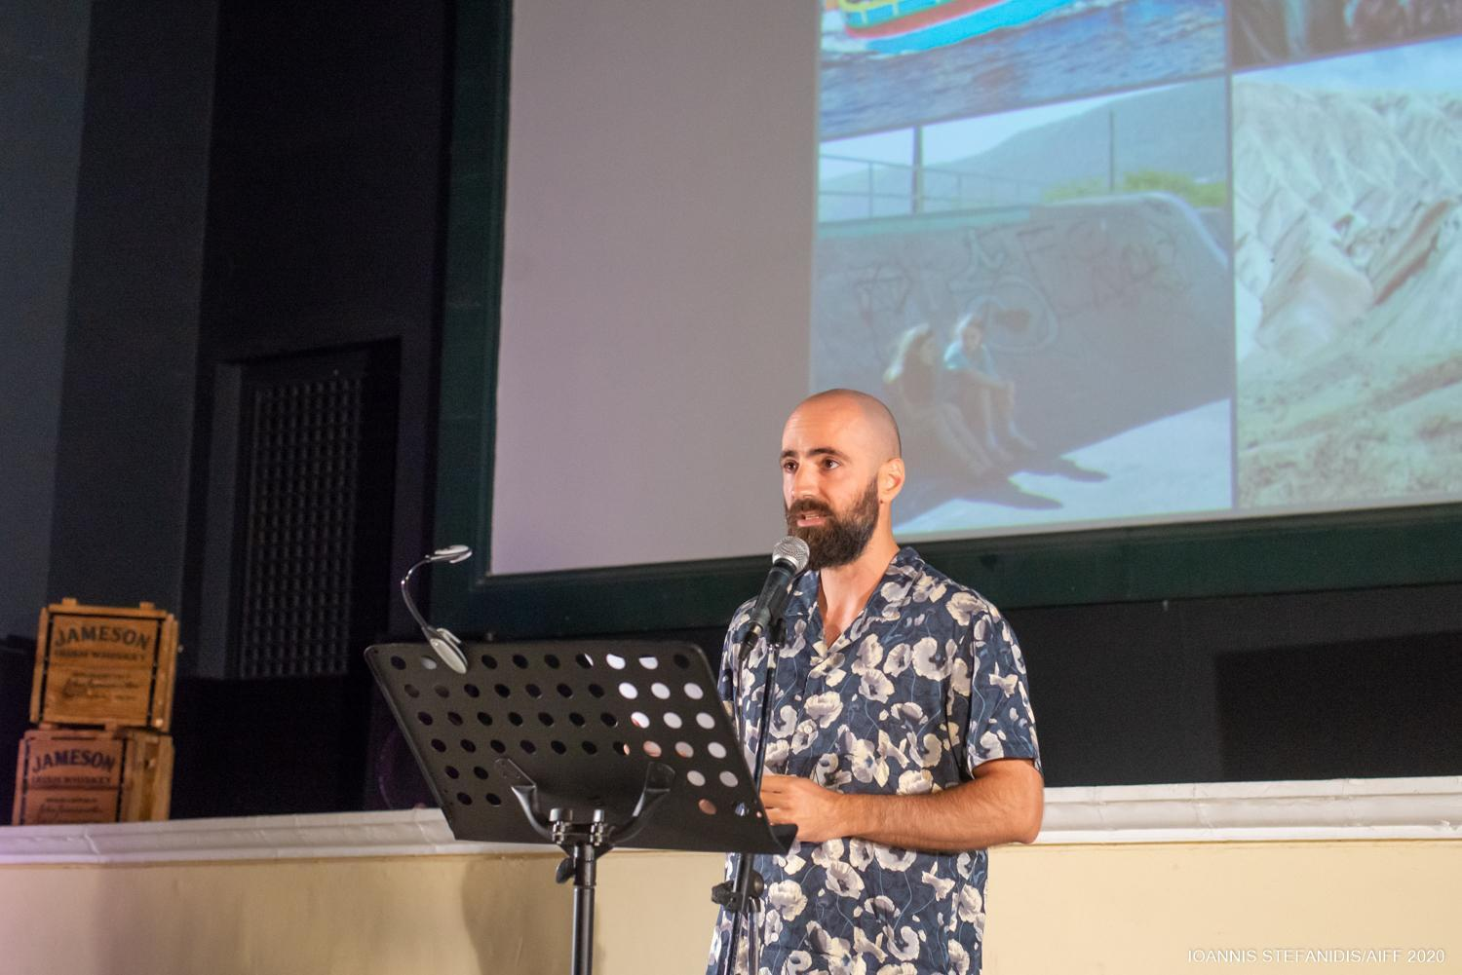 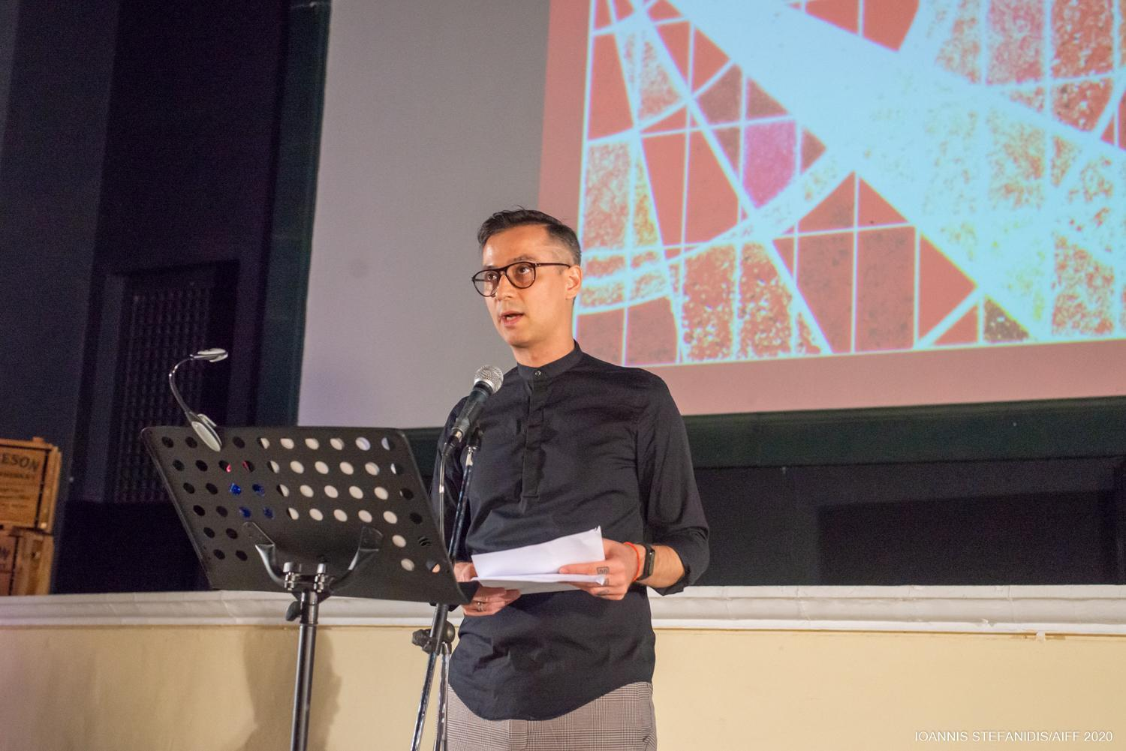Nektarios Sakkas Panos Gkenas
Loukas Katsikas took to the stage to preset the main tribute of this year's event titled THIS IS ORSON WELLES: RECONSTRUCTING A GENIUS which is presented on the occasion of the 80th anniversary of the first screening of the now legendary “Citizen Kane”, the best film of all time. The 27th AIFF has organised a complete tribute to Orson Welles' filmography, showing all of his fiction films, which will be introduced by prominent personalities from the field of cinema and culture. Most importantly, films will be shown not only in their latest but also in their most complete digital restoration.
Read in more details HERE
SPONSOR of the Main Tribute is ZAGORI GO GREEN SPARKLING.
The second tribute of the 27th event was presented by the Festival’s Communications Coordinator, Ms Maria Nathanael, in the presence of directors and activists, Ms Paola Revenioti and Erofylli Kokkali.
The Tribute “LIVES IN TRANSITION: TRANS CINEMA MATTERS” was created with great care by the Festival’s team and includes 13 films, both short and feature length, documentary and fiction films, from Greece and around the world, which tell funny and melancholy, affectionate and bright, playful and passionate stories about the lives and experiences of members of the trans community. The common theme behind the selection of the films to be screened as part of the tribute is that they are all told by trans people, either from the position of the director or from the role of the protagonist. The screenings will be honoured by the presence of the directors and actors, from Greece and abroad, while an OPEN DISCUSSION will be held titled "Trans visibility in cinema and mainstream narratives vs real life” .
Read in detail HERE.
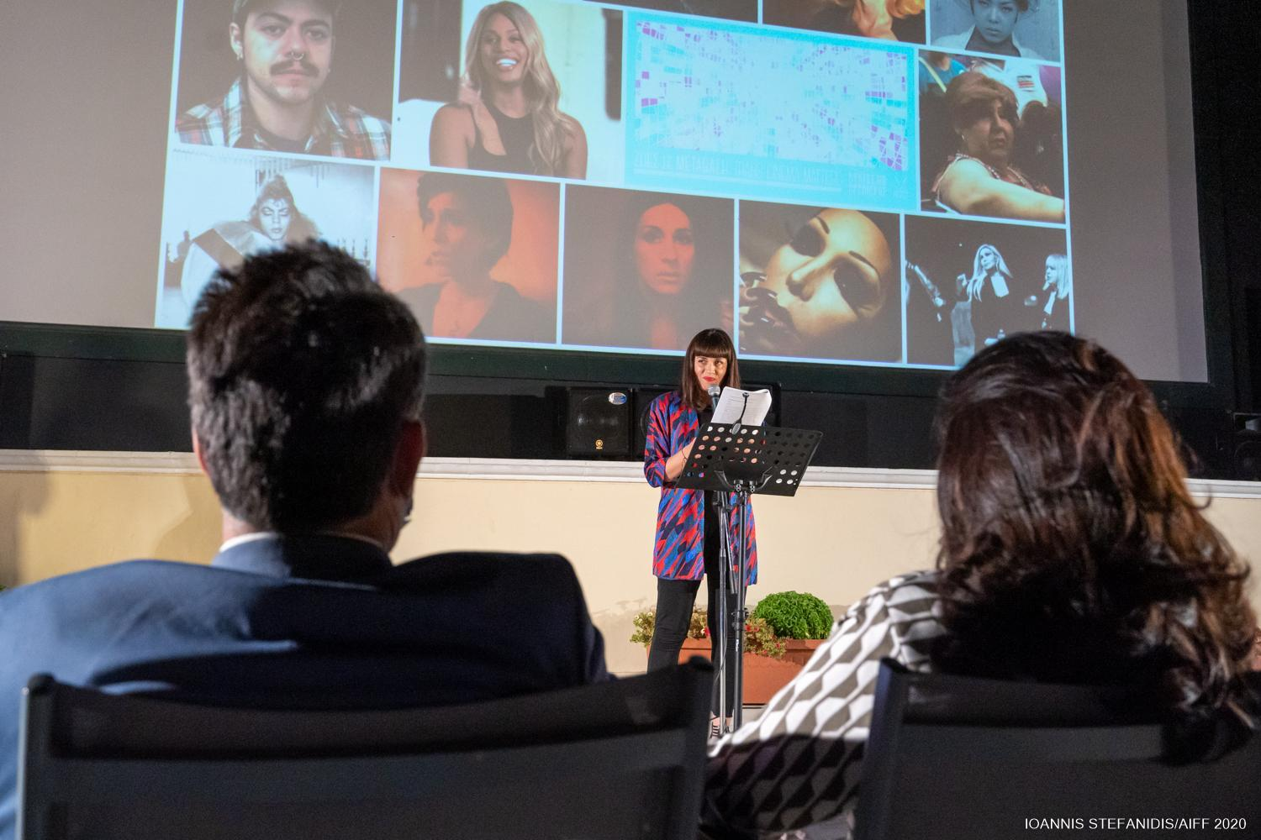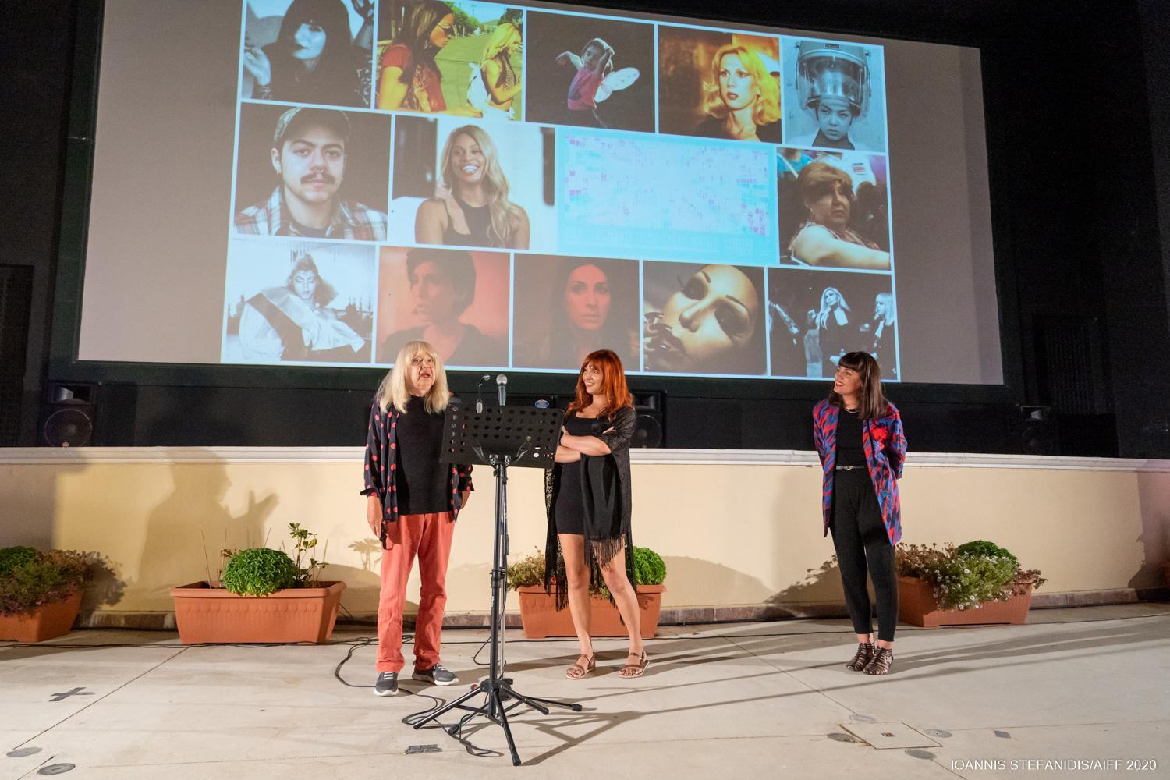 Maria Nathanael Paola Revenioti - Erofylli Kokkali
Continuing with the presentation, Mr Katsikas spoke of the award-winning and highly-anticipated premieres which will be screened at this year’s Festival such as the Palme d’Or and Golden Bear respective winners: TITANE by Julia Ducournau, “the second time in the history of the Cannes Festival that a woman wins the highly coveted top award of the Festival” and BAD LUCK BANGING OR LOONEY PORN by the highly-acclaimed Radu Jude “one of the leading directors of contemporary Romanian cinema, a film strictly unsuitable for minors and conservative viewers” as well as the latest films from some of the most important names in film such as Céline Sciamma, Sean Baker, Joachim Trier, Edgar Wright, Ben Whitley, Eytan Fox, Ari Folman and Clio Barnard.
More specifically, at the 27th Athens International Film Festival THE LAST DUEL will be screened, an impressive historical epic with Adam Driver, Matt Damon, Ben Affleck, directed by Ridley Scott, the recipient of the Berlin Festival’s Silver Bear the wonderful WHEEL OF FORTUNE AND FANTASY by Hamaguchi Ryūsuke, one of the leading young directors of Asian cinema, the long-awaited FRENCH DISPATCH by Wes Anderson, while fresh from its world premiere at the Toronto Festival we have EARWIG by Lucile Hadzihalilovic,"one of the most distinctive directors in film right now, who we have hosted along with her previous films "and the pioneering and hallucinogenic AFTER BLUE, a highly-anticipated second feature film of an enfant terrible of the French screen, Mr Bertrand Mandico (“The Wild Boys”). For the first and only time in our country the music film of one of the most important American directors will be screened on a big screen, a film about one of the three best bands that ever existed: THE VELVET UNDERGROUND by Todd Haynes. Finally, the 27th AIFF will hold the Greek premiere of - in the words of Loukas Katsikas “a rare cinematic experience, more like a ritual and meditation which one ought to experience exclusively in a dark cinematic venue”. The film is MEMORIA by the Palme d’Or winning Apichatpong Weerasethakul, starring Tilda Swinton.
Before concluding the Press Conference, the Festival’s General Coordinator, Ms Andy Dimopoulou, gave a detailed presentation of the Safety Guidelines for this year’s venue screenings and made reference to the Festival’s social policy in regards to supporting vulnerable social groups (support for the work of the “MISSION ANTHROPOS” organisation through the purchasing of tickets via viva.gr, Doctors Without Borders, Positive Voice, Orlando, Red Umbrella, Shedia Homeless Magazine ) and the accessibility of screenings.
The Press Conference was carried out with concurrent interpretation in the Greek sign language by Ms Theodora Tsapoiti.
Read more HERE.
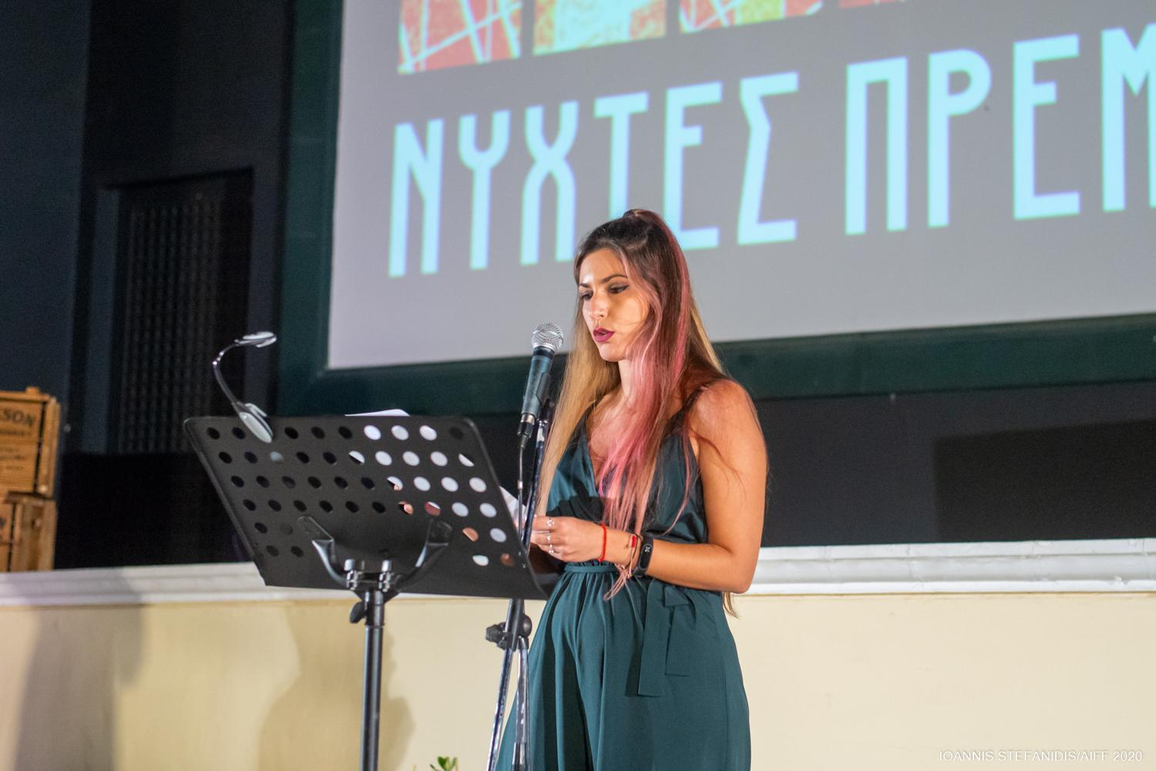 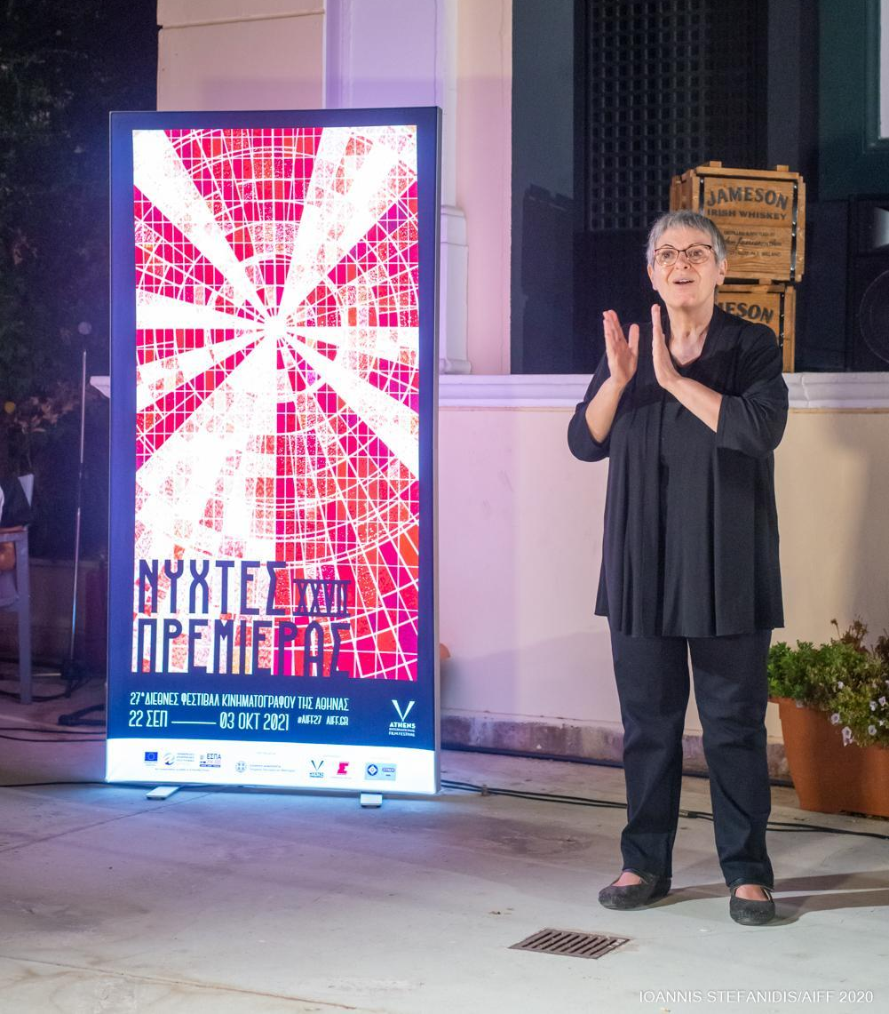Andy Dimopoulou Theodora Tsapoiti
Finally, concluding his speech and before wishing everyone a “Good Festival and safe return to venues”, the artistic director of the Athens International Film Festival thanked the supporters and especially the French Institute of Greece and the French Embassy in Greece, Goethe Institute of Athens, the British Council and the British Embassy in Athens, the Polish Embassy in Greece, the Swedish Embassy in Greece, the Swiss Embassy in Greece, the film distributors AMA FILMS, CAROUSEL FILMS, CINOBO, DANAOS FILMS, FEELGOOD ENTERTAINMENT, MIKROKOSMOS, ROSEBUD 21, SPENTZOS FILM, STRADA FILMS, TANWEER, TULIP ENTERTAINMENT, WEIRD WAVE, TROUT Creative Hub for the creation of this year’s promotional spot, the photographers and videographers, Vasilis Mexis for the poster design, Airotel Alexandros for the hospitality of Festival guests, the COOΚOOVAYA and AGORA restaurants for keeping guests and jury members fed, Viva.gr and Viva Wallet for issuing tickets and film passes as well as all the volunteers of the event for their immeasurable help.
OPENING and CLOSING FILMS
The 27th Athens International Film Festival will make a celebratory start at the Athens Concert Hall with the Greek premiere of the film awarded at this year’s Cannes festival “A HERO” by the two-time Oscar winner Asghar Farhadi ("A Separation", "The Salesman") on Wednesday 22nd September.

We’d like to thank SPENTZOS Films for kindly allowing us to screen the film .
The curtains will fall on this year’s event on Sunday 2nd October at IDEAL with the Closing Ceremony and the Presentation of the Awards of the International Competition Sections of the 27th Athens International Film Festival followed by the Greek premiere of the most highly-anticipated film of the season, DUNE by Denis Villeneuve.

We’d like to thank TANWEER for kindly allowing us to screen the film.
JAMESON was there to greet the audience of the Press Conference with a cinephile cocktail.
ZAGORI GO GREEN Sparkling refreshingly accompanied the event.
#aiff27
For a VIDEO of the press conference click HERE
The Festival PROGRAMME can be read HERE! .
For PHOTOGRAPHS of the Press Conference click HERE! .

The promotional SPOT of the 27th event, created by TROUT, can be seen HERE! .
You can find the detailed programme of the 27th Athens International Film Festival here: www.aiff.gr.
Please note that ticket presales (from www.aiff.gr and www.viva.gr and at physical points of sale) started on Thursday 16th September at 12.00 pm, while the sale of film passes for the 27th AIFF continues.

To purchase tickets online click here .

For the online screenings of the 27th AIFF visit online.aiff.gr

HYBRID VERSION OF THE 27TH ATHENS INTERNATIONAL FILM FESTIVAL
The city’s most important celebration, the Athens International Film Festival returns for the 27th year, optimistic and fully adapted to the new conditions, repeating the successful hybrid version of last year’s event, making itself accessible to as many viewers as possible.
The 27th AIFF will take place in the following indoor venues: ATHENS CONCERT HALL, IDEAL, DANAOS and TRIANON and for the first time at the MUNICIPAL THEATRE OF PIRAEUS as well as at the open air cinemas LAIS - The Greek Film Archive Foundation, RIVIERA, FLERY CINEMA and STELLA.
At the indoor venues (Athens Concert Hall, Danaos, Ideal, Trianon, Municipal Theatre of Athens) in accordance with the current health protocols, admission will be allowed to those who:
- are vaccinated
- were diagnosed with Covid-19 (the diagnosis must have been made in the last 6 months)
- who have received a negative rapid antigen test in the last 48 hours, in the event that they have not been vaccinated.

Viewers will be admitted with the following:

- a valid ticket
- a vaccination / recovery certificate or the negative rapid antigen test result
- proof of identity via ID card, passport or driving license.

Furthermore, for the added safety of our viewers, in collaboration with Festival Scope and Shift 72, the 27th Athens International Film Festival supplements its programme with a series of special screenings via a purpose-built digital platform (online.aiff.gr) where viewers will be able to enjoy films from the comfort of their homes, throughout Greece.

More specifically, the digital platform is included in this year’s event for viewers (medically vulnerable, caretakers or other people who work in close proximity to medically vulnerable people, etc.) who would not otherwise be able to attend screenings, by securing a certain number of geo-blocked screenings, adhering to all safety standards and to a high level of digital interaction matching the standards successfully set by major international festivals.
In the event that the pandemic conditions render it necessary, the platform in question will also be able to facilitate the digital fulfillment of part of the 27th ATHENS INTERNATIONAL FILM FESTIVAL while maintaining the inclusion of side events such as masterclasses, debates, the introduction of films by their directors, Q&A sessions as well as a wide-ranging interaction with the audience, adapted to the digital environment.

The 27th Athens International Film Festival will take place between 22nd September and the 3rd October 2021.
For updates and more information tune into the sites of aiff.gr and cinemagazine.gr and the relevant social media pages: Facebook AIFF, Instagram, Twitter.
The 27th Athens International Film Festival is affiliated with the PEP Attiki 2014 – 2020 and is co-funded by the European Regional Development Fund.

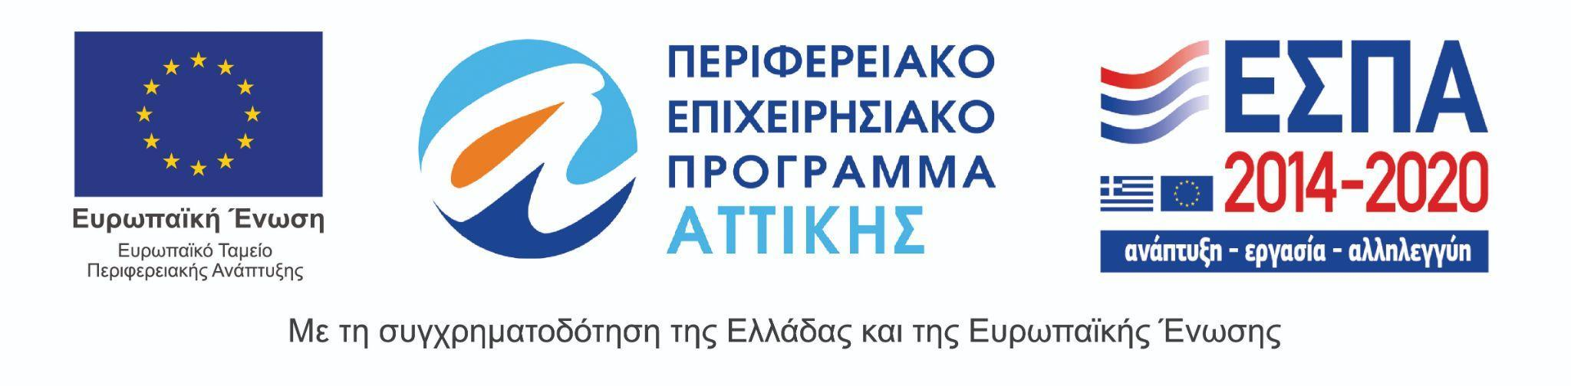
The 27th Athens International Film Festival takes place under the auspices of and with the financial support of the Ministry of Culture and Sports.

