27th ATHENS INTERNATIONAL FILM FESTIVAL

PRESS RELEASE
Greek Short Stories - In Competition

WORKSHOP
“Been there – Short that: Short Films - Long Journeys”
Monday 27th September @DANAOS | 12.00 p.m.

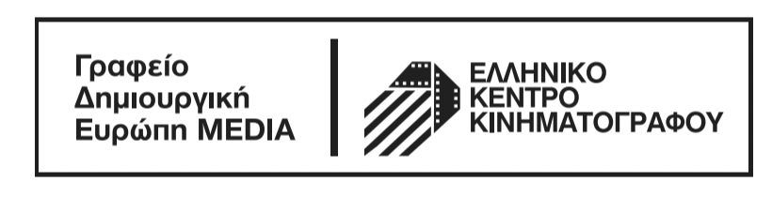

Αs part of the popular Greek Short Stories - In Competition section, which this year celebrates 10 years of caring about and promoting new Greek cinema, the 27th Athens International Film Festival is organising a workshop titled "Been there - Short that: Short Films - Long Journeys” in collaboration with the MEDIA Creative Europe Desk Office of the Greek Film Centre.
The workshop will take place on Monday 27th September at 12:00 at DANAOS cinema and will be held on the subject of helping Greek short films become more visible and familiarising Greek directors with the various applications and the procedures that must be followed in order for their film to be selected to participate in an International Festival.

The following will participate in the workshop: Wouter Jansen, International distributor of short films, producer Fani Skartouli and director Konstantinos Antonopoulos. Konstantinos Antonopoulos’ short film “Lea” earned an Honorary Distinction at the 19th Athens International Film Festival and "Without Glasses" won the Special Award of the Ministry of Macedonia and Thrace at the Drama Film Festival, while "Postcards from the End of the World" was selected for its world premiere by the Sarajevo Film Festival and enjoyed significant international success in festivals.

Anna Kasimati, Head of the Creative Europe MEDIA Desk Greece of the Greek Film Centre, will introduce the workshop which will be moderated by the Coordinator of the Greek Short Stories - In Competition section, Mr Panos Gkenas.

INFORMATION and PARTICIPATION INSTRUCTIONS:
MONDAY 27th SEPTEMBER 2021 |
12.00 p.m. (Arrival time: 11:00 a.m.)
DANAOS Cinema (Kifissias Ave 109, Athens)

In order to participate in the “Been there – Short that: Short Films - Long Journeys” workshop, it is imperative that you reserve a seat by entering your details HERE..
At the indoor venues (Athens Concert Hall, Danaos, Ideal, Trianon, Municipal Theatre of Athens) in accordance with the current health protocols, admission will be allowed to those who:

who have received a negative rapid antigen test in the last 48 hours, in the event that they have not been vaccinated.

- are vaccinated
- were diagnosed with Covid-19 (the diagnosis must have been made in the last 6 months) and
- who have received a negative rapid antigen test in the last 48 hours, in the event that they have not been vaccinated.

Viewers will be admitted with the following:

- a valid ticket
- a vaccination / recovery certificate or the negative rapid antigen test result
- proof of identity via ID card, passport or driving license.

A few words about the speakers:
Wouter Jansen
Wouter Jansen was head of programming at the Go Short - International Film Festival for 10 years. In 2013 he founded the sales and film distribution company Some Shorts, which in 2019 was renamed to Square Eyes. The purpose of the company is to represent bold, script-based, short and feature length films, in close collaboration with their directors. A small list of films has emerged from this project, which have premiered and won awards at festivals such as Cannes, TIFF, Berlin, Locarno and Clermont-Ferrand. Wouter Jansen has given lectures at Le Fresnoy, HEAD Geneva and the Netherlands Film Academy while at the same time running and moderating workshops at festivals such as IDFA, Locarno, True / False, Winterthur and more.

Fani Skartouli, Producer
She studied law and worked for international law firms in Brussels, Paris and Athens. Since 2016 she has been professionally active in film production. The short films "Postcards from the End of the World" and "Mom's Movie" have travelled to a variety of film festivals where they have been very successful. She is a Berlinale Talents alumna and a member of the EAVE Producers Network and the European Women’s Audiovisual Network (EWA).

Κωνσταντίνος Αντωνόπουλος, Σκηνοθέτης
He studied computer science at the Athens University of Economics and Business and film-making at Columbia University in New York. His recent short film Postcards from the End of the World (2019) has won numerous awards at international festivals. His projects have been supported by programs such as Berlinale Talent Project Market, Less Is More, First Film First, Oxbelly, European Short Pitch and SNF-Artworks.

Some information about the GREEK SHORT STORIES - In Competition section:
For a decade now, the Festival’s “Greek Short Stories” section has given its ongoing and diligent support with the aim of helping fresh new Greek films make their way to the big screen and to their audience. Greek directors have embraced this section with love and trust by submitting an ever-increasing number of films to the Festival throughout the years.
As part of the celebration of the 10-year anniversary of this section, the Festival’s online platform will host (οnline.aiff.gr) will host all the short films which have won the Best Film award in recent years (“Chamomile” by Neritan Zinxhiria, “Red Hulk” by Asimina Proedrou, “II” by Efthimis Kosemund, “Simon Says” by Nikos Tseberopoulos, “Limbo” by Konstantina Kotzamani, “Copa-Loca” by Christos Massalas, “Hector Malot: The Last Day of the Year“ by Jacqueline Lentzou, “The Distance Between Us and the Sky “ by Vasilis Kekatos and “The End of Suffering (A Proposal)” by Jacqueline Lentzou). From the 23rd September viewers will have the ability to watch, free of charge, a selection of some of the best Greek short films of recent years via the Festival’s platform at online.aiff.gr. We would like to thank the directors and their producers for allowing us to screen their films.
For this year's event, 40 Greek short stories, out of 273 entries, will compete for the awards, which this year are exclusively sponsored by the Greek Film Centre, a total amount of 5,000 Euros (2000 Euros for the GOLDEN ATHENA award and 1000 Euros each for the SILVER ATHENA, BEST DIRECTOR and BEST SCREENPLAY awards). Additionally, the Jury will traditionally present the BEST PERFORMANCE BY A FEMALE ACTOR and BEST PERFORMANCE BY A MALE ACTOR awards.

ΖΑΓΟΡΙ Go Green Sparkling will be there to refresh those attending the event while a mini lunch will be offered to all participants.
#aiff27 #aiffGreekShortStories

The Festival’s PROGRAMME can be found HERE
The promotional SPOT of the 27th event, created by TROUT, can be seen HERE! .
You can find the detailed programme of the 27th Athens International Film Festival here: www.aiff.gr.
Please note that ticket presales (from www.aiff.gr and www.viva.gr and at physical points of sale) started on Thursday 16th September at 12.00 pm, while the sale of film passes for the 27th AIFF continues.

To purchase tickets online click here .

For the online screenings of the 27th AIFF visit online.aiff.gr

HYBRID VERSION OF THE 27TH ATHENS INTERNATIONAL FILM FESTIVAL
The city’s most important celebration, the Athens International Film Festival returns for the 27th year, optimistic and fully adapted to the new conditions, repeating the successful hybrid version of last year’s event, making itself accessible to as many viewers as possible.
The 27th AIFF will take place in the following indoor venues: ATHENS CONCERT HALL, IDEAL, DANAOS and TRIANON and for the first time at the MUNICIPAL THEATRE OF PIRAEUS as well as at the open air cinemas LAIS - The Greek Film Archive Foundation, RIVIERA, FLERY CINEMA and STELLA.
At the indoor venues (Athens Concert Hall, Danaos, Ideal, Trianon, Municipal Theatre of Athens) in accordance with the current health protocols, admission will be allowed to those who:
- are vaccinated
- were diagnosed with Covid-19 (the diagnosis must have been made in the last 6 months)
- who have received a negative rapid antigen test in the last 48 hours, in the event that they have not been vaccinated.

Viewers will be admitted with the following:

- a valid ticket
- a vaccination / recovery certificate or the negative rapid antigen test result
- proof of identity via ID card, passport or driving license.

Furthermore, for the added safety of our viewers, in collaboration with Festival Scope and Shift 72, the 27th Athens International Film Festival supplements its programme with a series of special screenings via a purpose-built digital platform (online.aiff.gr) where viewers will be able to enjoy films from the comfort of their homes, throughout Greece.

More specifically, the digital platform is included in this year’s event for viewers (medically vulnerable, caretakers or other people who work in close proximity to medically vulnerable people, etc.) who would not otherwise be able to attend screenings, by securing a certain number of geo-blocked screenings, adhering to all safety standards and to a high level of digital interaction matching the standards successfully set by major international festivals.

The 27th Athens International Film Festival will take place between 22nd September and the 3rd October 2021.
For updates and more information tune into the sites of aiff.gr and cinemagazine.gr and the relevant social media pages: Facebook AIFF, Instagram, Twitter.
The 27th Athens International Film Festival is affiliated with the PEP Attiki 2014 – 2020 and is co-funded by the European Regional Development Fund.

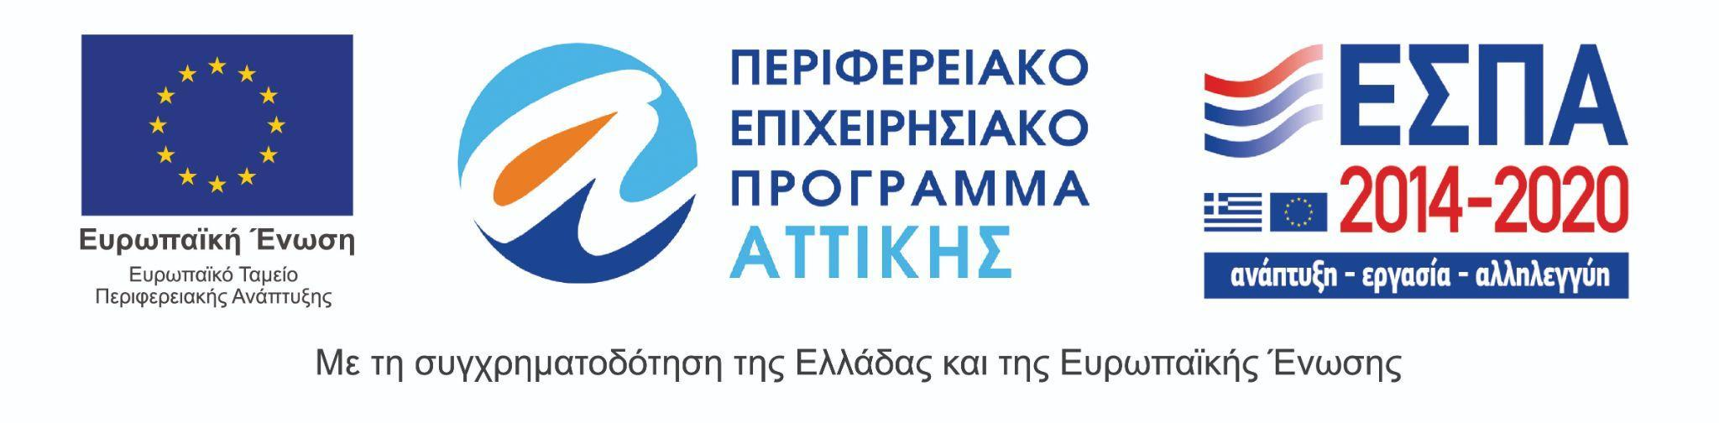
The 27th Athens International Film Festival takes place under the auspices of and with the financial support of the Ministry of Culture and Sports.

