PRESS RELEASE
The Palme d’Or and Golden Bear at the
27th Athens International Film Festival 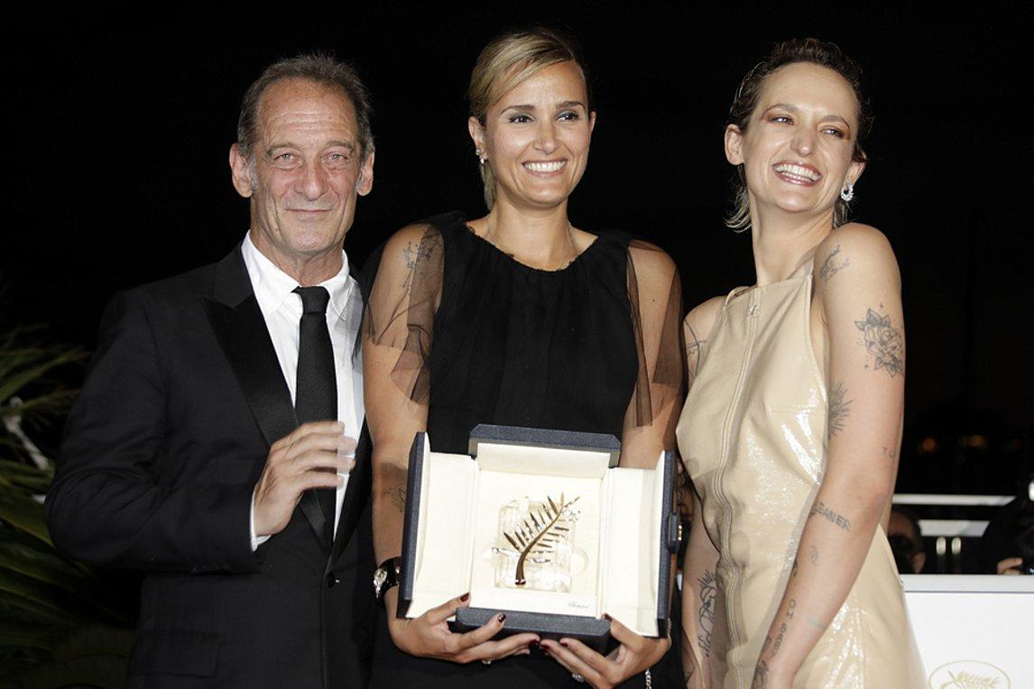
Only a short while after their first global screening and their subsequent triumphant victory at the Cannes Film Festival and the Berlin Film Festival respectively, the much-talked-about and highly-anticipated “Titane” by Julia Ducournau and “Bad Luck Banging or Looney Porn” by Radu Jude will make their Greek debut at the 27th Athens International Film Festival.
It is with great joy that the 27th Athens International Film Festival announces the first titles to be featured at this year’s event with the “golden” Greek premieres of the two festival winners of the season: “Titane” by Julia Ducournau and “Bad Luck Banging or Looney Porn” by Radu Jude.
The recent Palme d’Or winner constitutes a serendipitous “reunion” with an old acquaintance of the Festival, who is currently enjoying international recognition. The Golden Bear winner offers the Athens International Film Festival a chance to be the first to introduce to Greek audiences one of the most unconventional and bound to be talked-about films in recent years.

A few words about the films
“Titane” by Julia Ducournau
The French director, who we were introduced to in 2016 with “Raw” and who we had the pleasure to host at that year’s Athens international Film Festival, triumphed this year at the world’s biggest cinematic event. Her second feature film earned a controversial win, making Ducournau the second female director to be awarded the Palme d’Or, 28 years after Jane Campion’s “The Piano”.
In “Titane”, a series of unexplained crimes become the reason for a father to reconnect with his son, who has been missing for ten years, plot elements which make for a risky and provocative attack on the senses: a bold, belligerent and audacious thriller in which the concepts of identity and sexual behaviour meet “Crash” and David Cronenberg’s style of physical horror.
“Titane” will be released in cinemas on the 28th October by Cinobo.

“Bad Luck Banging or Looney Porn” by Radu Jude
By far the best film of this year’s Berlin Film Festival gives a nod to Bertolt Brecht, Luis Buñuel, Walter Benjamin, Dušan Makavejev and John Waters: an extremely appropriate cinematic challenge, exquisitely political and blunt to the point of redemption which rightfully won the Golden Bear through its narrative of the comically tragic and unexpected events that take place when a sex tape made by a couple for personal use mysteriously ends up on the internet.
One of the most highly-acclaimed and award-winning directors of contemporary Romanian cinema, Radu Jude invites viewers to a postmodern and engaging game, a review and fresh study of modern History through the use of blunt satyre and surreal comedy.
“Bad Luck Banging or Looney Porn” will be released in cinemas on the 7th October by Cinobo.
You can find additional photos from the films here.

We would like to remind you that in light of the health pandemic faced in Greece and abroad and following the safe and successful running of last year’s hybrid event of the Festival our aim is to host the 27th Athens International Film Festival in both open-air and indoor cinemas always respectful of the rules and adhering to the specifications for running the event as defined by the competent bodies of State and with utmost regard for the safety of the public and our audience members.
For viewers (medically vulnerable, caretakers or other people who work in close proximity to medically vulnerable people, etc.) who would not otherwise be able to attend screenings, for the second year running the Athens International Film Festival will make a part of its programme available online via the purpose-built and popular digital platform online.aiff.gr through which a certain number of geo-blocked screenings have been secured, adhering to all safety standards and to a high level of digital interaction matching the standards successfully set by last year’s Festival event as well as other major international festivals.
In the event that the pandemic conditions render it necessary, the platform in question will also be able to facilitate the digital fulfillment of the Festival in its entirety while maintaining the inclusion of side events such as masterclasses, debates, the introduction of films by their directors, Q&A sessions as well as a wide-ranging interaction with the audience, adapted to the digital environment.

The 27th Athens International Film Festival will take place between 22nd September and the 3rd October 2021.
For updates and more information tune into the sites of aiff.gr and cinemagazine.gr and the relevant social media pages: Facebook AIFF, Instagram, Twitter.
The 27th Athens International Film Festival is affiliated with the PEP Attiki 2014 – 2020 and is co-funded by the European Regional Development Fund.
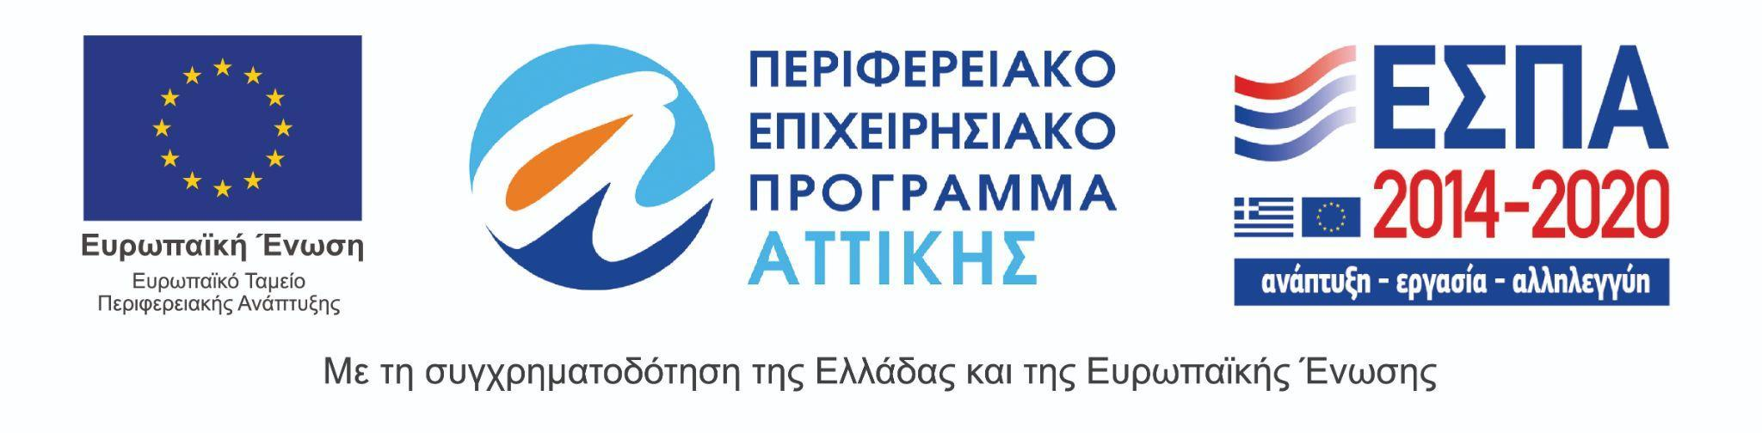
The 27th Athens International Film Festival takes place under the auspices of and with the financial support of the Ministry of Culture and Sports.
