28ΤΗ ATHENS INTERNATIONAL FILM FESTIVAL | 28 September - 9 October 2022
ATHENS CONCERT HALL
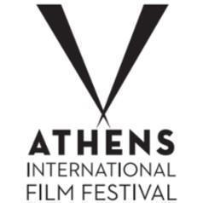
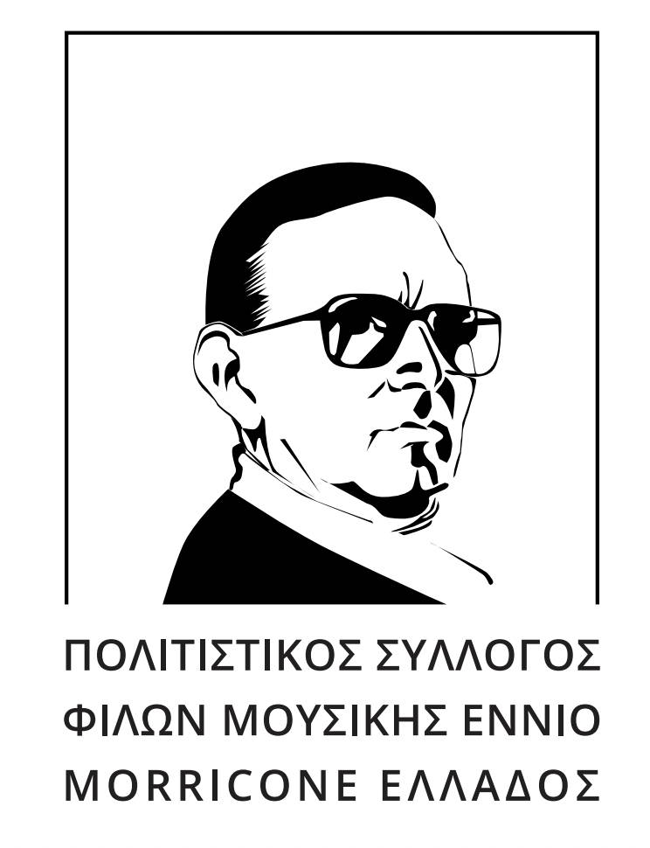
PRESS RELEASE

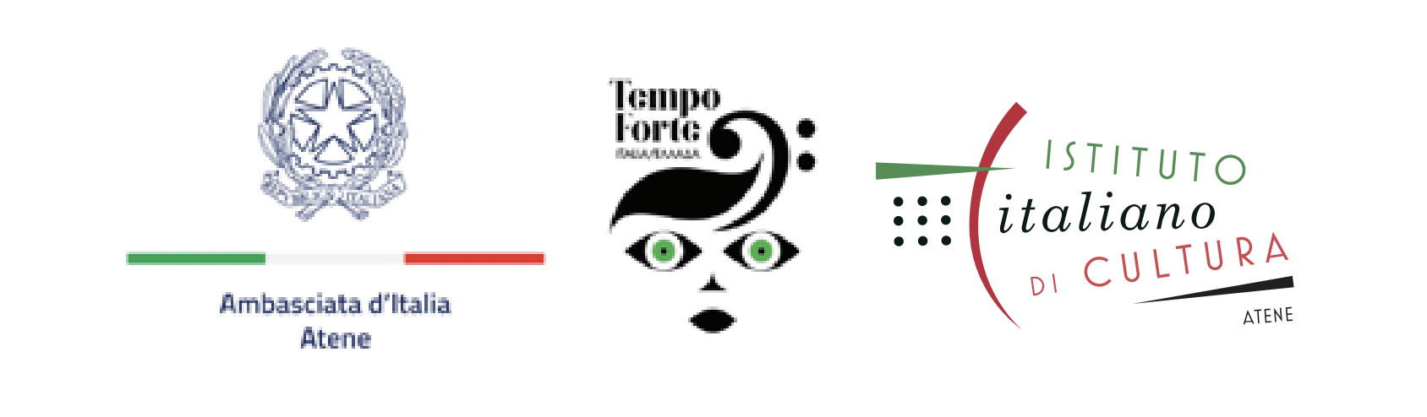
MONDO MORRICONE
The great feature of the 28th Athens International Film Festival on Ennio Morricone
Co-organized in collaboration with the Greek Cultural Association Friends of Ennio Morricone’s Music, the Embassy of Italy and the Italian Institute of Culture

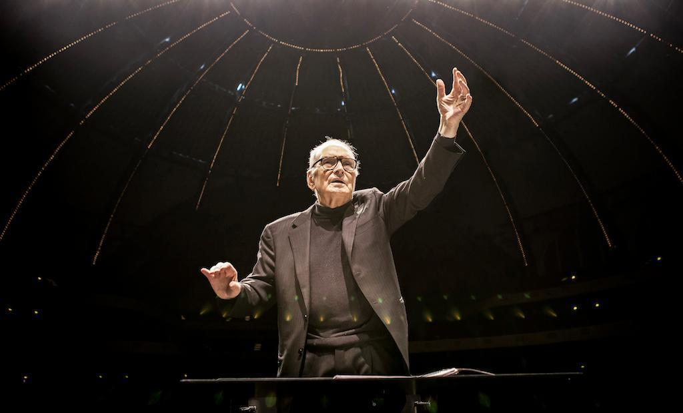

Ennio Morricone already has a place in the classics pantheon.
He was the Mozart, he was the Bach, he was the Beethoven of celluloid. And he will be forever.

Two years after the loss of such a legend, the 28th Athens International Film Festival honors the work and the personality of the great Italian maestro, through a multifaceted feature that will be ‘heard’ beyond the big screen.

The feature consists of:
The Greek premiere of the awarded documentary ‘Ennio’, directed by Giuseppe Tornatore, at the Athens Concert Hall on Saturday 1st October, in the presence of the great maestro’s son, Marco Morricone, the producer Gianni Russo. Before the screening, there will be a concert by the internationally acknowledged pianist and distinguished composer Stavros Lantsias and ‘Stavros Lantsias Quartet’, presenting some of the composer’s greatest music themes.

Book presentation ‘Ennio Morricone -In search of that sound – my music my life’, in presence of the author Alessandro De Rosa, in the Teaching Hall of the Music Library (Friends of Music Society, at the Athens Concert Hall).

Exhibition entitled ‘Ennio Formes’ at Olympia, Municipal Music Theatre ‘Maria Callas’

In detail:
‘Ennio’ by Giuseppe Tornatore, preceded by a ‘Stavros Lantsias Quartet’ concert, with Ennio Morricone compositions.
Saturday 1.10| 19.30 | Triantis Hall, Athens Concert Hall, Vasilissis Sofias Avenue 85, 115 21, Athens
Tickets: 9 €
Buy your ticket here: https://www.megaron.gr/event/nuchtes-premieras/

The Greek premiere of the awarded documentary ‘Ennio’, directed by Giuseppe Tornatore, at the Athens Concert Hall on Saturday 1st October, in the presence of the great maestro’s son, Marco Morricone, the producer Gianni Russo and Alessandro De Rosa, official Morricone biographer. Before the screening, there will be a concert by the internationally acknowledged pianist and distinguished composer Stavros Lantisas and ‘Stavros Lantsias Quartet’, taking us to a journey in the music universe of the Italian composer.

‘Ennio’ by Giuseppe Tornatore
Without Ennio Morricone, the marriage of film and music would have been left incomplete. His arrangements, his amazing underlines, the intuitive ‘reading’ of his works and of course his unforgettable themes are the 500 + (!) tokens of the genius of this modest bespectacled man who put our lives to melody. And Giuseppe Tornatore, winner of an Oscar for ‘Nuovo Cinema Paradiso’ with the status of the collaborator and the scope of an unpretentious sentimentalist offers this respectful thanks on behalf of all of us, gathering in his film some of the greatest directors of international cinema (Clint Eastwood, Wong Kar Wai, Bernardo Bertolucci, Quentin Tarantino et. al) and music (John Williams, Bruce Springsteen, Hans Zimmer, Quincy Jones, among others) to bow before the Maestro’s greatness.

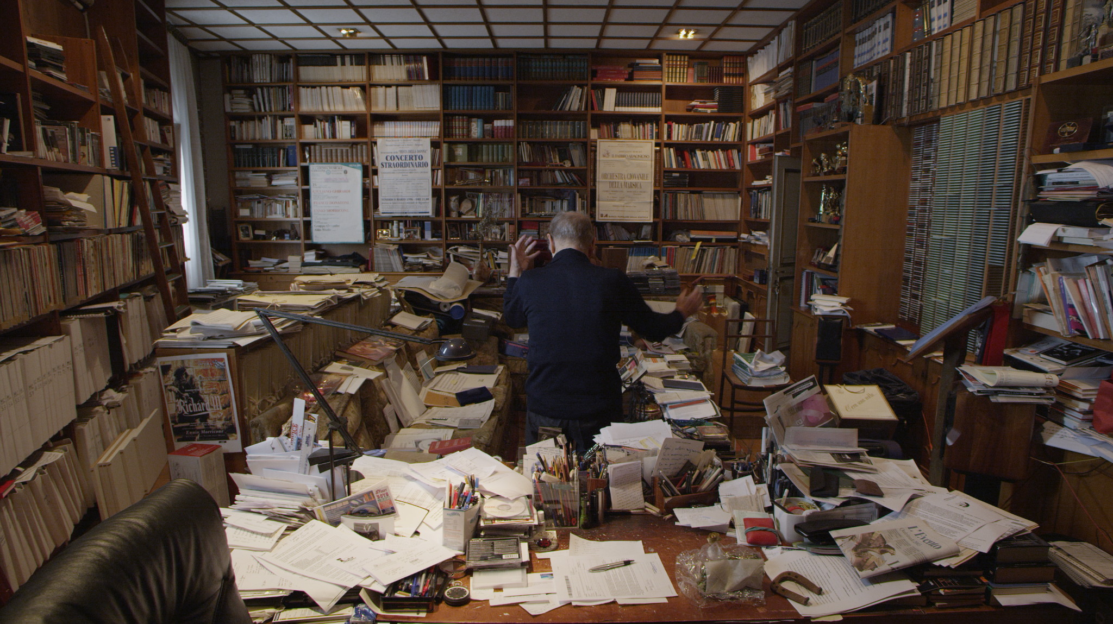

«Stavros Lantsias Quartet»
Stavros Lantsias: piano, Andreas Polyzogopoulos: trumpet & flugelhorn, Michalis Kalkanis: contrabass, Michalis Kapilidis: drums
STAVROS LANTSIAS
Stavros Lantsias, α Cypriot pianist and composer is one of the most acknowledged jazz musicians in the contemporary Greek music scene. With brilliant music studies in Nicosia and the US (Berklee, Boston) he has recorded several records and has collaborated with many musicians. His personal style is bold and strong, making every live appearance a music event promising to surprise and impress jazz lovers.

CULTURAL ASSOCIATION OF ENNIO MORRICONE MUSIC FRIENDS OF GREECE
Non-profit association dedicated to the work of the great Italian composer Ennio Morricone with about 500 film and television music investments. It was founded in 2011 and is based in Larissa. It has 4,200 members to date and is the only association worldwide. It aims to promote the musical work of the award-winning composer. Konstantinos Papakostas is the main initiator of the idea of creating this association and as President together with the members, they work tirelessly, with faith and dedication for the realization of the association's goals.
The activities of the association are mainly focused on film screenings with music by the composer, in archaeological and cultural sites, as well as art events and design representations inspired by his work.
For more information about the association: http://www.enniomorricone.gr/

‘ENNIO FORMES’: An exhibition dedicated to the great Italian Composer
22.09 - 9.10 | Olympia Municipal Music Theatre ‘Maria Callas’ | Akadimias 59 | Opening Times: Tuesday - Friday (11.00 - 19.00), Saturday & Sunday (11.00 - 15.00). Monday Closed | Free Entrance
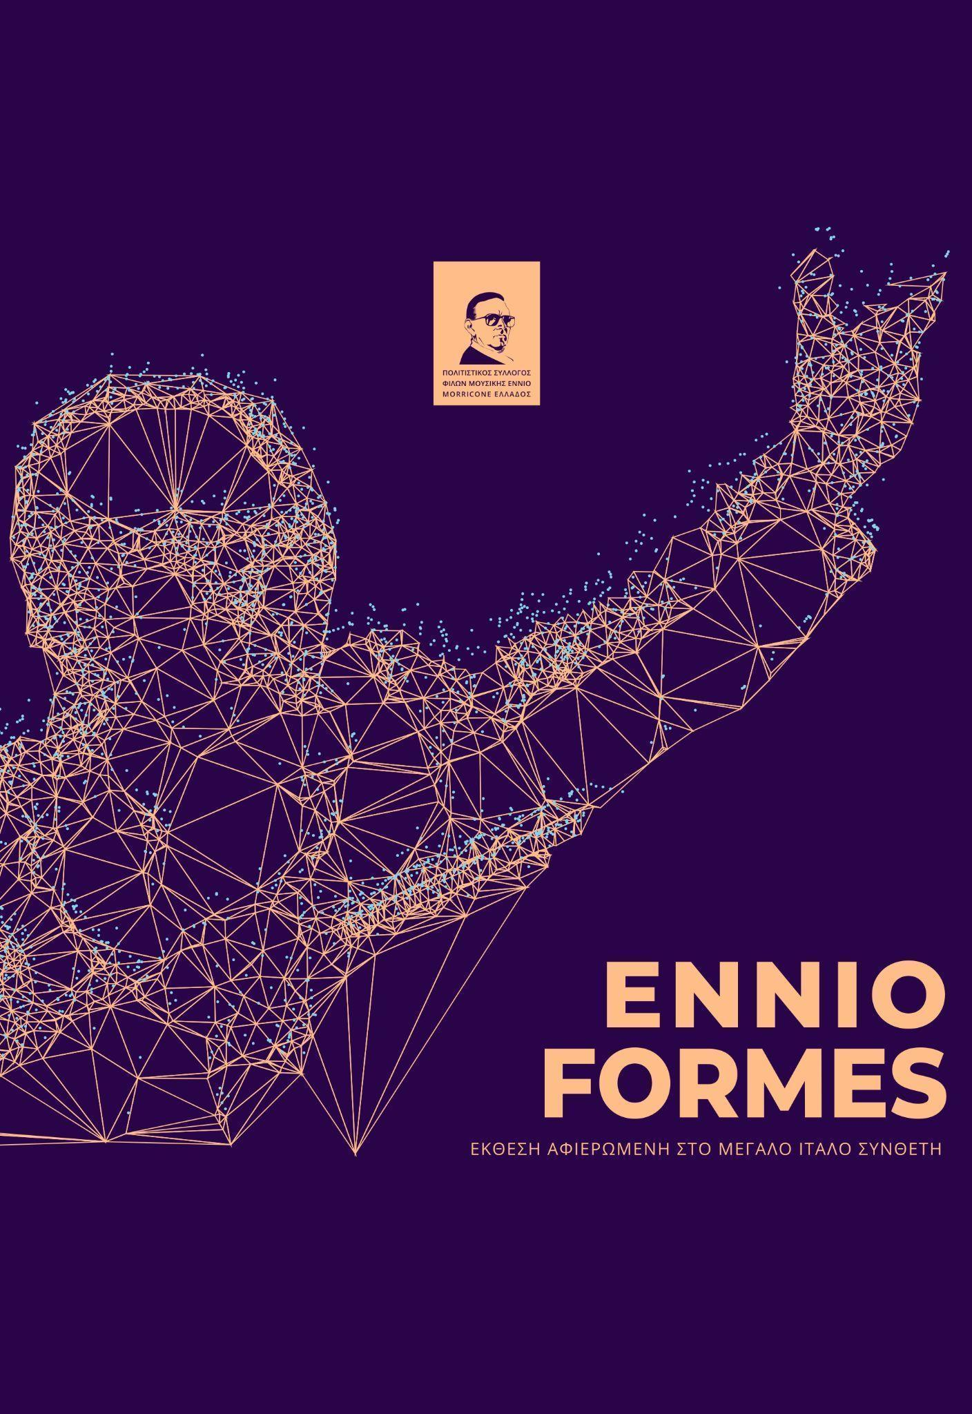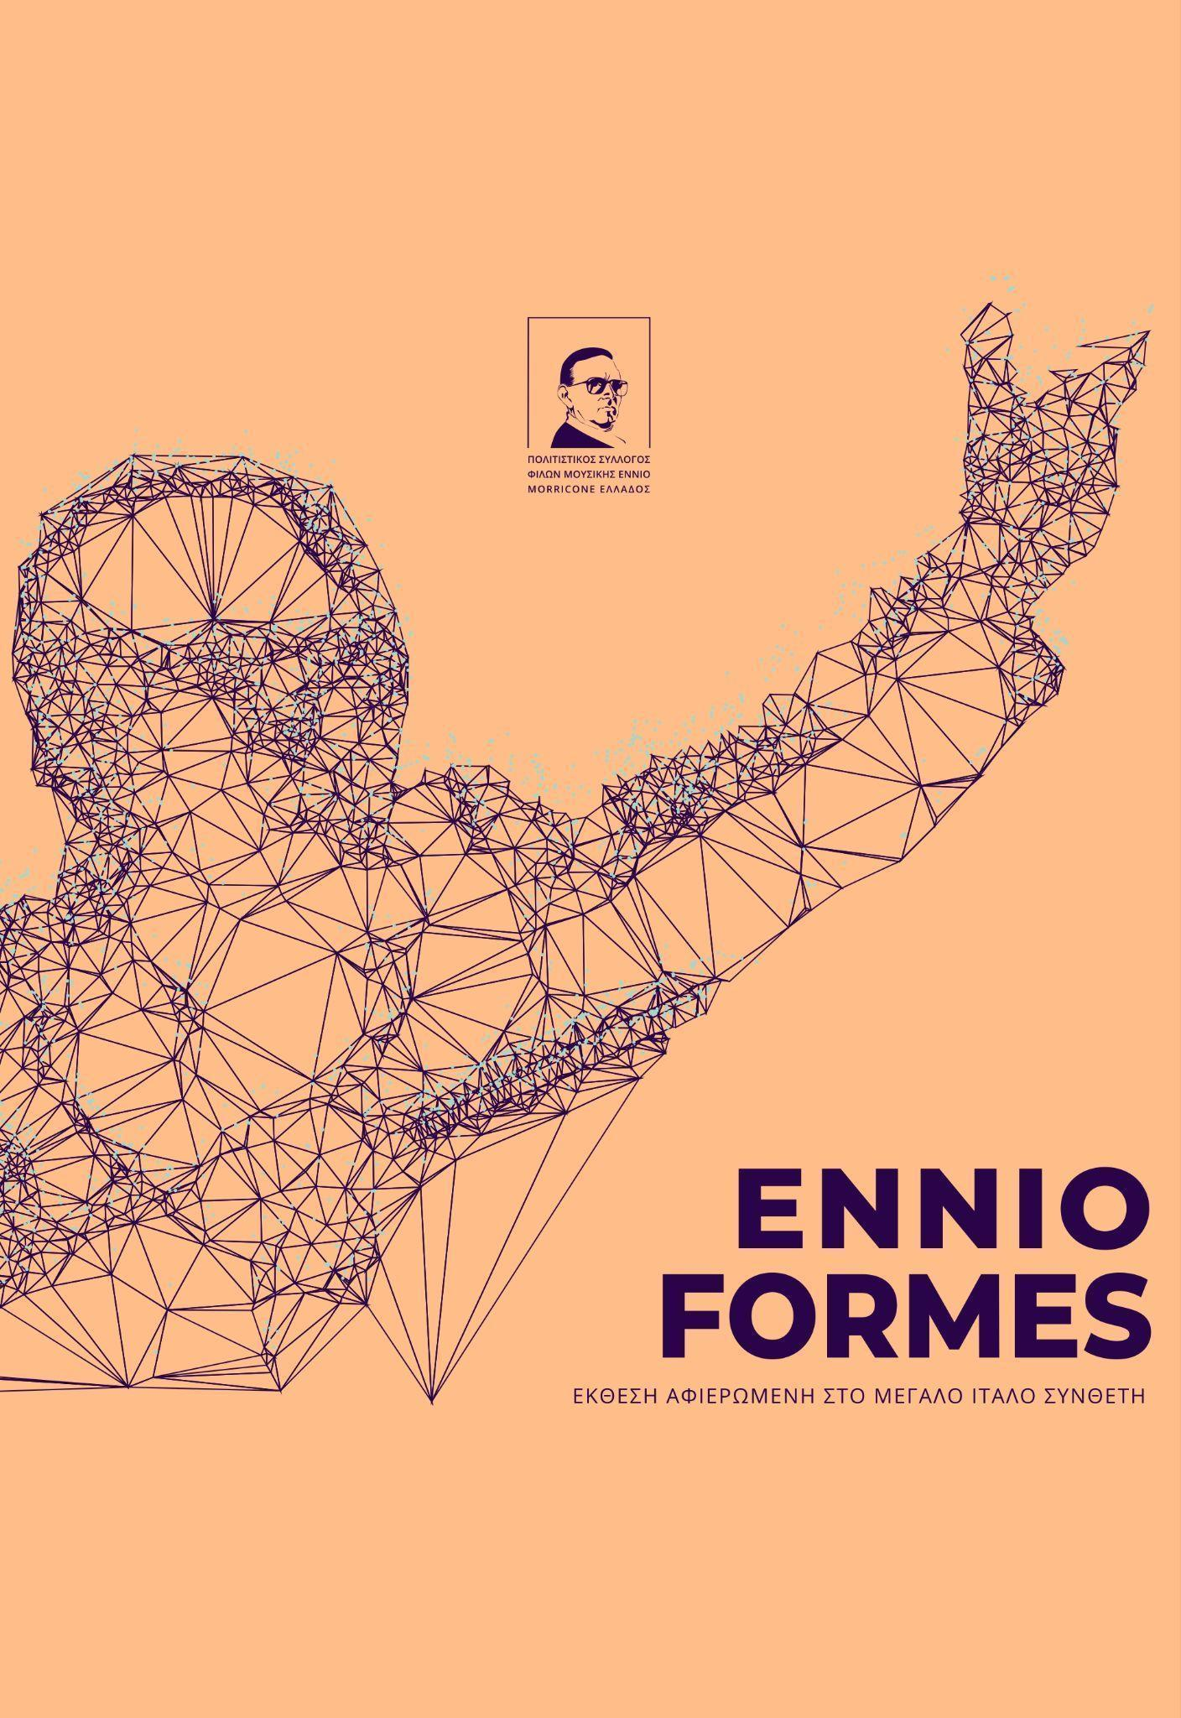
13 visual artists, graphic designers, street and tattoo artists created and present for the first time in Athens their work, in a group exhibition inspired by the great Italian composer. The initiative belongs to the Greek cultural association friends of Ennio Morricone’s music and refers to the presentation of visual work and image, inspired by the composer and his work.
The exhibition aims to bring together and in contact with a greater audience the artists who were inspired by the dynamics of Morricone’s music. His music is a way of thinking, an attitude, a philosophy, visualised in this exhibition through various creative techniques and visual writings. Every piece is inspired by his steps over the course of time. The participating visual artists were invited to depict Morricone not just as a representation or with references to his works, but to trace the notion, the impression and the feeling associated with the great composer.

The names of the artists are: G.Antonopoulos, Ast.Dimitriou, G.Dimitriou, D.Dimopoulos, D.Kalogirou, Ast.Laskaris, C.Laskaris, S.Bakalis, P.Dolas, G.Petrou, C.Samaras, E.Sarli, Z.Seitani, Al.Mantzari, P.Tsioutras, PUPPET.
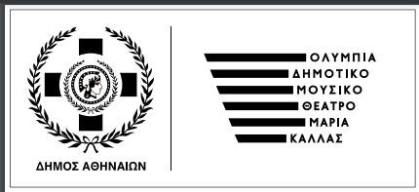
Co-organized with the Greek cultural association friends of Ennio Morricone’s music , the Embassy of Italy, the Italian Institute of Culture and in collaboration with Culture, Sports & Youth Organisation of the City of Athens and Olympia Municipal Music Theatre ‘Maria Callas’
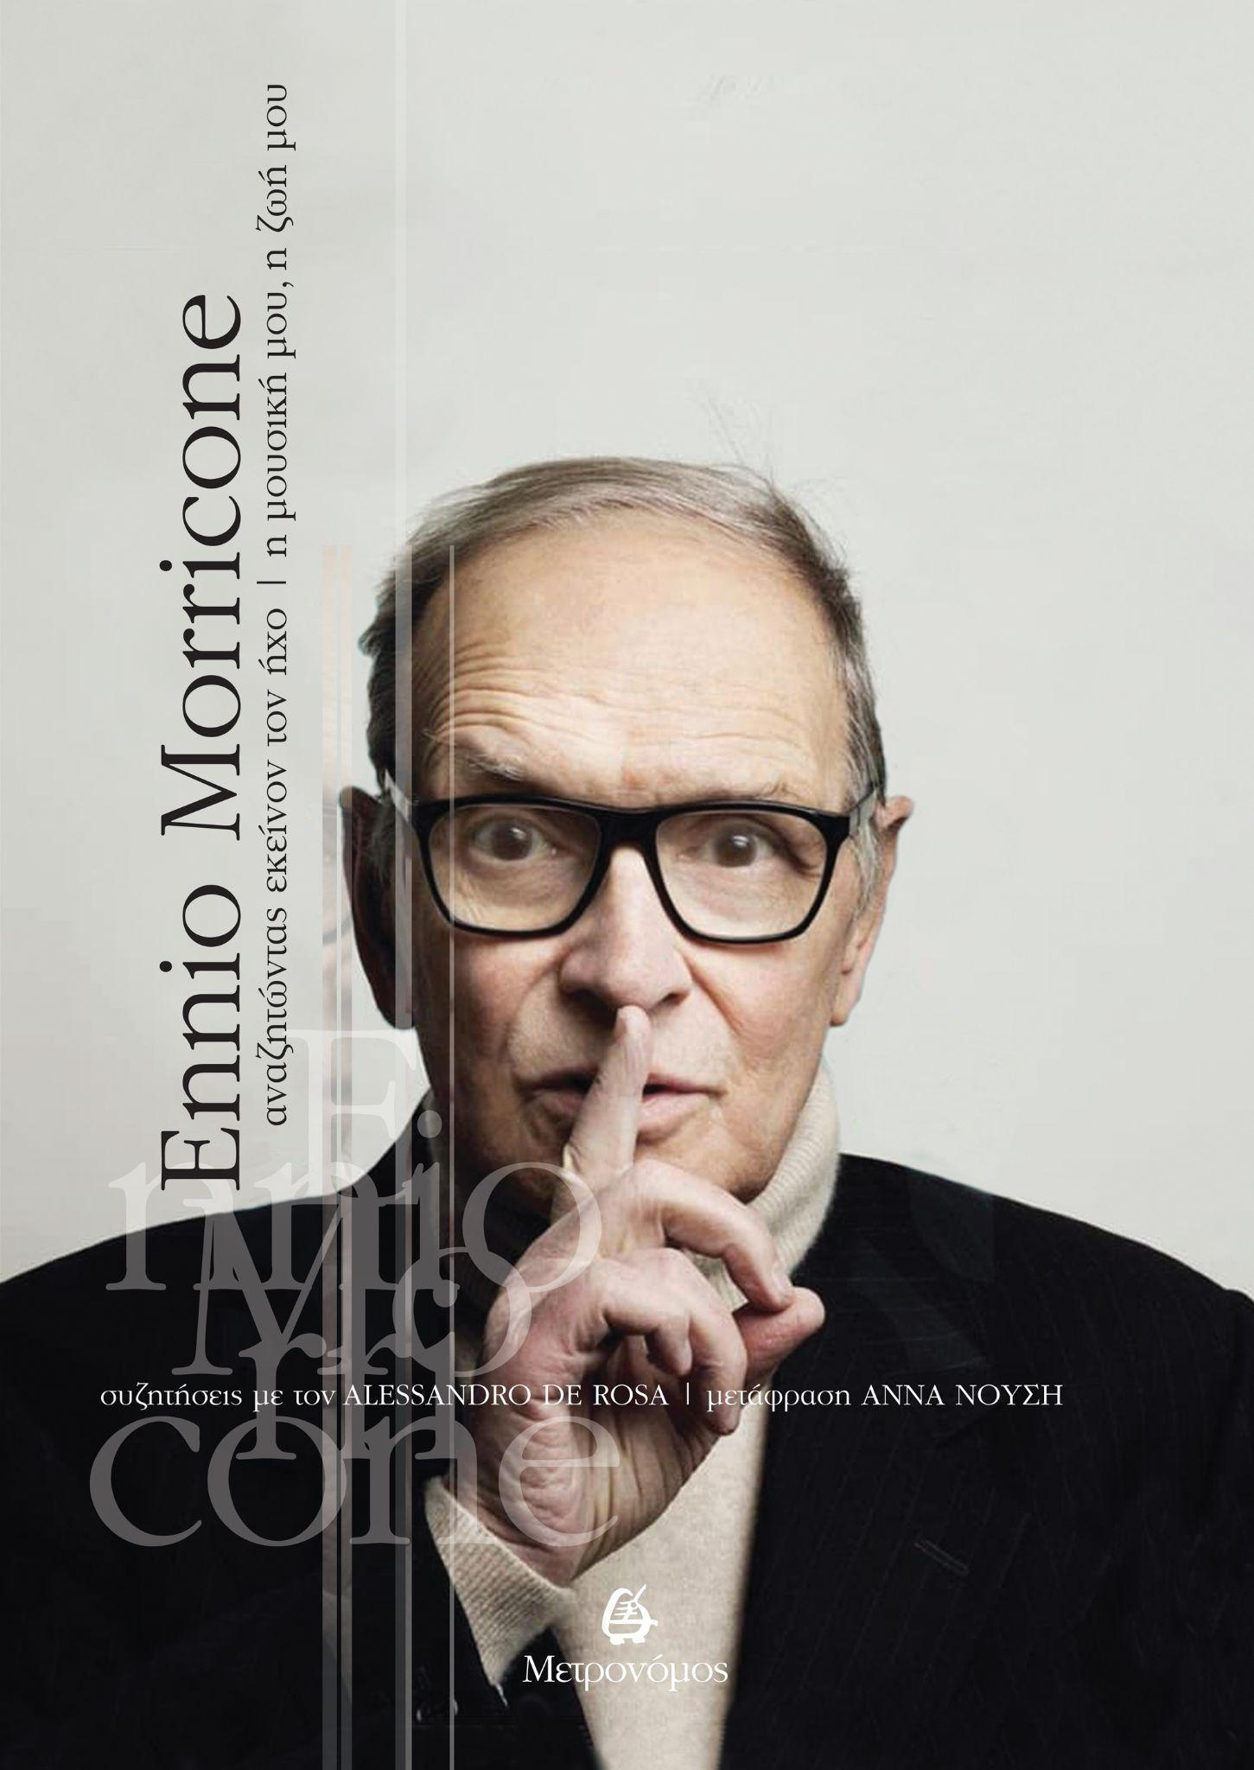
Book presentation ‘Ennio Morricone -In search of that sound – my music my life’, by Alessandro De Rosa, Translation: Anna Nousi, Metronomos
Friday 30.09 | 12.00 | Teaching Hall of the Music Library (Friends of Music Society, the Athens Concert Hall). (Vasilissis Sofias 85| Free Entrance

Alessandro de Rosa reads between the lines of the pentagram offering a valuable, authentic and detailed portrait, completing with words the iconic, clear sheet music of Morricone’s career.
On Friday 30th September, the Italian author and the translator of the book, Anna Nousi, will present the Greek edition by Metronomos Publishing, at the Athens Concert Hall Music Library. The special event will be honoured by the composer’s son, Marco Morricone and the documentary ‘Ennio’ producer, Gianni Russo. The discussion will be coordinated by Eleni Mitsiakis, Musicologist, Producer Coordinator of the Friends of Music Association and member of the International Federation of Film Music Critics (IFMCA). Cassandra Foundoulaki on the piano will accompany the event.

In collaboration with the Greek cultural association friends of Ennio Morricone’s music, the Embassy of Italy, the Italian Institute of Culture, the Friends of Music Society and Metronomos Publishing.
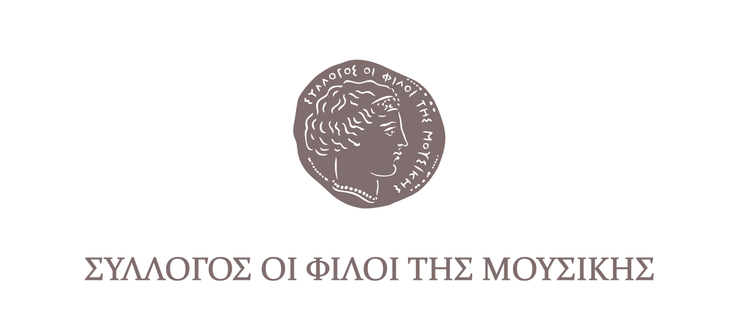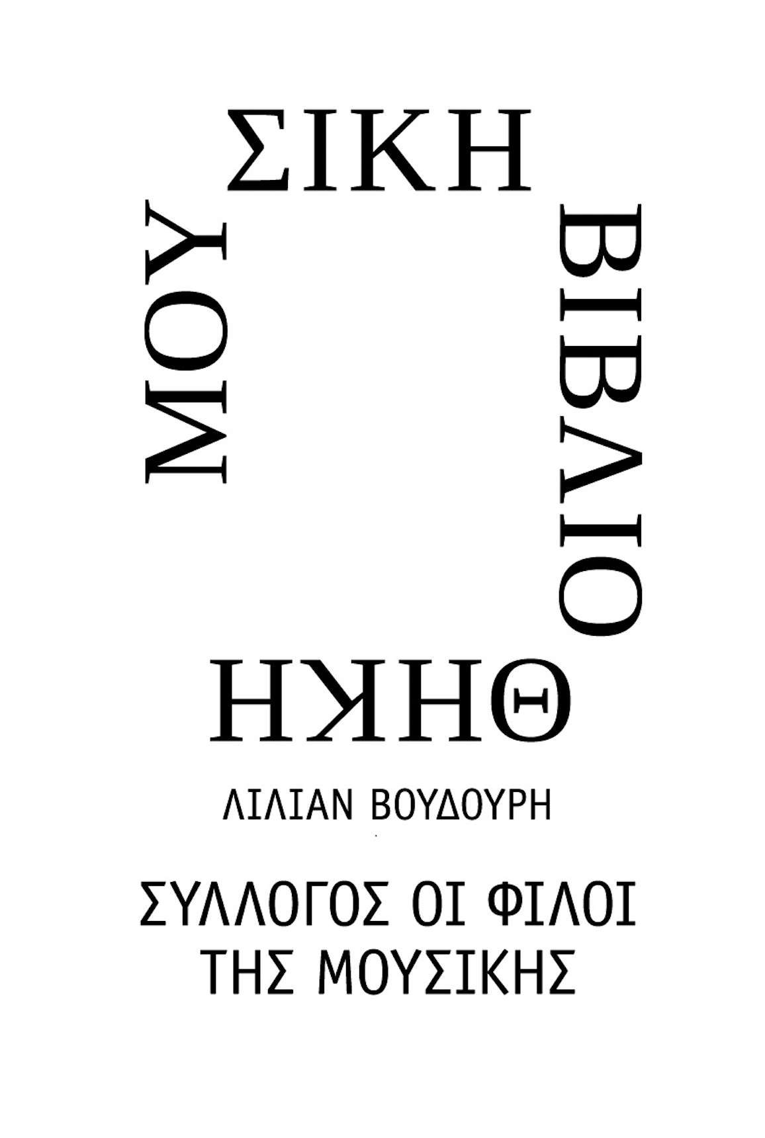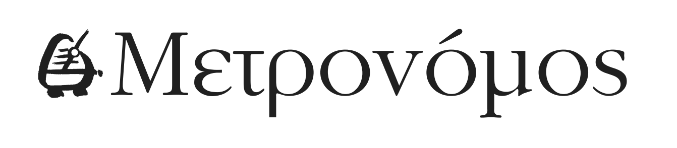
Follow the link for
PHOTOGRAPHS of the feature

For constant updates and more information about the Athens International Film Festival stay tuned to aiff.gr and cinemagazine.gr and our social media pages:: Facebook AIFF, AIFF Instagram, Cinemagazine Instagram, Twitter.

The 28th Athens International Film Festival is part of the Attica Regional Development Programme 2014-2020 and is co-funded by the European Regional Development Fund.

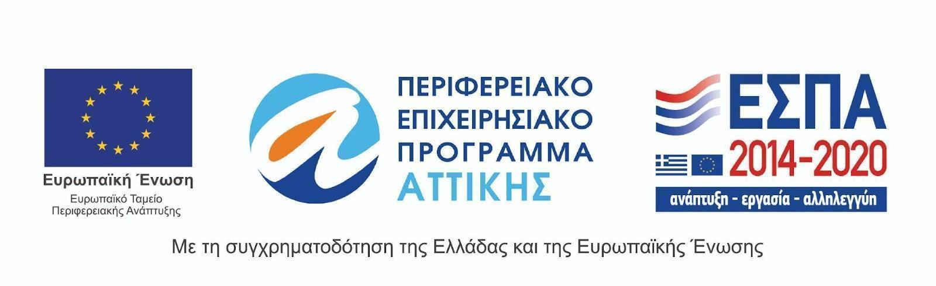
The 28th Athens International Film Festival is held under the auspices of the Ministry of Culture and Sports.

